Email to Students
Greetings-
I’m excited to begin learning together again. We’re going to do this using a tool called Teams. This tool is part of Office 365 and has been set up by the Issaquah School District to support a collaborative learning environment.
Below you will find a step-by-step guide for how to find and begin using our classroom Team. This team was set up by Issaquah School District based on student enrollment. You have already been added to the team automatically, and when you log in it will be there waiting for you. I will be using this team to communicate and share resources and assignments around learning for that class.
I am also including directions on how to join additional teams. These teams will be used for meeting together synchronously. I have created them so that you will have flexibility to work with me at times that are a good fit for you and your family. These teams will be made up of students from different classes based on sign-up sheet I sent last week. So you may see and hear some familiar faces/voices but you also might be getting to know some new people. Either way I’m excited to begin diving into our content again. I, and this is important, have not added you to these teams yet. You will need to follow the directions below and use this code (Code here) to join the team.
Please email me right away if you are having trouble with getting into Teams or joining the additional team.

What is Teams?
Teams is a digital platform within Office 365 that brings conversations, content, and apps together in one place. It enables teachers to create collaborative, paperless classrooms and also can be used to create professional learning communities.
You already have access to the tools through ISD’s Office 365 account.

Accessing Teams
Visit Teams by logging into Office.com and then clicking on the Teams icon at the top of the dashboard or download the app (android || iOS)
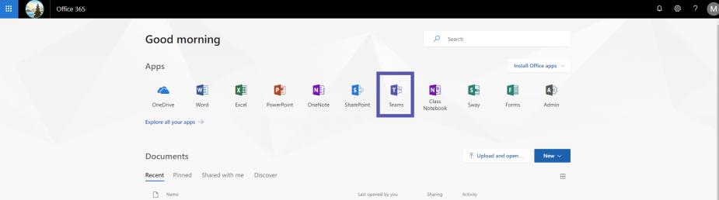
You can also install the Teams desktop application to your computer.

Logging Into Teams
Use the following credentials:
Username: ISD username as an email address (e.g. – moorjos25@issaquah.wednet.edu)
Password: ISD network password (what you log onto a computer at school with)

Getting to Your Teams
Once you’ve logged into Office and clicked on the Teams icon, you will see a grid view of all your Teams. Click on the Team you want to interact with. This will open your team. On the left, you will see a list of channels for your class. Each of these channels has a space to have conversations called Posts and a place to share files, called Files.
Each teacher will have slightly different set-up and expectations for how and where to interact in teams. It is important to pay attention to these expectations and norms in order to support a rich and collaborative environment.

A Few Things to Keep in Mind
- Make sure you are where you want to be. Look for team icon at the top to make sure you are in the right team. Then also check the name of the channel next to the icon.

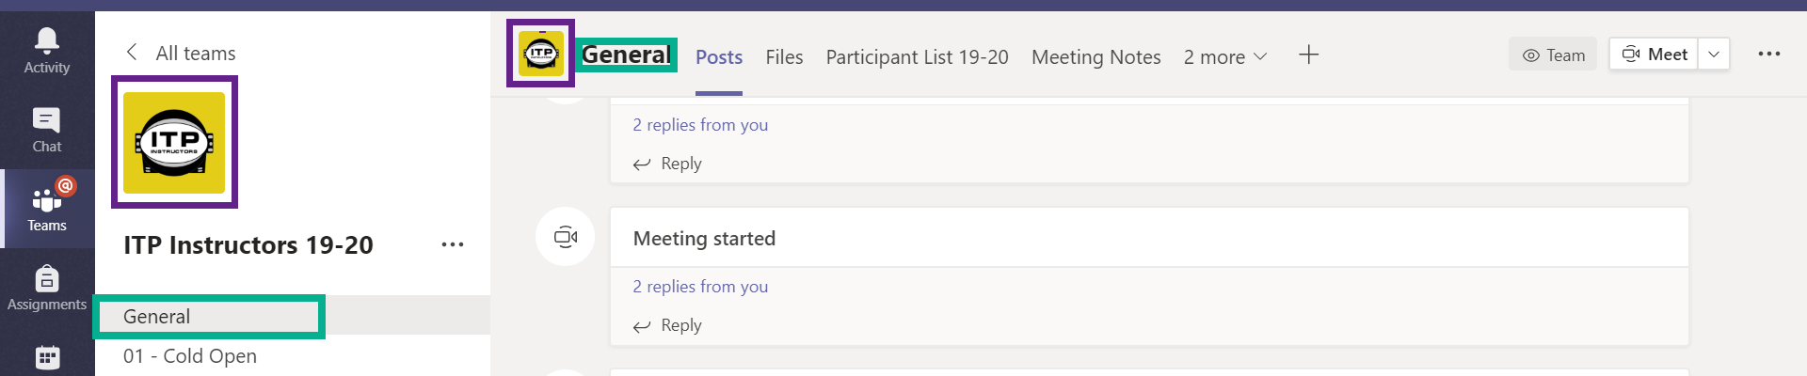
- Use the Reply button carefully. Conversation threads in teams can get busy and if you are not careful you might end up replying to the wrong conversation or worse, starting a whole new conversation.

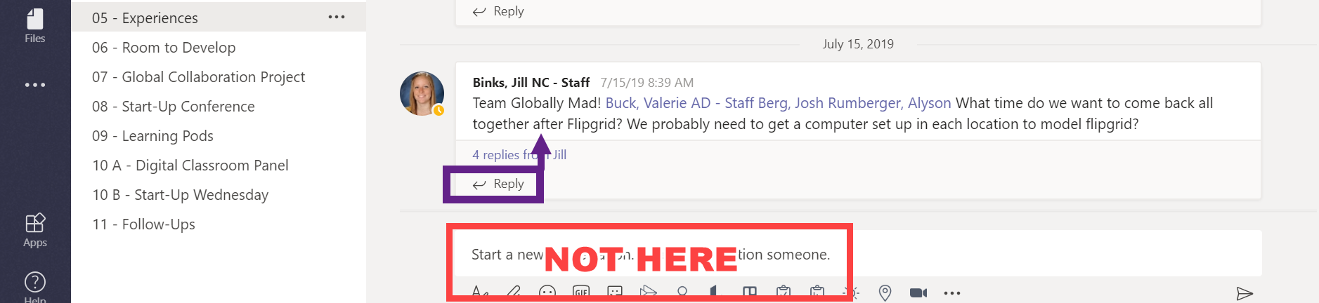

- Any Microsoft document you upload to a conversation or the files tab is editable by all members of the team. This is great for collaboration, but makes it really important that you pay attention to where you are and where you are putting stuff.
Joining Other Teams
You have already been made a member of the team for this class, but I may be asking you to join other smaller or differently configured teams. For these, you will receive a code to join (so exclusive!) Follow the directions below to join those invite only teams.
- Write down (or copy the code you received)
- Log into Office.com and Teams just like normal
- On the tile screen look for a Join Team button in the upper right of the window

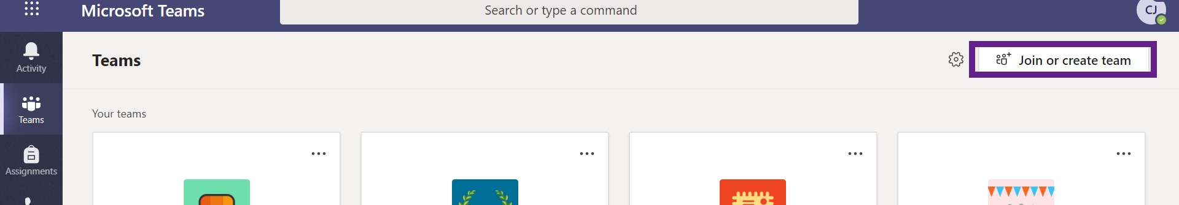

- Click on this button and on the next screen a box will appear with a spot to enter that code

- That’s it. You’re in!

Joining a Meeting in Teams
- Log into Teams and click into the Team where the meeting is being held.
- Then go to the Channel where the meeting is being held.
- Once in that join the video chat 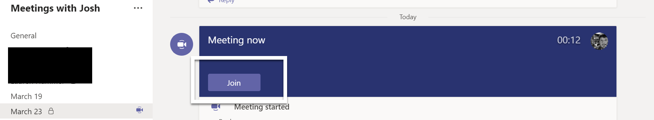

- To join the video chat, you should see a big purple bar with a Join button. Click that button and then make the following choices
  - Camera toggled off
  - Microphone toggled off
  - Then click Join

