Contextos 1. Escucha las conversaciones y decide si es lógico o ilógico.

Decide if each conversation is logical or not logical. Consider the question and whether the response is appropriate.
- lógico ilógico
- Lógico ilógico
- Lógico ilógico
- Lógico ilógico
- lógico ilógico
- lógico ilógico

Contextos 2. Eslóganes. Escucha los eslóganes y escoge el problema que corresponde. You Will hear a list of slogans. The slogans are numbered. Match the slogans you hear to the problems listed below.
- La contaminación del aire ____
- La deforestación _____
- La extinción de animales _____
- El ecoturismo ______
- La contaminación del agua _____
- La basura en las calles _____

(scroll to next page for answers)

Contextos 1. Escucha las conversaciones y decide si es lógico o ilógico.
- lógico ilógico (where does the path lead us? To the lake. Logical)
- Lógico ilógico (Are there many animals in the desert? Yes, there are stars and moons. Illogical)
- Lógico ilógico (What do you recycle in your house? plastic containers and glass bottles. Logical)
- Lógico ilógico (What do you see in the sky? A beautiful flower. Illogical)
- lógico ilógico ( why can’t we fish here? Because the river is contaminated/polluted. logical)
- lógico ilógico (what can the government do to protect forests? Make laws to prohibit deforestation. Logical)

Contextos 2. Eslóganes. Escucha los eslóganes y escoge el problema que corresponde.

- La contaminación del aire _4____
- La deforestación __1___
- La extinción de animales __5___
- El ecoturismo __6____
- La contaminación del agua __3___
- La basura en las calles __2___

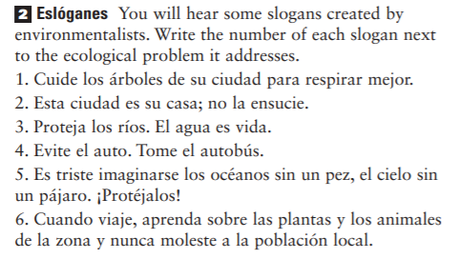
- Take care of the trees so you breathe better.
- The city is your house. Don’t dirty it.
- Protect rivers, water is life.
- Avoid cars. Take the bus.
- It’s sad to imagine oceans without fish, sky without birds. Protect them.
- When you travel, learn about the animals and plants of the

