Me llamo _________________________________ Español 3 Lección 7: La tecnología y la ciencia
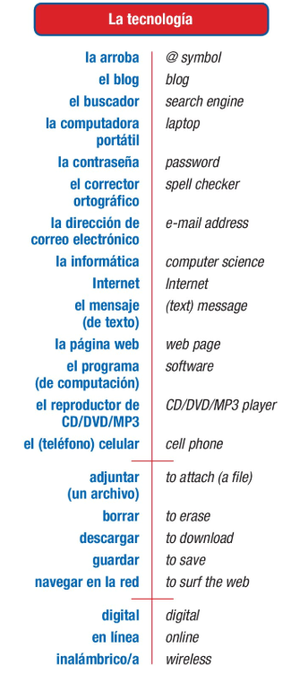
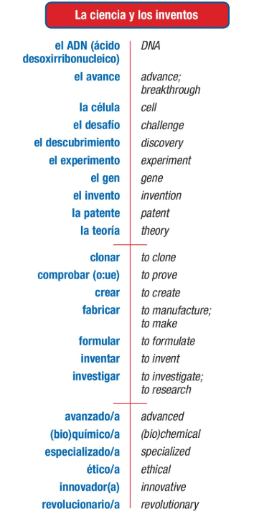
- B.
After studying this chapter, I can:
- Discuss tech and science
- Use the present perfect to say what I have done or someone has done
- Use the past perfect to say what I or someone else had done
- Use the present perfect subjunctive to express feelings or doubt about what someone has done

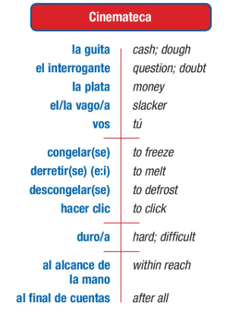
D.
C.
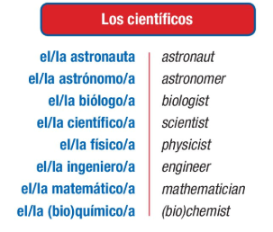
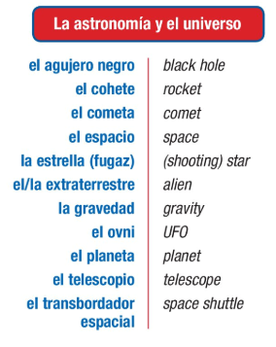
E.

A.Vocabulario: Escribe la palabra que mejor corresponde.
Ovni cohete buscador telescopio clonar arroba
- _ arroba ____:se utiliza en las direcciones de correo electrónico
- ___ Ovni _____:un objeto extraterrestre, objeto volador no identificado
- __ clonar _____:reproducir un ser vivo exactamente igual
- __ buscador ____: se utiliza para investigar en Internet
- ___ cohete __: el vehículo que se utiliza para ir al espacio
- __ telescopio ____: se utiliza para ver las estrellas
- inalámbrico el celular/móvil el buscador la patente el corrector ortográfico adjuntar un archivo
- Para encontrar una lista de sitios web se necesita ____ el buscador _____________
- Para navegar en la red en la playa se necesita _____ inalámbrico (also known as wifi =”weefee”)______________
- Para hacer una llamada en un autobús se necesita _____ el celular/móvil _____
- Para escribir sin errores en la computadora se necesita____ el corrector ortográfico _______
- Para proteger la información de la computadora se necesita __(whoops no answer given, should be _____guardar [un archivo])_______
- Para demostrar que uno es el inventor de un objeto se necesita ___ la patente _________
- Para observar la Luna y las estrellas desde la Tierra se necesita __(_Also not given) el telescopio_________
- La contraseña el extraterrestre el gen la patente
- ______ la contraseña ______ palabra o serie de letras o números que da acceso a una computadora
- ______ el gen __ partícula formada por ADN que se encuentra en el núcleo de las células y que determina la herencia
- __ la patente _____ documento que reconoce a alguien como autor de un invento
- ___ el extraterrestre ____habitante de un planeta que no es la Tierra

~~~~~~~~~~~~~~~~~~~~~~~Gramática: The Perfect Tenses ~~~~~~~~~~~~~~~~~~~~~~~~~~~
All perfect tenses are formed using the verb haber + a past participle.
- The present perfect uses present conjugations of the verb haber and translates as I have verbed.
Note: This tense is heavily used in Spain. Many parts of Latin America use the preterite instead.

- The pluscuamperfecto (the imperfect perfect/past perfect) uses imperfect conjugations of the verb haber and translates as I had verbed.

- The present perfect subjunctive uses present subjunctive conjugations of the verb haber and translates as It is not true / he wishes (or any other KEY) that I have verbed. The same KEYS that open the door for the present subjunctive apply to opening the door for the the present perfect subjunctive.

6.1 The Present Perfect (el presente perfecto o el pretérito perfecto del indicativo)
The present perfect tense is used to talk about what someone has done. It translates as I have done, You have done, She has done, etc. The present perfect tense is formed with haber(conjugated in the present) + a past participle. = I have verbed.
past participles: -ado / - ido / -ierto, -ito, etc
haber (present tense)
he | hemos
has
ha | han
THIS IS IMPORTANT: The past participle will not change in form (-os, -as) when it is part of a perfect tense; it ONLY changes when it is being used as an adjective.
**Note: these are not “HAVE” as in possession. Use TENER for that meaning.**
To form PAST PARTICIPLES of Regular Verbs:
- –AR verbs: Drop the –ar, add –ado
- –ER or –IR verbs: drop the –ER or –IR, add –ido.
Verb | Root | Ending | Participle and Meaning
Tomar | tom | -ado | _tomado__ = Taken
Comer | com | -ido | __comido_ =Eaten
Vivir | viv | -ido | _vivido__ =lived
Sound familiar?

Somewhat irregular: Past Participles ending in ído (need accent)
Caer | Caído
Creer | Creído
Leer | Leído
Oír | Oído
Reír | Reído
traer | traído

Remember some irregulars from Spanish 2??? Abierto, escrito….
Verb | Participle Form | Meaning
Abrir | abierto | Opened
Cubrir | cubierto | Covered
Decir | dicho | Said
Escribir | escrito | Written
Hacer | hecho | Done
Imprimir | impreso | Printed
Morir | muerto | Died
Poner | puesto | Put
Resolver | resuelto | Resolved, solved
Romper | roto | Broken
Ver | visto | Seen
Volver | vuelto | Returned
freír | frito | Fried
descubrir | descubierto | Discovered
Any others you like:

In Spanish, we will never separate the verb haber + past participle. This means that to say you have not done something, the word no will come before the conjugated form of haber. I have not eaten = (Yo) no he comido..
Spanish does NOT use the verb tener to talk about what someone has done.
Now try these translations: If you need to, write the infinitive verb so you know what participle you’re making.
- I have eaten (comer): __Yo he comido.
- You have worked: __has trabajado______
- He has invented: ______él ha inventado______
- They have not investigated: ___No han investigado____________
- I have done it: ____Yo lo he hecho_____
- We have not broken it: ___(nosotros)no lo hemos roto______
- I have resolved it: ____Yo lo he resuelto____
- There has been a problem: ____ha habido un problema_(from haber because to say there is or there was you would use hay or había)____
- You have discovered them: ___(Tú) los has descubierto__________
- You (formal) have read: _______usted ha leído______
- We have gone: ____hemos ido_____________
- You have downloaded: ____has descargado__________
- They have not frozen __No han congelado________
- She has said it to me: _______ me (person first) lo (item after) then verb. Me lo ha dicho. __________
- You all have washed your hands: __Ustedes se han lavado las manos_____

6.2 The Past Perfect (Pluscuamperfecto) aka “Imperfect Perfect”
The past perfect tense is used to talk about what someone had done or what had occurred. It translates as I had done, You had done, She had done, etc. The past perfect tense is formed with haber(conjugated in the imperfect) + a past participle.= I had verbed.
past participles: -ado / - ido / -ierto, -ito, etc
-ado / - ido / ierto, ito, etc
haber (imperfect tense)
había | habíamos
habías
había | habían
The past perfect is often used with the word ya (already) to indicate that an action, event or state had already occurred before another. Remember that In Spanish, we will never separate the verb haber + past participle. This means that to say you had already done something, the word ya will come before the conjugated form of haber.
The past perfect is often used in conjunction with antes de + [noun] or antes de + [infinitive] to describe when the action(s) had occurred.
Now try these translations:
- I had already studied: ___Yo ya había estudiado___ 3. You had called: habías llamado____
- He had gotten dressed: ___él se había visto (vestirse) or
él se había puesto la ropa_______ 4.. We had already traveled: _(nosotros) ya habíamos viajado________
YA =already.
- I had already gone =(Yo) Ya había ido.
- We had already eaten dinner when you called: __Ya habíamos cenado cuando llamaste____
- They had already fallen asleep when I arrived: ____Ya se habían dormido cuando llegué___________
- Before starting school, I had learned to read: ___Antes de empezar la escuela, yo había aprendido a leer.
- Before last year, you had never played soccer: __Antes del año pasado, (tú) nunca habías jugado al fútbol. _
Say what you had already done before each situation:
- antes de ver la tele, ya había terminado la tarea.
- antes del desayuno _____ ya nos habíamos arreglado (gotten ready)___________
- antes de ir a clase _____ ya habíamos hablado con amigos_____
- antes del almuerzo __ ya me había lavado las manos______
- antes de la cena ___ ya habíamos puesto la mesa _(set the table)______
- antes de acostarme__ ya me había lavado/cepillado los dientes _________
Try these! UNA MEZCLA
- We have studied. Hemos estudiado.
- The boys had run. ___Los chicos habían corrido__________
- My sister has eaten. ____Mi hermana ha comido____________
- Her friend has lived in Spain. ___Su amiga ha vivido en España.___________
- Have you learned? ________¿Has aprendido?_____________
- What have you eaten? _____¿Qué has comido?______________
- We had not worked ____No habíamos trabajado___________
- You hadn’t known _______No habías sabido _________________
- I hadn’t been happy _______No había sido/estado feliz__________
Contesta en español:
- ¿Han hecho ustedes la tarea? ___Sí, hemos hecho la tarea_________
- ¿Has aprendido la información? _____No, no he aprendido la información__________
- ¿Qué has comido hoy? __He comido pan con mantequilla y frutas____________
- ¿Qué habías hecho cuando (whoops didn’t finish)

6.3 The Present Perfect Subjunctive(el pretérito perfecto del subjuntivo o el presente perfecto del subjuntivo)
The present perfect subjunctive, like the present perfect indicative, is used to talk about what someone has done or what has happened. It translates as I have done, You have done, She has done, etc, but it used with a KEY For the subjunctive. = It is not true / he wishes (or any other KEY) that I have verbed.
If your first clause requires subjunctive, you would use the subjunctive of haber and then the same participle.
What kinds of things cause the subjunctive in the main clause?
Wish/want Emotion Doubt Desire Impersonal/insist Need General = Subjunctive!

So if you have one of these WEDDINGS in the first part, you will use the present perfect in the second clause if you’re referring to the past.
The present perfect tense is formed with haber(conjugated in the present subjunctive) + a past participle.
past participles: -ado / - ido / -ierto, -ito, etc
haber (present subjunctive tense)
Haya | hayamos
hayas
haya | hayan

So remember, take the form of HABER, then add the participle. This makes the compound tense of the present perfect.
In Spanish, we will never separate the verb haber + past participle. This means that to say you have not done something, the word no will come before the conjugated form of haber.
Sequence of tenses
In Spanish, they keep one half of the sentence in the same tense as the second half.
In English, we might say: I hope you ordered pizza.
I hope =present (and opens the door for the next clause to be subjunctive) You ordered = past.
In Spanish, they keep the tense of one clause the same in the second clause.
In Spanish, they will say
I hope that [Espero que] you have ordered pizza. –[hayas pedido la pizza]
(present) (present perfect subjunctive)
¡Practiquemos! Usamos el presente perfecto o el presente perfecto del subjuntivo (he has ha o haya hayas)
- Espero que (tú) _hayas llegado __ (llegar) a tiempo.
- Es triste que (nosotros) __hayamos vivido_____ (vivir) así.
- Es posible que ella ___haya viajado____ (viajar) a España.
- Estoy contenta de que ustedes ___hayan aprendido______ (aprender) mucho.
- Pienso que la clase _____ha empezado (non-key!)_________ (empezar) ya.
- Creemos que la información ___ha sido (non-key!)_______(ser) importante.
- No es verdad que la chica ___haya estado______ (estar) en todas sus clases.
- Es horrible que tú ______hayas roto__________(romper) la pierna.
- Me gusta que ustedes ____hayan escrito_______ (escribir) la novela.
Choose a key for the subjunctive! Espero que, es importante que, necesitamos que, no es cierto que…
- ustedes / llegar a tiempo: Espero que ustedes hayan llegado a tiempo.
- mis amigas / descubrir una cura ______Es fabuloso que mis amigas hayan descubierto una cura __________
- mi familia / traer las hamburguesas ___Espero que mi familia haya traído hamburguesas____________
- ti / gustar la comida ___Me alegro de que (a ti) te haya gustado la comida
- usted /hacer ejercicio ________No es necesario que usted haya hecho ejercicio______
- mi primo / no adjuntar el archivo ______Dudo que mi primo no haya adjuntado el archivo
- mis papás / ser innovadores _______No creo que mis papás hayan sido innovadores____________

~Diminutivos y Aumentativos:~
- Diminutives and augmentatives (diminutivos y aumentativos) are frequently used in conversational Spanish. They emphasize size or express shades of meaning like affection, amazement, scorn, or ridicule. Diminutives and augmentatives are formed by adding a suffix to the root of nouns, adjectives (which agree in gender and number), and occasionally adverbs.
- Because formation and use of diminutives and augmentatives varies greatly from one region to another, there are very few established rules about this aspect of the Spanish language. In this section, you will learn to recognize the most commonly used suffixes and their uses. Try to use only those you have learned from native speakers or teachers. Adding them to words you are not sure of can lead to misunderstanding!
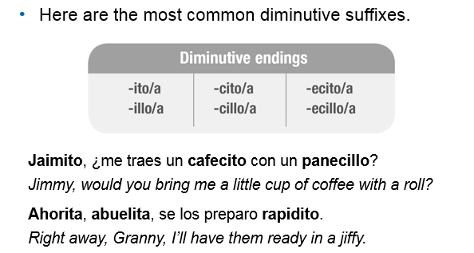
Most words form diminutive by adding –ito/a. The suffix illo/a is common in some regions, including Spain. For words ending in vowels (NOT –E), the last vowel is dropped.
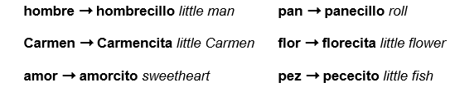

Libro librillo. Ventana ventanilla, Miguel miguelito, ahora ahorita
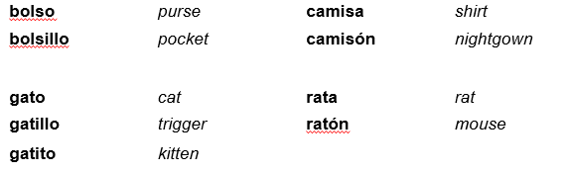
Some change meaning!

Most words that end in –e, –n, or –r use the forms –cito/a or –cillo/a. However, one syllable words often use –ecito/a or –ecillo/a. chico ➞ chiquillo little boy; very small
amigo amiguito, agua agüita (little bit of water) , luz ➞ lucecita little light
Try these! Restate the description using a diminutivo.
- Una campana pequeña =____una campanita________
- Muy cerca = _____cerquita (cercita would be pronounced “seeta” and it needs to sound like k)_____________
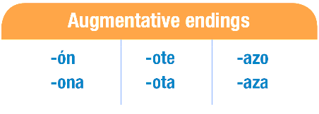
- Una cucharada = ________cucharadita____________
The most common augmentative suffixes are forms of –ón/–ona, –ote/–ota, and –azo/–aza.
There is a tendency to change a feminine word to a masculine one when the suffix –ón is used, unless it refers specifically to someone’s gender.
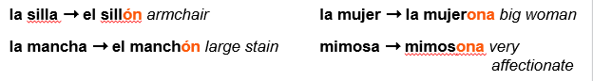
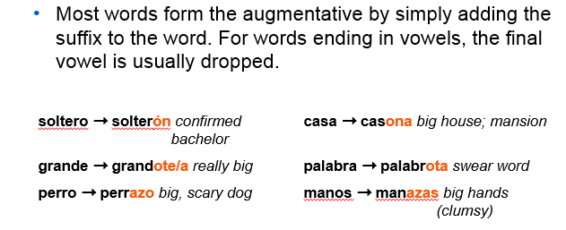
palabra palabrota = bad words/profanity!
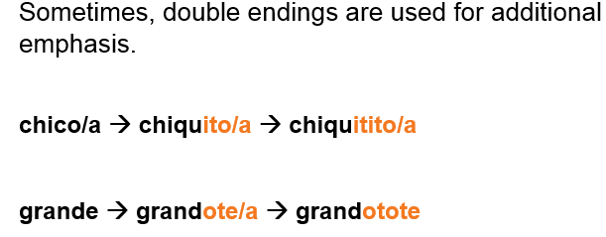

Try these! Restate the description using an aumentativo.
- Un perro muy grande: un __perrote OR perro grandote_______
- Una casa: ___una casona____________
- Una mano: una _____manote________________
- Unos abrazos muy grandes: unos abrazotes
Práctica: Carlos siempre habla usando diminutivos y aumentativos. Completa sus descripciones con el diminutivo o aumentativo de las palabras entre paréntesis. You decide which to use for each!
Ayer fui al (1) ____________________ (mercado) de antigüedades que está muy (2) ____________________ (cerca) de mi (3) ____________________ (casa) y compré algunas (4) ____________________ (cosas) muy valiosas. En el primer puesto, un (5) ____________________ (hombre) muy simpático me aconsejó comprar un (6) _________________ (libro) viejo y muy bonito. Cuando regresé a casa, tenía mucho frío y me tomé un (7) ____________________ (café) para calentarme. Me senté en mi (8) ____________________ (silla) favorita y empecé a leer. Fue una mañana muy divertida.

