Me llamo _________________________________ Español 3 Lección 7: La tecnología y la ciencia
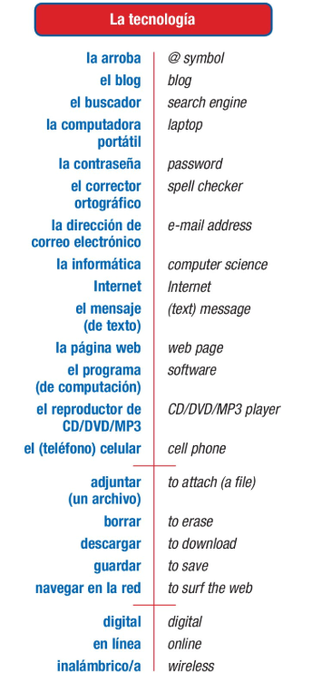
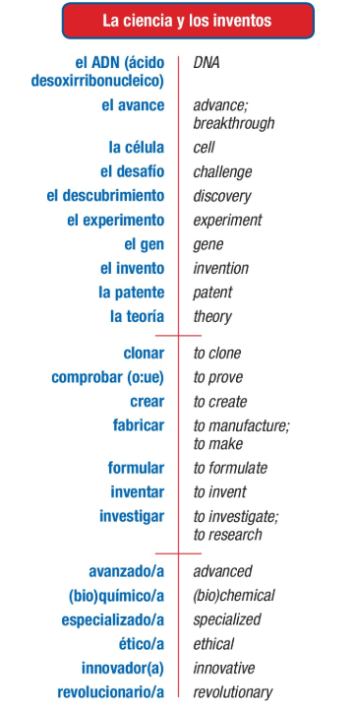
- B.
After studying this chapter, I can:
- Discuss tech and science
- Use the present perfect to say what I have done or someone has done
- Use the past perfect to say what I or someone else had done
- Use the present perfect subjunctive to express feelings or doubt about what someone has done

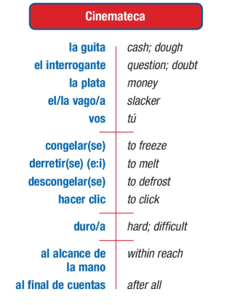
D.
C.
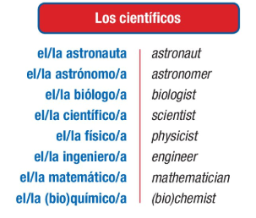
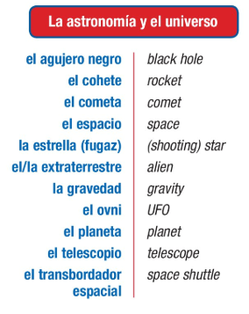
E.

A.Vocabulario: Escribe la palabra que mejor corresponde.
Ovni cohete buscador telescopio clonar arroba
- ______________:se utiliza en las direcciones de correo electrónico
- ______________:un objeto extraterrestre, objeto volador no identificado
- ______________:reproducir un ser vivo exactamente igual
- ______________: se utiliza para investigar en Internet
- ______________: el vehículo que se utiliza para ir al espacio
- ______________: se utiliza para ver las estrellas
- inalámbrico el celular/móvil el buscador la patente telescopio el corrector ortográfico adjuntar un archivo guardar un archivo
- Para encontrar una lista de sitios web se necesita ____________________________
- Para navegar en la red en la playa se necesita ____________________________
- Para hacer una llamada en un autobús se necesita ____________________________
- Para escribir sin errores en la computadora se necesita____________________________
- Para proteger la información de la computadora se necesita ____________________________
- Para demostrar que uno es el inventor de un objeto se necesita ____________________________
- Para observar la Luna y las estrellas desde la Tierra se necesita ____________________________
- La contraseña el extraterrestre el gen la patente
- _______________________ palabra o serie de letras o números que da acceso a una computadora
- __________________________ partícula formada por ADN que se encuentra en el núcleo de las células y que determina la herencia
- __________________________ documento que reconoce a alguien como autor de un invento
- __________________habitante de un planeta que no es la Tierra

~~~~~~~~~~~~~~~~~~~~~~~Gramática: The Perfect Tenses ~~~~~~~~~~~~~~~~~~~~~~~~~~~
All perfect tenses are formed using the verb haber + a past participle.
- The present perfect uses present conjugations of the verb haber and translates as I have verbed.
Note: This tense is heavily used in Spain. Many parts of Latin America use the preterite instead.

- The pluscuamperfecto (the imperfect perfect/past perfect) uses imperfect conjugations of the verb haber and translates as I had verbed.

- The present perfect subjunctive uses present subjunctive conjugations of the verb haber and translates as It is not true / he wishes (or any other KEY) that I have verbed. The same KEYS that open the door for the present subjunctive apply to opening the door for the the present perfect subjunctive.

6.1 The Present Perfect (el presente perfecto o el pretérito perfecto del indicativo)
The present perfect tense is used to talk about what someone has done. It translates as I have done, You have done, She has done, etc. The present perfect tense is formed with haber(conjugated in the present) + a past participle. = I have verbed.
past participles: -ado / - ido / -ierto, -ito, etc
haber (present tense)
he | hemos
has
ha | han
THIS IS IMPORTANT: The past participle will not change in form (-os, -as) when it is part of a perfect tense; it ONLY changes when it is being used as an adjective.
**Note: these are not “HAVE” as in possession. Use TENER for that meaning.**
To form PAST PARTICIPLES of Regular Verbs:
- –AR verbs: Drop the –ar, add –ado
- –ER or –IR verbs: drop the –ER or –IR, add –ido.
Verb | Root | Ending | Participle and Meaning
Tomar | tom | -ado | ____________ = Taken
Comer | com | -ido | ____________ =Eaten
Vivir | viv | -ido | ____________ =lived
Sound familiar?

Somewhat irregular: Past Participles ending in ído (need accent)
Caer | Caído
Creer | Creído
Leer | Leído
Oír | Oído
Reír | Reído
traer | traído
Remember some irregulars from Spanish 2??? Abierto, escrito….
Verb | Participle Form | Meaning
Abrir |  | Opened
Cubrir |  | Covered
Decir |  | Said
Escribir |  | Written
Hacer |  | Done
Imprimir |  | Printed
Morir |  | Died
Poner |  | Put
Resolver |  | Resolved, solved
Romper |  | Broken
Ver |  | Seen
Volver | vuelto | Returned
freír |  | Fried
descubrir |  | Discovered

In Spanish, we will never separate the verb haber + past participle. This means that to say you have not done something, the word no will come before the conjugated form of haber. I have not eaten = (Yo) no he comido..
Spanish does NOT use the verb tener to talk about what someone has done.
Now try these translations: If you need to, write the infinitive verb so you know what participle you’re making.
- I have eaten (comer): __Yo he comido.
- You have worked: _________________________________
- He has invented: _________________________________
- They have not investigated: _________________________________________
- I have done it: _________________________________
- We have not broken it: _________________________________
- I have resolved it: _________________________________
- There has been a problem: _________________________________
- You have discovered them: _________________________________
- You (formal) have read: _________________________________
- We have gone: _________________________________
- You have downloaded: _________________________________
- They have not frozen ________________________________________
- She has said it to me: ________________________________________
- You all have washed your hands: ________________________________________

6.2 The Past Perfect (Pluscuamperfecto) aka “Imperfect Perfect”
The past perfect tense is used to talk about what someone had done or what had occurred. It translates as I had done, You had done, She had done, etc. The past perfect tense is formed with haber(conjugated in the imperfect) + a past participle.= I had verbed.
past participles: -ado / - ido / -ierto, -ito, etc
-ado / - ido / ierto, ito, etc
haber (imperfect tense)
había
The past perfect is often used with the word ya (already) to indicate that an action, event or state had already occurred before another. Remember that In Spanish, we will never separate the verb haber + past participle. This means that to say you had already done something, the word ya will come before the conjugated form of haber.
The past perfect is often used in conjunction with antes de + [noun] or antes de + [infinitive] to describe when the action(s) had occurred.
Now try these translations:
- I had already studied: ___Yo ya había estudiado___ 3. You had called: _________________________
- He had gotten dressed: _________________________ 4.. We had already traveled: _________________________
YA =already.
- I had already gone =(Yo) Ya había ido.
- We had already eaten dinner when you called: ___________________________________________________________
- They had already fallen asleep when I arrived: ____________________________________________________________
- Before starting school, I had learned to read: _____________________________________________________________
- Before last year, you had never played soccer: ____________________________________________________________
Say what you had already done before each situation:
- antes de ver la tele, ya había terminado la tarea.
- antes del desayuno ___________________________________________
- antes de ir a clase ____________________________________________
- antes del almuerzo ____________________________________________
- antes de la cena ___________________________________________
- antes de acostarme____________________________________________
Try these! UNA MEZCLA
- We have studied. Hemos estudiado.
- The boys had run. ___________________________________
- My sister has eaten. ___________________________________
- Her friend has lived in Spain. ___________________________________
- Have you learned? ___________________________________
- What have you eaten? ___________________________________
- We had not worked __________________________________________
- You hadn’t known _____________________________________________
- I hadn’t been happy __________________________________________
Contesta en español:
- ¿Han hecho ustedes la tarea? ______________________________________________
- ¿Has aprendido la información? _____________________________________________
- ¿Qué has comido hoy? ___________________________________________

6.3 The Present Perfect Subjunctive(el pretérito perfecto del subjuntivo o el presente perfecto del subjuntivo)
The present perfect subjunctive, like the present perfect indicative, is used to talk about what someone has done or what has happened. It translates as I have done, You have done, She has done, etc, but it used with a KEY For the subjunctive. = It is not true / he wishes (or any other KEY) that I have verbed.
If your first clause requires subjunctive, you would use the subjunctive of haber and then the same participle.
What kinds of things cause the subjunctive in the main clause?
Wish/want Emotion Doubt Desire Impersonal/insist Need General = Subjunctive!

So if you have one of these WEDDINGS in the first part, you will use the present perfect in the second clause if you’re referring to the past.
The present perfect tense is formed with haber(conjugated in the present subjunctive) + a past participle.
past participles: -ado / - ido / -ierto, -ito, etc
haber (present subjunctive tense)
Haya

So remember, take the form of HABER, then add the participle. This makes the compound tense of the present perfect.
In Spanish, we will never separate the verb haber + past participle. This means that to say you have not done something, the word no will come before the conjugated form of haber.
Sequence of tenses
In Spanish, they keep one half of the sentence in the same tense as the second half.
In English, we might say: I hope you ordered pizza.
I hope =present (and opens the door for the next clause to be subjunctive) You ordered = past.
In Spanish, they keep the tense of one clause the same in the second clause.
In Spanish, they will say
I hope that [Espero que] you have ordered pizza. –[hayas pedido la pizza]
(present) (present perfect subjunctive)
¡Practiquemos! Usamos el presente perfecto o el presente perfecto del subjuntivo (he has ha o haya hayas)
- Espero que (tú) _hayas llegado __ (llegar) a tiempo.
- Es triste que (nosotros) __________________________ (vivir) así.
- Es posible que ella _________________________ (viajar) a España.
- Estoy contenta de que ustedes ____________________________ (aprender) mucho.
- Pienso que la clase ______________________________________ (empezar) ya.
- Creemos que la información _____________________________(ser) importante.
- No es verdad que la chica ________________________________ (estar) en todas sus clases.
- Es horrible que tú _____________________________________(romper) la pierna.
- Me gusta que ustedes _______________________________ (escribir) la novela.
Choose a key for the subjunctive! Espero que, es importante que, necesitamos que, no es cierto que…
- ustedes / llegar a tiempo: Espero que ustedes hayan llegado a tiempo.
- mis amigas / descubrir una cura _____________________________________________________
- mi familia / traer las hamburguesas _____________________________________________________
- ti / gustar la comida _____________________________________________________
- usted /hacer ejercicio _______________________________________________________
- mi primo / no adjuntar el archivo _____________________________________________________
- mis papás / ser innovadores _________________________________________________________

~Diminutivos y Aumentativos:~
- Diminutives and augmentatives (diminutivos y aumentativos) are frequently used in conversational Spanish. They emphasize size or express shades of meaning like affection, amazement, scorn, or ridicule. Diminutives and augmentatives are formed by adding a suffix to the root of nouns, adjectives (which agree in gender and number), and occasionally adverbs.
- Because formation and use of diminutives and augmentatives varies greatly from one region to another, there are very few established rules about this aspect of the Spanish language. In this section, you will learn to recognize the most commonly used suffixes and their uses. Try to use only those you have learned from native speakers or teachers. Adding them to words you are not sure of can lead to misunderstanding!
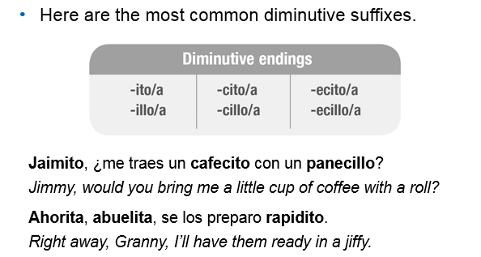
Most words form diminutive by adding –ito/a. The suffix illo/a is common in some regions, including Spain. For words ending in vowels (NOT –E), the last vowel is dropped.
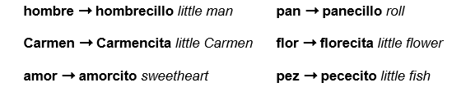

Libro librillo. Ventana ventanilla, Miguel miguelito, ahora ahorita
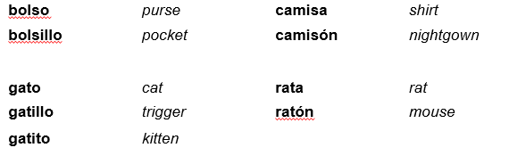
Some change meaning!

Most words that end in –e, –n, or –r use the forms –cito/a or –cillo/a. However, one syllable words often use –ecito/a or –ecillo/a. chico ➞ chiquillo little boy; very small
amigo amiguito, agua agüita (little bit of water) , luz ➞ lucecita little light
Try these! Restate the description using a diminutivo.
- Una campana pequeña =_________________________________
- Muy cerca = ________________________________
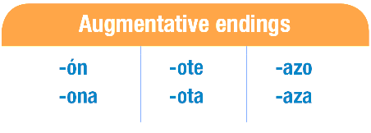
- Una cucharada = ___________________________________
The most common augmentative suffixes are forms of –ón/–ona, –ote/–ota, and –azo/–aza.
There is a tendency to change a feminine word to a masculine one when the suffix –ón is used, unless it refers specifically to someone’s gender.
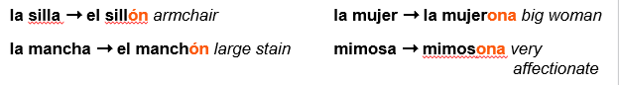
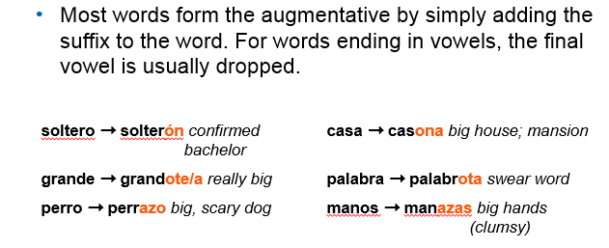
palabra palabrota = bad words/profanity!
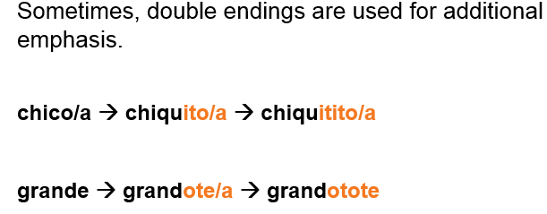

Try these! Restate the description using an aumentativo.
- Un perro muy grande: un __perrote OR perro grandote_______
- Una casa: _______________________________________
- Una mano: una _______________________________________
- Unos abrazos muy grandes: un _______________________________________
Práctica: Carlos siempre habla usando diminutivos y aumentativos. Completa sus descripciones con el diminutivo o aumentativo de las palabras entre paréntesis. You decide which to use for each!
Ayer fui al (1) ____________________ (mercado) de antigüedades que está muy (2) ____________________ (cerca) de mi (3) ____________________ (casa) y compré algunas (4) ____________________ (cosas) muy valiosas. En el primer puesto, un (5) ____________________ (hombre) muy simpático me aconsejó comprar un (6) _________________ (libro) viejo y muy bonito. Cuando regresé a casa, tenía mucho frío y me tomé un (7) ____________________ (café) para calentarme. Me senté en mi (8) ____________________ (silla) favorita y empecé a leer. Fue una mañana muy divertida.

