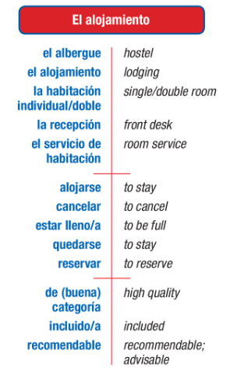
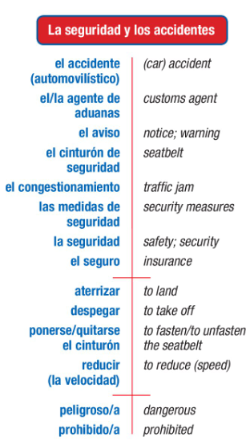
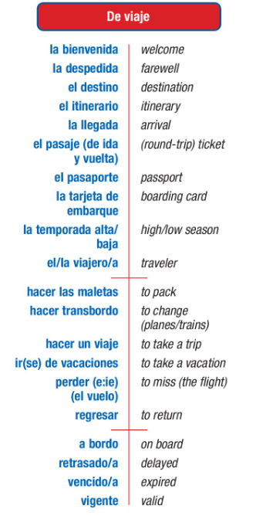
Me llamo________________________________ Español 3 Lección 5: ¡De Viaje!
B.Safety/security & accidents
C. Lodging /room& board
- Travel
El pase de abordar; | boarding pass La tarjeta de | embarque
El reclamo de equipaje | baggage claim

.

De buena calidad | of good quality

E. By the ocean
D. Excursions
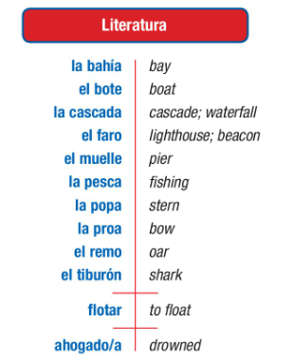
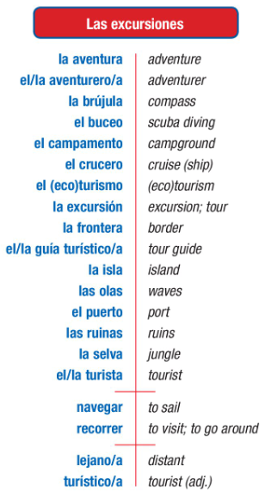

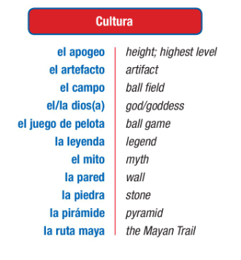
~~~~~~~~~~~~~~~~~~~~~~~~~~~~~~~~~~~Extras~~~~~~~~~~~~~~~~~~~~~~~~~~~~~~~~~
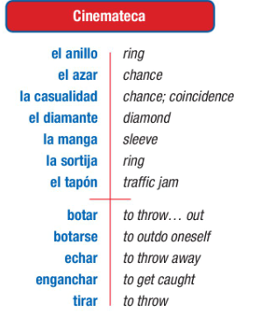

Vocabulario:
- El aeropuerto internacional: Read the descriptions of the scenarios below, and determine which statement corresponds with each scenario.
- Un hombre con una maleta está tratando de comprar un pasaje, pero el empleado de la aerolínea le está explicando que ya no quedan más asientos disponibles
- Una pareja con maletas está en la puerta de embarque. El hombre le habla a la empleada.
- Un joven llega al aeropuerto con una hora de retraso y el empleado le da la mala noticia.
- El empleado de una aerolínea habla con un viajero que tiene el pasaporte vencido.
- Dos azafatas esperan a los pasajeros en la zona de embarque.
- Una empleada de la oficina de informes está hablando por un micrófono para avisar que el avión saldrá dos horas más tarde.

_____ a. “Tengo dos pasajes reservados para San José”.
_____ b. “Para volar necesita tener el pasaporte vigente”.
_____ c. “Lo siento señor, el vuelo está lleno”.
_____ d. “El vuelo con destino a la Ciudad de Panamá está retrasado”.
_____ e. “¡Atención, señores! Los pasajeros del vuelo 508 con destino a La Paz ya pueden embarcar”.
_____ f. “Me temo que ha perdido su vuelo”.

- Escribe la palabra correcta para cada definición.
brújula olas frontera pasaporte crucero tarjeta de embarque recepción vigente isla

- ________________ documento necesario para ir a otro país
- ________________ las forma el movimiento del agua del mar
- ________________ vacaciones en un barco
- ________________ instrumento que ayuda a saber dónde está el Polo Norte
- ________________ línea que separa dos países
- ________________ lugar del hotel donde te dan las llaves de la habitación
- ________________ documento necesario para poder subir a un avión
- ________________ lo contrario de vencido
- ________________ lugar rodeado de agua

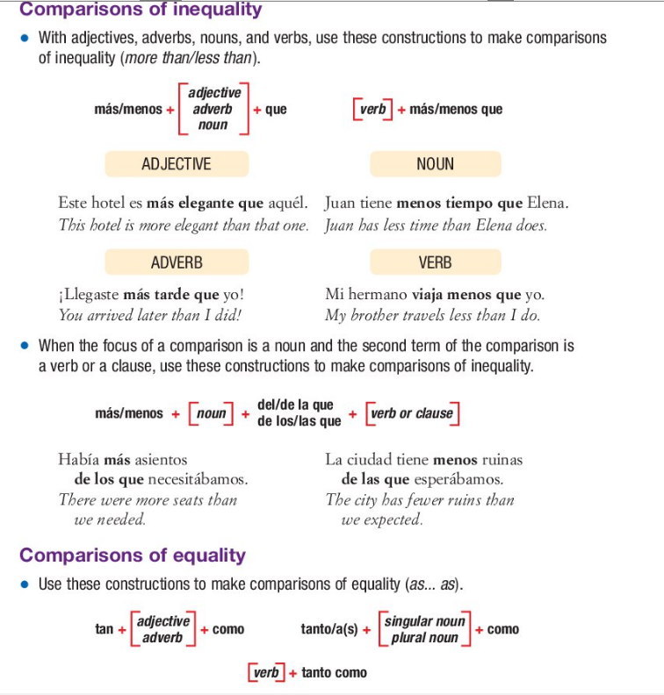

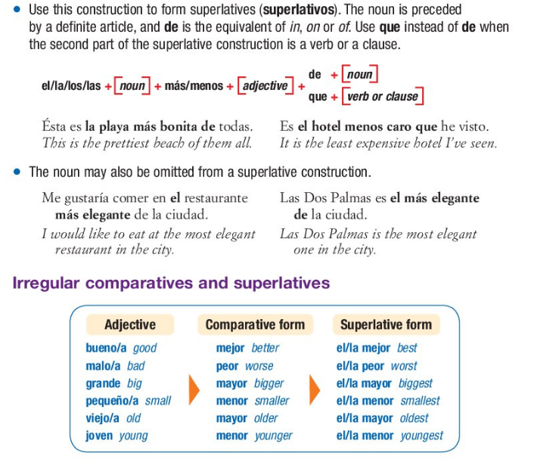

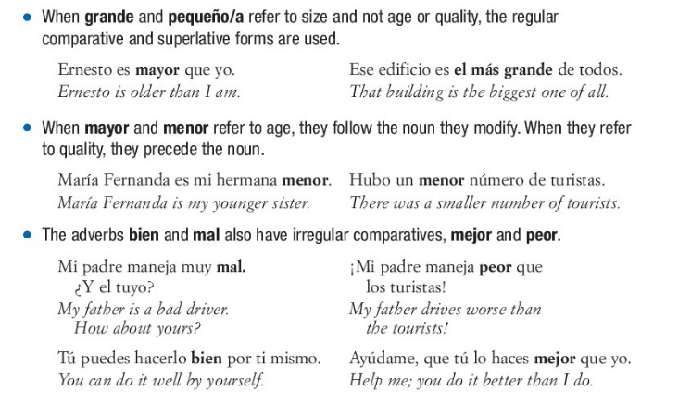

Práctica: Choose the option that has the same meaning as the given sentence.
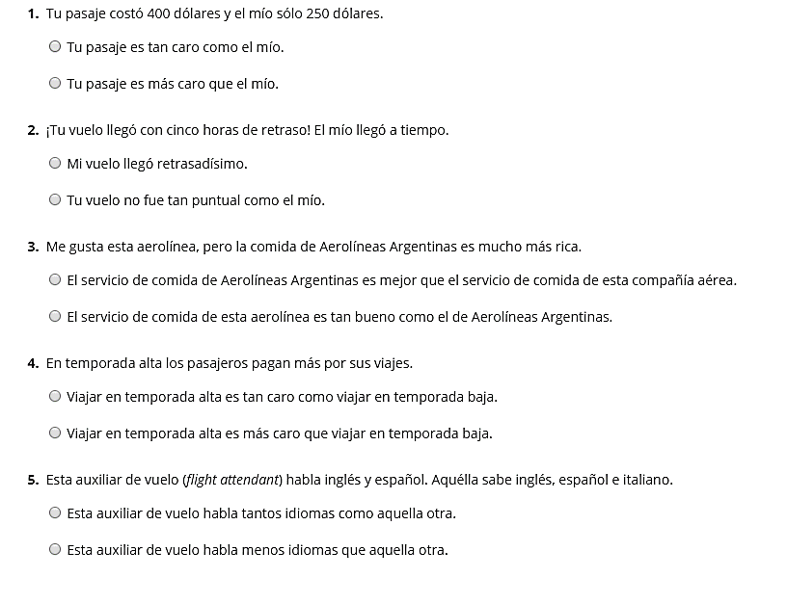

Haz comparaciones con la información. Watch for irregulars for best, worst, etc!
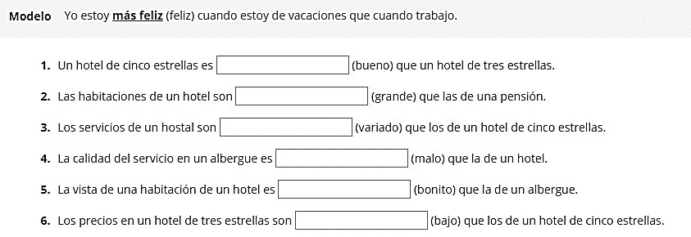

¡Para expresarte!
- Yo soy más _____________ que ________________.
- En mi clase, ______________ es menos ______________ que __________________.
- Yo soy tan ___________________ como _______________________.
- Me gusta ___________________ tanto como _________________________
- Prefiero _____________________ más que ______________________.

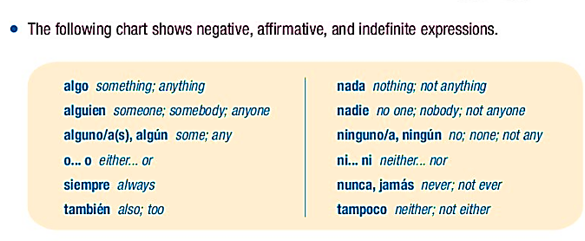

Los contrarios: write the word that is the opposite of the one listed.

- Algo (something) __nada (nothing)___
- También _tampoco____
- Algo __nada______
- Tampoco _también______
- Siempre __nunca___
- O __ni___
- algún __ningún (ninguno/as)____
- nunca _siempre_
- alguien _nadie___
- siempre __nunca_____
- algunos _ningunos___
- nada __algo___
- ni ___o____

Choose which option has the same meaning as the given sentence.
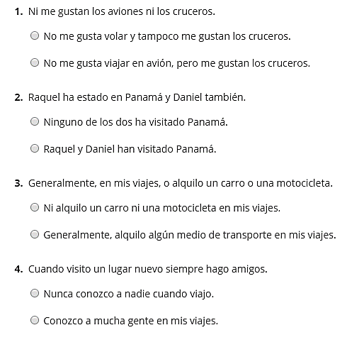

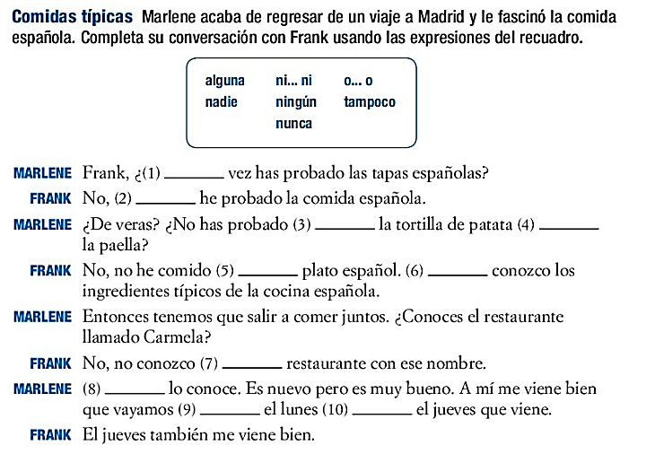

~~~~~~~~~~~~~~~~~~~~Gramática: ¡El subjuntivo! Wait…Again??? ~~~~~~~~~~~~~~~~~~~
The indicative is used to express actions, states, or facts the speaker considers to be certain. The subjunctive expresses the speaker’s attitude toward events, as well as actions or states that the speaker views as uncertain.
Forms of the present subjunctive
- The subjunctive (el subjuntivo) is used mainly in the subordinate (dependent) clause of multiple-clause sentences which express will, influence, emotion, doubt, or denial. The present subjunctive is formed by: taking the present yo form, dropping the –o, and adding the opposite ending. This means that –AR verbs get E, ES, E, EMOS, EN and –IR/-ER verbs get –A, AS, A, AMOS, AN.
Verbs that end in –car, –gar, and –zar undergo spelling changes in the present subjunctive.
Practicar, yo ___________________________nosotros____________________
Cazar, tú ___________________________nosotros____________________
Pagar, ella ___________________________nosotros____________________
- Verbs with irregular yo forms show that same irregularity in all forms of the present subjunctive.
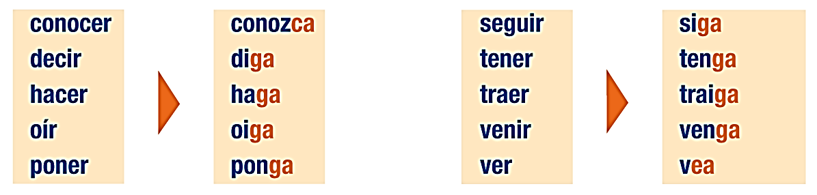

Verbs with stem changes in the present indicative show the same changes in the present subjunctive. Stem-changing –ir verbs also undergo a stem change in the nosotros/as and vosotros/as forms of the present subjunctive:
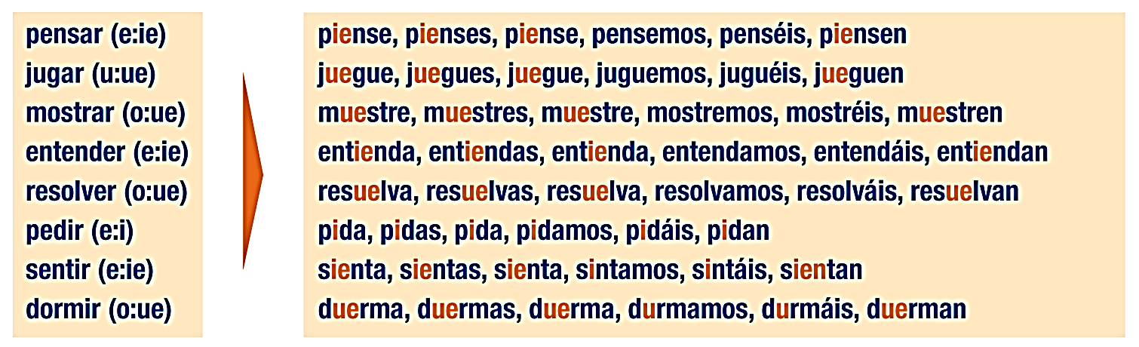

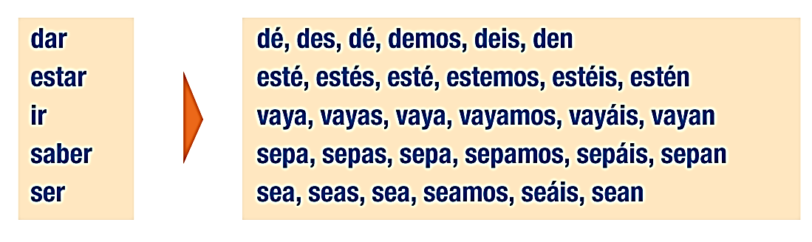
- The following five verbs are irregular in the present subjunctive. PLUS haber = DISHES

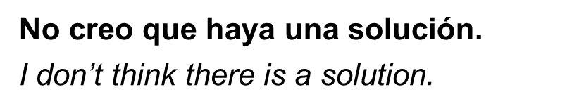
DISHES:
D _________________________________________
I_________________________________________
S_________________________________________
H_________________________________________
E_________________________________________
S_________________________________________

Práctica con la formación:
tú nosotros ellos
- Tener ____________________________________________________
- Trabajar____________________________________________________
- Empezar____________________________________________________
- Decidir____________________________________________________
- Venir____________________________________________________
- Traer ____________________________________________________
- Servir____________________________________________________
- Comenzar____________________________________________________
- Cruzar ____________________________________________________
- Reducir____________________________________________________
- despegar____________________________________________________
- aterrizar ____________________________________________________

~~~~~~~~~~~~~~LOS USOS DEL SUBJUNTIVO~~~~~~~~~~~~
- The subjunctive with will and influence:
When the subject of the main clause of a sentence exerts influence or will on the subject of the subordinate clause, the verb in the subordinate clause takes the subjunctive.
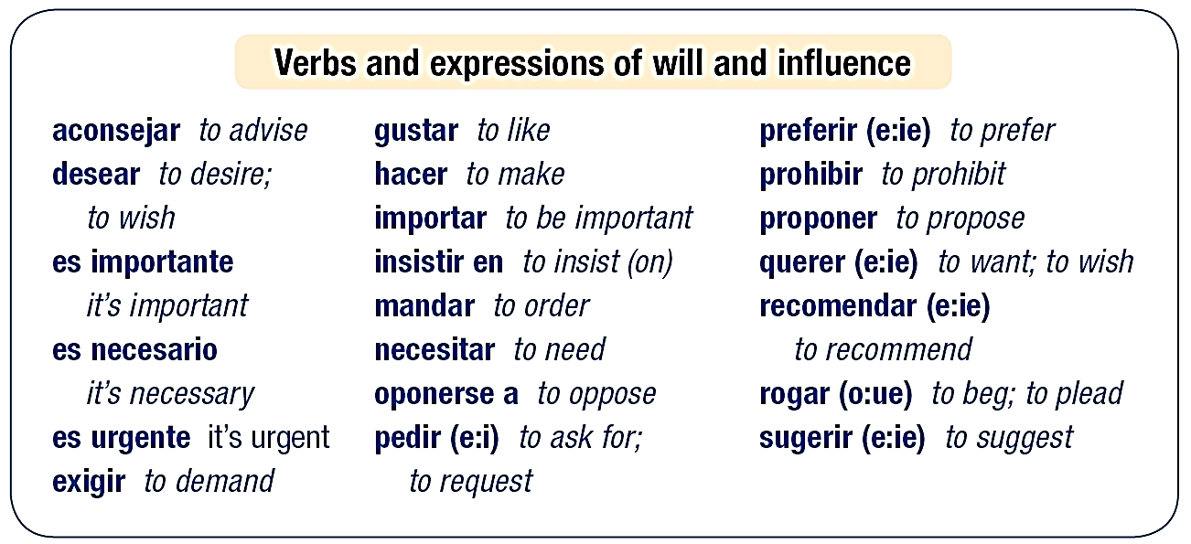

- Pedir is used with the subjunctive to ask someone to do something.
- Preguntar is used to ask questions, and is not followed by the subjunctive

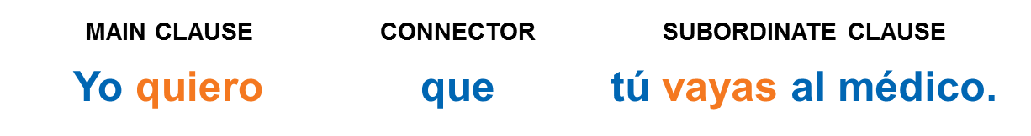
- The infinitive, not the subjunctive, is used with verbs and expressions of will and influence if there is no change of subject in the sentence. The que is unnecessary in this case.
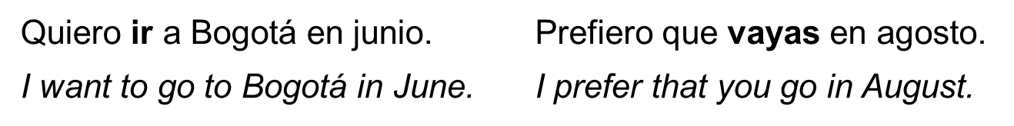
Práctica:
- Es importante que ______________________________________________________
- Mis padres insisten en que _______________________________________________________
- Es necesario ___________________________________________________
- Mi amiga me recomienda que _____________________________________________
- The subjunctive with emotion:
When the main clause expresses an emotion like hope, fear, joy, pity, or surprise, the verb in the subordinate clause must be in the subjunctive if its subject is different from that of the main clause.
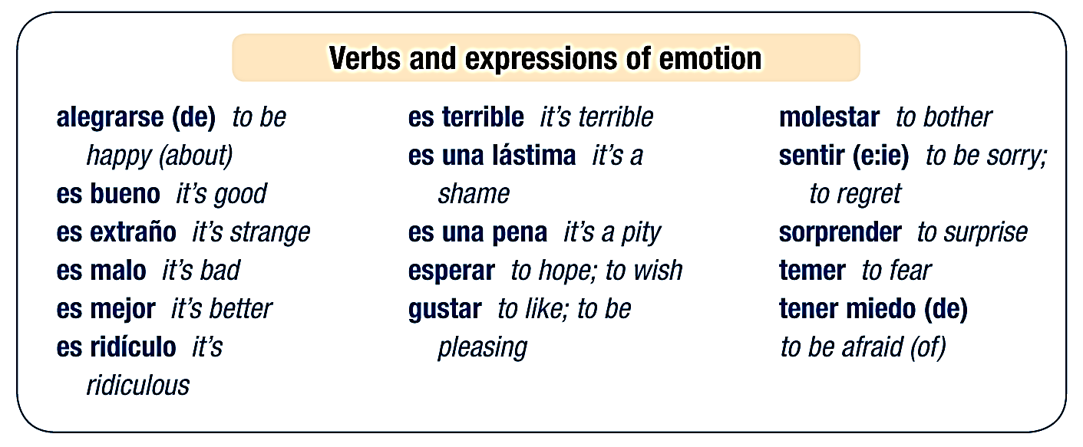
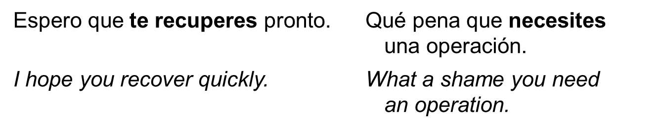
Práctica:
- Me alegro de que ___________________________________________________
- Ustedes esperan que ___________________________________________
- Esperamos __________________________________________
The expression ojalá (I hope; I wish) is always followed by the subjunctive. The use of que with ojalá is optional.
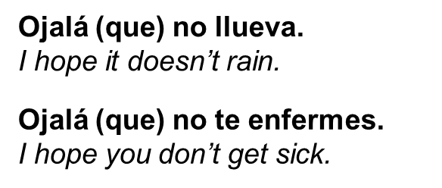

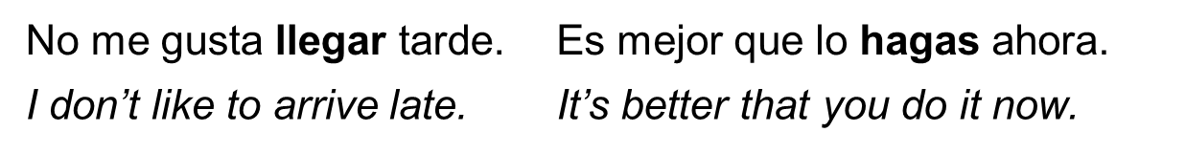
- The infinitive, not the subjunctive, is used with verbs and expressions of emotion if there is no change of subject in the sentence.

- The subjunctive with doubt and denial
When the main clause implies doubt, uncertainty, or denial, the verb in the subordinate clause must be in the subjunctive if its subject is different from that of the main clause.
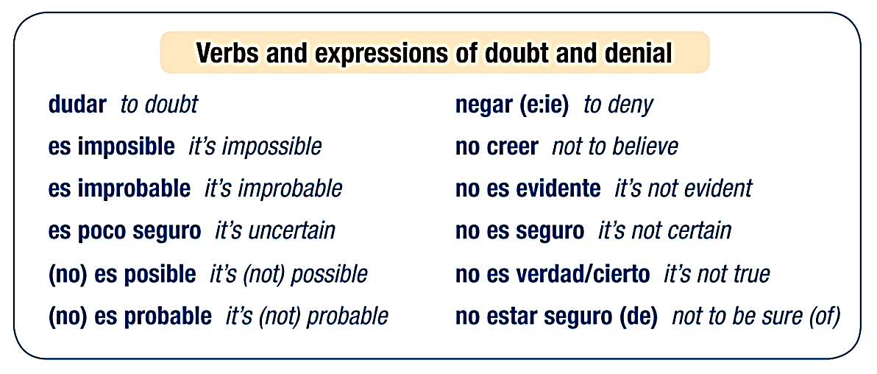

The infinitive, not the subjunctive, is used with verbs and expressions of doubt or denial if there is no change in the subject of the sentence. The subjunctive is also used after quizá(s) and tal vez (maybe; perhaps) when they signal uncertainty, even if there is no change of subject in the sentence.
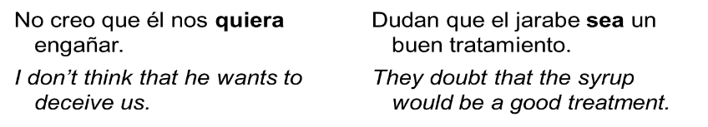
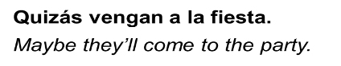

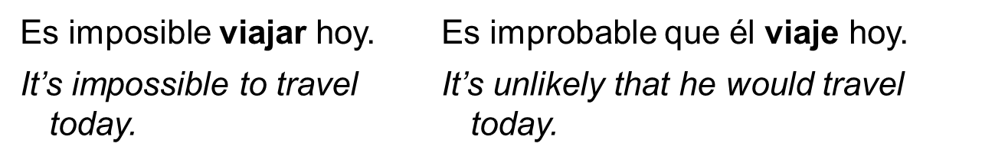

Práctica:
- No es seguro que la clase _______________________________________________
- Tal vez ustedes _________________________________________________

- The subjunctive with the unknown/uncertain/nonexistent
When an adjective clause describes an antecedent that is known to exist, use the indicative. When the antecedent is uncertain or unknown, use the subjunctive.
- To rephrase: If the speaker is talking about an item/person that they KNOW is definitely in existence, don’t use subjunctive. If they’re looking for or asking about something and aren’t sure about its existence, the dependent clause is subjunctive.
(I’m looking for a job (A job, not THE job) that pays well (uncertain if it will be found)
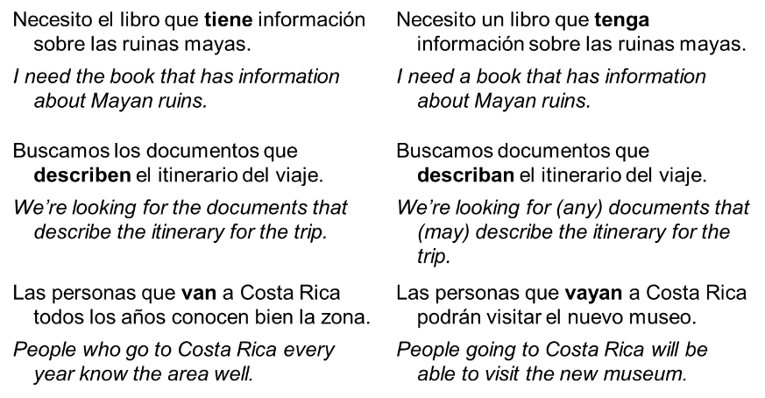
ANTECENDENT CERTAIN INDICATIVE ANTECENDENT UNCERTAIN SUBJUNCTIVE

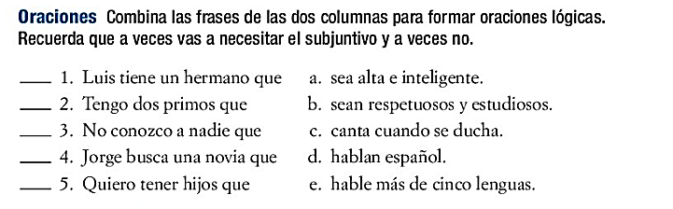

- When the antecedent of an adjective clause is a negative pronoun (nadie, ninguno/a), the subjunctive is used in the subordinate clause.
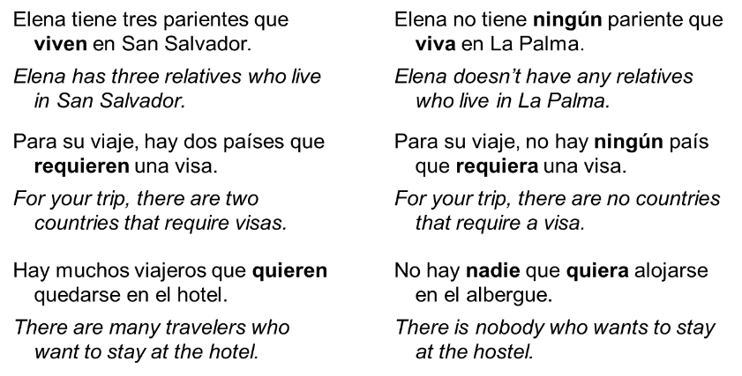
Exists (certain = indicative) Doesn’t exist (uncertain = subjunctive)

Do not use the personal a with direct objects that represent hypothetical persons.
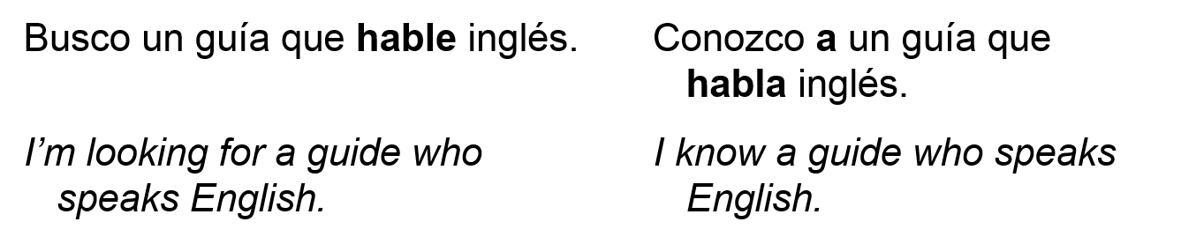

unknown /uncertain (subjunctive) Exists (certain) = indicative
Decide which best completes the statement, based on whether the subject is unknown or certain to exist.
1. Luis tiene un hermano que … A. hable más de cinco lenguas. B. canta cuando se ducha.
2. Tengo dos primos que …A.hablan español. B. sean respetuosos y estudiosos.
3. No conozco a nadie que …A. sea muy económico. B. hable más de cinco lenguas.
4. Jorge busca una novia que…A. sea alta e inteligente. B. sean respetuosos y estudiosos.
5. Quiero tener hijos que…A. hablan español. B.sean respetuosos y estudiosos.

Práctica:
- No tengo ningún amigo que ___________________________________
- No veo a ninguna chica que ____________________________________
- No hay maestro que ______________________________
- ¿Conoces a una persona que ___________________________________?
- The subjunctive is commonly used in questions with adjective clauses when the speaker is trying to find out information about which he or she is uncertain. If the person who responds knows the information, the indicative is used.
Doesn’t exist (uncertain = subjunctive) Exists (certain = indicative)
