Me llamo ______________________________________ Español 2 Mini-Unit ¡El Subjuntivo!
Guión/Table of contents:
Pg. 1: in context
Pg. 2: English vs. Spanish
Pg. 3-6 explanation
Pg. 7-10 conjugations
Pg. 11-12 = practice
Pg. 13: KEYS + NON-KEYS

- Read the following email, paying close attention to the bolded word forms and the underlined/italicized phrases.
Querid@ amig@,
1.Estoy feliz de que tú vayas a México para estudiar. ¡Quiero que tú tomes muchas fotos! 2.También, es importante que tú y tus amigos viajen mucho y que conozcan muchas ciudades nuevas y a personas interesantes. 3.Espero que tu familia nueva sea muy simpática y que tú y tus amigos participen en todas sus actividades. ¡Necesito que me traigas muchos regalos! Recomiendo que pruebes toda la comida, porque 4. es bueno explorar las comidas nuevas cuando viajas. 5.Deseo que tú regreses con una habilidad de hablar muy bien el español. 6.Mientras que estés allí, es necesario que estudies un poco también. 7.¡Mis amigos y yo te recomendamos que busques un novio o novia hispanohablante porque es más fácil aprender el español así! Bueno, me tengo que ir. ¡Mi madre insiste en que mi hermano y yo durmamos ahora!
B. Con un(a) amig@: discuss the following questions. Write down your predictions.
1. What do you notice about the form of the bolded words?
________________________________________________________________________________________________________
2. Did you notice any trends or outliers? If so, which?
________________________________________________________________________________________________________
3. What is the function of the underlined/italicized phrases?
________________________________________________________________________________________________________

In Spanish, the subjunctive mood allows us to express our wants and desires for the people and world around us. It also gives us an opportunity to express our doubts and emotions about the world and people around us.
In English, there is no difference between the way we conjugate a verb to show that something does happen versus that we want it to happen. Look:
versus
I want you to make me a sandwich.

I want to make a sandwich.
You make me a sandwich.

However, Spanish speakers will conjugate the verb differently when something happens versus it being a want or desire. (This makes the Spanish teachers wonder about what this says about Spanish speakers’ view of their own influence on the world vs. English speakers’ view of their influence.) Look:
versus
Yo quiero que tú me hagas un sándwich.
Yo quiero hacer un sándwich.
Tú me haces un sándwich.

Go back to the letter on the first page of this packet. Can you create a recipe for the type of sentence you see in the shaded box above?
__________________________________________________________________________________________________________________________
A shared learning goal from now til the end of the school year to for you to be able to express your wants, desires, and emotions for, your doubts about, and generalized comments about the other people and the world around you. To accomplish this, pick a theme of importance in your life. Here are some themes you may like: relationships (parents, friends, significant others, etc.), the environment, school, sports, jobs, college.
My theme is: ______________________________________________________________________________
Make a list of Spanish words you already know that relate to that theme:
________________________________________________________________________________________________________________________________________________________________________________________________________________________________________________________________________
Now think about how what we’ve practiced in class with subjunctive keys/triggers might help you to talk about that theme. What subjunctive KEYS would you like to use to express your thoughts about that theme? List some here. __________________________________________________________________________________________________________________________________________________________________________________________________________________________________________________
Can you express your wants and desires for, or doubts and emotions about that theme?
_____________________________________________________________________________________________________________________________________________________________________________________________________________________________________________________________________________________________________________________________________________________________________________________________________________________________________________________________________________________________________________________________________

More about the subjunctive structure…..
In English and Spanish, you will often see 2 parts of a sentence, and these two parts will form two separate clauses. You are going to have the main clause with subject #1 (which we will call the “key/llave” or “trigger” for the subjunctive) and the subordinate/dependent clause with subject # 2 (different!) (which depends on the main clause).
Here are some examples of the subjunctive being used in English. In English, we don’t usually use the subjunctive for situations like this. Instead, we add “for” and an infinitive, like this:
- It’s good for you guys to spend time together.
- He wants them to study more.
- It’s possible for my mom to be home by 5.
- I doubt that you go to Hawaii every 6 months.

In Spanish, all of these sentences would have to be reworded with a “that” (que) and then a new subject and the verb in the subjunctive.
Re-write those sentences with a “that” in English:
- It’s good for you guys to spend time together. _____________________________________________________
- He wants them to study more. _____________________________________________________
- It’s possible for my mom to be home by 5. _____________________________________________________
For the below sentences, if there are 2 subjects, circle both. Then underline the “key” if there is one.
It’s important to study. It’s important for the students to understand. I need him to take a train.
We need to take a bus. It’s uncertain that they will arrive early.

Recipe/ la receta: When there is a KEY, and a QUE, and a NEW subject, use the subjunctive!
Key + que + new subject = subjunctive.
Key + no que / no new subject = infinitive (don’t conjugate)
NON-key + que + new subject = indicative (no flipped ending)

So now, on to USING the subjunctive with impersonal expressions:
Impersonal expression (this is the “key/trigger”) +que + new subject + present subjunctive of the verb
It’s important to study= One subject = it.
Es importante estudiar (one subject? Just use the infinitive – to study = estudiar.
It’s important that you study. (2 subjects. Also, are you definitely studying? No. This person speaking feels that it’s important, but you can’t say “estudias” because that means you definitely study. The subjunctive is going to open up the idea that there is no guarantee here).
In Spanish: Es importante que tú estudies. (2 subjects)
It’s important that you study (for you to study)
Sometimes in English we don’t say things exactly grammatically correct, so sometimes instead of “that” we use “for (subject) to.”
It’s necessary for you guys to get good grades on this quiz = what you are really saying is…
“it is necessary that you guys get good grades on this quiz.”
Es necesario que ustedes saquen buenas notas en esta prueba.

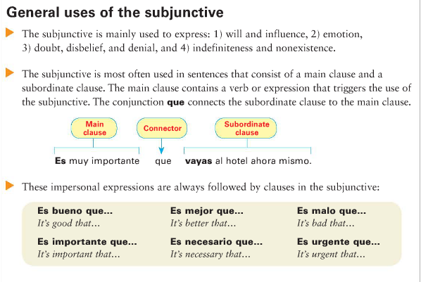

You need the subjunctive with impersonal expressions when you have two different subjects:
- It’s = one subject.
- Then you have the expression like “important” or “interesting”
- and then you have QUE,
- then a new subject like a different person or thing,
- then the subjunctive form of the new verb:

Subject /expression + QUE + new subject + subjunctive
It’s bad that that Jacinta is not in school today =
Es malo QUE Jacinta no esté en la escuela hoy.
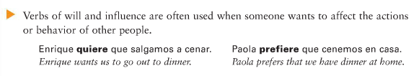

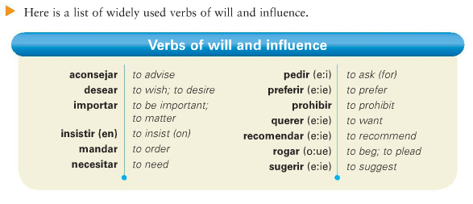
When the main clause contains an expression of will or influence (trying to get someone to do something/expressing that you want something to happen) then as long as you have 2 different subjects, the subjunctive is required.

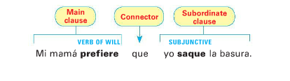

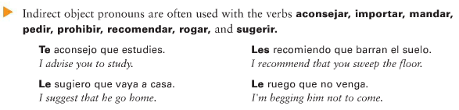
How many subjects do you see in the above examples?
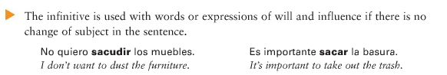

How many subjects do you see in the above examples?
Doubt, denial, desire, demands, impersonal expressions = all subjunctive!
Truth and certainty= not subjunctive!
21.They prefer that____
- I desire to____
- We desire for them to____
- It’s definitely true that ____
- It’s necessary that ____
- It’s sad that _____
- It’s terrible that ______
- I need to ____
- It’s important to spend time with friends ___
- It’s good for her to spend time with friends ____
- It’s sad to lose __________
- It’s sad that they lose__________

Decide whether the following phrase is a key the subjunctive or the indicative.

- It’s better that____
- It’s urgent that____
- It’s necessary that____
- It’s important to____
- It’s true that____
- It’s good that____
- I want for____
- He demands that ____
- It’s good that ____
- I know that ____
- We insist that____
- He needs that____
- We recommend that ____
- They request that ___
- It’s important that ____
- It’s important for _____
- It’s necessary to ____
- I need for____
- She begs that____
- We prefer to____

~~~~~~~~~~~~~Constructions with the present subjunctive~~~~~~~~~~~~~~~~
The construction of the present tense subjunctive sentence with impersonal expressions will look like:
Impersonal expression (this is the “KEY”) +que + new subject + present subjunctive of the verb
(it’s interesting, it’s good, it’s bad)
OR
Verb of influence (this is the “KEY”) +que + new subject + present subjunctive of the verb
(He wants, they need, we demand, etc)
To use subjunctive with impersonal expressions or verbs of influence, you need to have a different subject than what you started with!
~~~~~~~~~~~~~~~~~How to form the present subjunctive~~~~~~~~~~~~~
The present subjunctive:
Take present yo, drop o, add opposite ending! Sound familiar?
Regular verbs:
Viajar Venir Correr
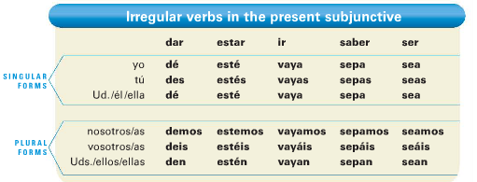
Irregular verbs in the present subjunctive:
D I S H E S !
DAR = _____________________________
IR _____________________________
SER _____________________________
HABER _____________________________
ESTAR _____________________________
SABER _____________________________
To Recap:
-cer and -cir will often become zca =
Conozca, traduzcas, produzcamos, conduzcan

CAR GAR ZAR will apply in all forms!
-CAR QUE(S,N,MOS)
-GAR GUE (S,N,MOS)
-ZAR CE (S,N,MOS)

Stem-changing:
Stem change like normal for yo, tú, él, and ellos:

What about nosotros?
Form | Type of verb | Stem-changed?
….que empecemos la prueba
……que sirvamos la pizza.
……que Juguemos con los niños.
……que durmamos ahora.
……que no perdamos el partido!

Therefore, what is my rule for stem-changing in nosotros for the subjunctive?
_______________________________________________________________________________________________________

In the present subjunctive, stem-changing verbs that end with -AR or -ER will stem change in every form but nosotros (and vosotros)
Jugar = Juegue, jueguen, juguemos
Entender = Entienda, entendamos
Empezar = __________________________________
Contar =__________________________________
Mostrar__________________________________
Perder=__________________________________
-IR verbs stem change in every form of the subjunctive. The nosotros form gets one vowel change (I or U)
Pedir = Pida, pidamos.
Servir =Sirva, nosotros? __________________________
Dormir = Duerma, nosotros? __________________________

Recipe:
KEY:
Es importante, Es bueno, Es necesario, Es posible,…etc…
Quiere (Someone wants)…
Necesita (Someone needs)…
Insiste en (Someone demands/insists)…
Desea (Someone wishes)…
Etc…

TRIGGER/KEY
QUE

New subject

Present subjunctive verb

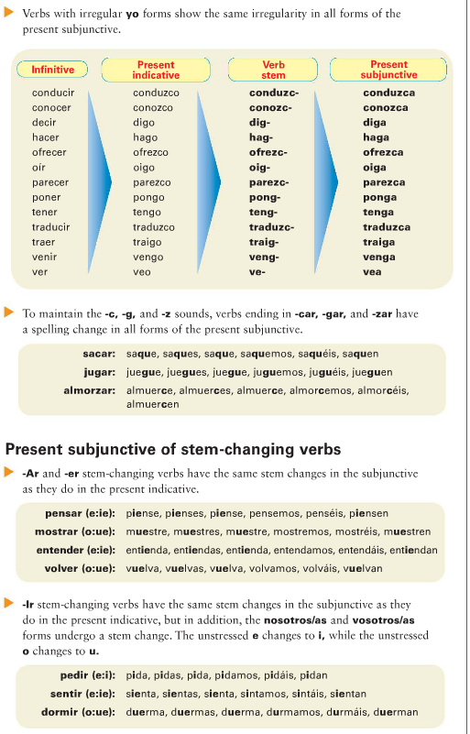
A Recap of the FORMATION:

- Escribe las formas correctas del subjuntivo de los verbos indicados.
- Alquilar, beber, vivir. Que yo alquile, beba, viva.
- Estudiar, aprender, asistir. que tú ________________________________________________
- Encontrar, poder, dormir. que ellos________________________________________________
- Hacer, tener, venir. que nosotros________________________________________________
- Dar, hablar, escribir. Que nosotros ________________________________________________
- Pagar, empezar, buscar. que nosotros________________________________________________
- Entender, dormir, saber. que ustedes________________________________________________
- Ser, ir, saber. que tú________________________________________________
- Estar, dar, oír. que yo ________________________________________________
- Escribe la forma correcta del verbo.
- Es interesante que ustedes ____________(ir) a España.
- Necesito que ustedes ______________(poner) la mesa.
- Las chicas quieren que yo no les __________________(dar) tarea.
- Mi familia quiere que nosotros les _________________(visitar).
- El maestro te pide que le ________________(ayudar) tú con el proyecto.
- Mis padres desean que yo les ______________ (decir) la verdad.
- Tus amigos recomiendan que tú _____________(sacar) la basura.
- Es importante que los estudiantes _______________(entender) la información.
- Yo prefiero que __________________(empezar) la fiesta más tarde.
- Escoge el verbo correcto y escríbelo en el espacio.
abramos hagan den hagamos comas llegue aprendan conozcamos tomemos

- Yo sugiero que ustedes __________ la tarea.
- Recomendamos que tú ___________ en la cafetería.
- Es bueno que _____________ las niñas muchas lenguas extranjeras.
- El doctor prefiere que yo ______________ temprano a la cita.
- La enfermera recomienda que nosotros ______________ la medicina.
- Ella insiste en que nosotros __________________ la puerta.
- Crea oraciones nuevas con el subjuntivo. Remember, you will need 2 different subjects for each.
- Recomendar / terminar = Ustedes recomiendan que nosotros terminemos el proyecto.
- Necesitar / lavar _____________________________________________________
- Pedir / limpiar_____________________________________________________
- Es malo / planchar _____________________________________________________
- Es urgente / arreglar _____________________________________________________
- Querer / jugar_____________________________________________________

- Crea DOS oraciones: A = NO subjuntivo, B = subjuntivo. Use a KEY for each.
- It’s rare…strange / comer

A. ____Es extraño comer las papas en un sándwich.
B. ___Es extraño que las chicas coman las papas todos los días._______________

- It’s necessary / dormir
A. _____________________________________________________________________________________________
B. _____________________________________________________________________________________________

- It’s a shame(a pity) / perder
A. _____________________________________________________________________________________________
B. _____________________________________________________________________________________________

- It’s possible / bailar
A. _____________________________________________________________________________________________
B. _____________________________________________________________________________________________

- querer / oír
A. _____________________________________________________________________________________________
B. _____________________________________________________________________________________________

- Recomendar / estar
A. _____________________________________________________________________________________________
B. _____________________________________________________________________________________________

- Sugerir / llegar
A. _____________________________________________________________________________________________
B. _____________________________________________________________________________________________

- Dudar /jugar
A. _____________________________________________________________________________________________
B. _____________________________________________________________________________________________

- Alegrarse de / ver
A. _____________________________________________________________________________________________
B. _____________________________________________________________________________________________

- no pensar / empezar
A. _____________________________________________________________________________________________
B. _____________________________________________________________________________________________
- Be careful here! What will happen for line B? pensar / tener
A. _____________________________________________________________________________________________
B. _____________________________________________________________________________________________
The subjunctive is formed using this sentence structure:
KEY /TRIGGER VERB + QUE + VERB IN THE SUBJUNCTIVE
(CONJUGATED FOR SUBJECT A) (CONJUGATED FOR SUBJECT B)
KEYS:

WILL AND INFLUENCE
- aconsejar que: to advise that
- desear que: to desire/wish that
- exigir que(exijo): to demand that
- insistir en que: to insist that
- mandar que: to order that
- necesitar que: to need that
- pedir (e:i) que: to request (ask) that
- preferir (e:ie) que: to prefer that
- prohibir que: to prohibit that
- querer (e:ie) que: to want that
- recomendar (e:ie) que: to recommend that
- rogar (o:ue) que: to beg/plead that
- sugerir (e:ie) que: to suggest that
- (me, te, le etc) importa que: to matter (to someone) that

DOUBT AND DENIAL
- dudar que: to doubt that
- hay duda que: there is doubt that
- negar (e:ie)que: to deny that
- no creer que: to not believe that
- no estar seguro/a de que: to not be sure that
- Es dudoso que: it’s doubtful that
- No pensar (e-ie) que: to not think that

IMPERSONAL EXPRESSIONS:
- es importante que: it is important that
- es necesario que: it is necessary that
- es urgente que: it is urgent that
- es bueno que: it is good that
- es extraño que: it is strange that
- es malo que: it is bad that
- es mejor que: it is better that
- es ridículo que: it is ridiculous that
- es terrible que: it is terrible that
- es una lástima que: it is a shame that
- es una pena que: it is a pity that
- es imposible que: it is impossible that
- es improbable que: it is improbable that
- es posible que: it is possible that

EMOTIONS
- alegrarse de que: to be happy that
- esperar que: to hope/wish/ expect that
- (me, te, le etc) gusta que: it pleases someone that
- (me, te, le etc) molesta que: it bothers someone that
- sentir (e:ie) que: to be sorry (regret) that
- (me, te, le etc) sorprende que: it surprises someone that
- temer que: to fear that
- tener miedo de que: to be afraid that
- Ojalá (que) : Hopefully/God-willing

NON-KEYS:

- NO QUE DUE TO LACK OF 2ND SUBJECT Use the infinitive (not conjugated form).

- VERBS AND EXPRESSIONS OF CERTAINTY Use the indicative (not subjunctive).

- no dudar que: to not doubt that
- no negar (e:ie)que: to not deny that
- creer que: to believe that
- estar seguro/a de que: to be sure that
- es cierto que: it is true/certain that
- es obvio que: it is obvious that
OJALÁ (may God will it that; hopefully) will always use the subjunctive but the que is optional
TAL VEZ y QUIZÁ(S) both mean maybe and will use the subjunctive when the speaker is doubtful about the situation

- seguro que: it is sure that
- es verdad que: it is true that
- pensar que: to think that
- no hay duda que: there is no doubt that
- No cabe duda que: there’s no room for doubt that
- Pensar que : to think that

