Español 3: Proyecto: Visitemos Una Ciudad Hispanohablante
- WHO: This is a project you will do individually or with one other person (see me to discuss groups of 3)
- WHAT: Research and present on one Spanish-speaking city in one of the Spanish-speaking countries of the world. You can research in any language you choose, however the final product will be in Spanish.

- PRODUCT: 4 options! Note: All projects need to include a bibliography /works cited. You should use a MINIMUM OF 3 different sources. Using Wikipedia is okay, but please include 3 other sources.

- A skit /scenario with dialogue, recommendations, conflicts, and resolutions centered on visiting the city/activities to do in the city /recommendations/suggestions. You can perform your skit in class or you can film it outside of class to show during class. You will also submit a written script.
- A travel brochure to recommend/encourage/persuade people to travel to this city. You will share this with the class and supplement your brochure with a written task.
- A travel poster to recommend/encourage/persuade people to travel to this city. You will share this with the class and supplement your poster with a written task or script.
- A tourism website to recommend/encourage/persuade people to travel to this city, which you will share with the class. Your website will include all components of the written task.

- WHY: So often, we only learn about a few Spanish-speaking countries and their capitals. This is your chance to explore and then teach us about one of the many Spanish-speaking cities within the Spanish-speaking world, make recommendations and encourage us to visit and do specific activities that are unique to that area, and spark some interest in traveling there in the future!
- WHEN: We will use some class time over the next few weeks. Official due date and points TBD. This is the final assessment for the chapter, so it will be similar in value to a chapter exam.
- Use your online resources to find a list of cities in the Spanish-speaking countries below.
- Narrow your list down to a few cities. Then, pick from that list to determine which city you will research.
- There are MANY cities to choose from, so we will avoid repeating cities within your class.
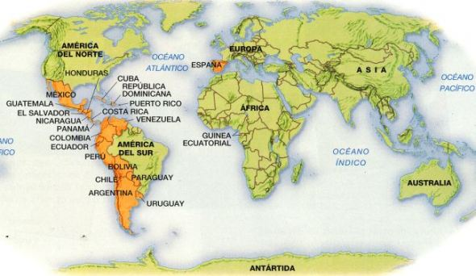
Topics to include/organizer to help you:
The name of the city and what country it is in

People with what types of interests might find this an attractive place?
Size of city and a comparison to a US city so we can relate

Climate, Seasons, Weather, and how these impact tourism

Founding /settling information if possible, especially if this relates to the Spanish language/cultures

Any indigenous history if possible / any interesting religious info

Attractions/things to do and see in this city, specific to tourism/travel

Types of food they eat there: must-haves, must-tries?

Sports, Arts, and Entertainment, as related to travel/tourism
Animals and vegetation of significance there / how this impacts tourism

Currency used and what that means for tourists

Government / current events of significance and how this impacts tourism
Is there a large presence of other cultures coexisting in this city? If so, which?
Any customs or facts that would be surprising/strange/interesting/fun for tourists/travel?

Anything else that is a major draw for tourism / why should someone spend vacation here?

Your recommendations for lodging: many countries have different options (not just hotels!)

When researching:
Your research can be in English, but you will get excellent information from Spanish sites as well.
The goal is for your peers to understand your presentation. This means that it is necessary for you to use grammar and vocabulary that you know. When possible, use cognates. The goal is not to type your script in English, copy it into a translator, and then read it in Spanish.
Use WordReference.com (the app is WordRef) or SpanishDict to look up words, small phrases, and conjugations.
Typing in entire sentences on google translate? Not okay.
When paraphrasing or directly quoting, give credit where it is due and cite your sources. However, please limit your paraphrase and direct quote to one of each per project. Figure out how to rephrase the information in your own words, using what you know. I want to see what YOU can do with the language. It is extremely obvious when you use translators. If I have a concern about what you produced, I will not assess what you have turned in, and you will re-do the project.
Non-negotiables: Vocabulary and Grammar, and where to find the guidelines in your paquete:
- A minimum of 2 uses of the subjunctive with will and influence (pg. ____ )
- A minimum of 2 uses of the subjunctive with expressions of emotion (pg. ____)
- A minimum of 2 uses of the subjunctive with expressions of doubt, denial, or uncertainty (pg. ____)
- A minimum of 1 use of the indicative with certainty (pg. ____)
- A minimum of 1 use of a comparative or superlative (pg. ____)
- Use of the vocabulary from this chapter (25-40 new words)
Rubric:
Aspect of task: | Novice (6-6.5) | Approaching (7-8) | Meets (8.5-9.5) | Exceeds (10)
Content/accuracy of written task and product  (20) | Limited information/ recommendations for travel. | Most information in the product and written task is accurate. May have some inaccuracies or lack of connection between travel recommendations and culture. | Most information in the product and written task is accurate. Evident connection between travel recommendations and culture, several activities and sights mentioned. | All information in the product and written task is accurate and detailed. Clear connection between travel recommendations and culture, many activities and sights mentioned and discussed in detail.
Comprehensibility/  Language structures | Uses short phrases or simple sentences. May or may not have all 8 grammatical requirements. Errors make comprehension difficult | Uses short phrases or simple sentences. May or may not have all 8 grammatical requirements. Errors sometimes interfere with comprehension | Uses complete, connected sentences or short paragraphs. Writing is organized logically. Meets all 8 grammatical requirements in order to persuade. Errors do not interfere with comprehension. | Uses complete and sometimes complex sentences and/or paragraphs and is organized logically. Uses language structures, including grammatical requirements with minimal errors, in order to persuade and recommend.
Vocabulary | Uses limited vocabulary from the unit, frequent errors. | Uses limited vocabulary from the unit, may have errors. | Uses 25-40 vocabulary terms from the unit. All vocabulary use is accurate | Accurately uses a wide variety of vocabulary, including 25-40 vocabulary terms from the unit.
Presentation | Limited images and information, or images and information do not correspond to each other and/or to written task | Images and information are organized, but connection may be unclear or doesn’t correspond to written task | Images and information are organized & correspond with written task. Positively influence viewer. | Images and information are well-organized, connection is clear, corresponds well with written task, formatting is attractive and positively influences the viewer.

