Nombre: _____________________ Español 3 Repaso y Lección 1: Las relaciones personales

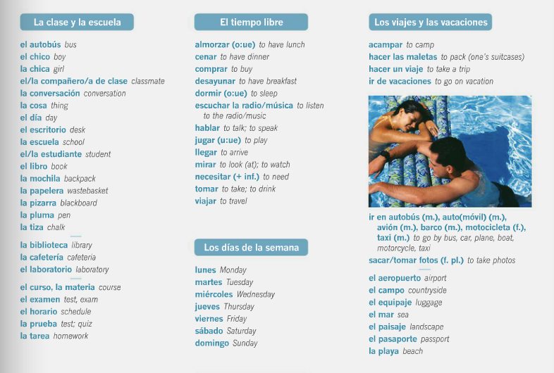

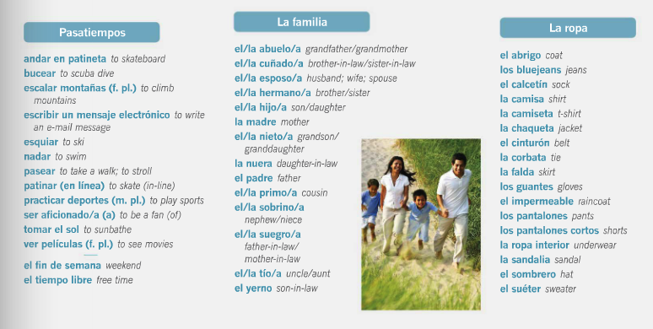

Español 3 Lección 1: Las relaciones personales

- Las Personalidades
autoritario/a | strict; authoritarian
cariñoso/a | affectionate
celoso/a | jealous
cuidadoso/a | careful
falso/a | insincere
gracioso/a | funny; pleasant
inseguro/a | insecure
(in)maduro/a | (im)mature
mentiroso/a | lying
orgulloso/a | proud
permisivo/a | permissive; easy-going
seguro/a | sure; confident
sensato/a | sensible
sensible | sensitive
tacaño/a | cheap; stingy
tímido/a | shy
tradicional | traditional

- Los estados emocionales

agobiado/a | overwhelmed
ansioso/a | anxious
deprimido/a | depressed
disgustado/a | upset
emocionado/a | excited
preocupado/a (por) | worried (about)
solo/a | alone; lonely
tranquilo/a | calm

- Los sentimientos

adorar |  | to adore
apreciar |  | to appreciate
enamorarse (de) |  | to fall in love (with)
estar harto/a (de) |  | to be fed up (with); to be sick (of)
odiar |  | to hate
sentirse (e:ie) |  | to feel
soñar (o:ue) con |  | to dream (about)
tener celos (de) |  | to be jealous (of)
tener vergüenza (de) |  | to be ashamed/embarrassed (of)
- Las relaciones personales  el/la amado/a |  | loved one; sweetheart
el ánimo |  | spirit
atraer |  | to attract
el cariño |  | affection
 | casado/a |  | married
 | la cita (a ciegas) |  | (blind) date
 | el compromiso |  | commitment; responsibility
 | la confianza |  | trust; confidence
 | coquetear |  | to flirt
 | cuidar |  | to take care of
 | dejar a alguien |  | to leave someone
 | el desánimo |  | the state of being discouraged
 | discutir |  | to argue
 | divorciado/a |  | divorced
 | el divorcio |  | divorce
 | educar |  | to raise; to bring up
 | hacerle caso a alguien |  | to pay attention to someone
 | impresionar |  | to impress
 | llevar... años de (casados) |  | to be (married) for... years
 | llevarse bien/mal/fatal |  | to get along well/ badly/terribly
 | mantenerse en contacto |  | to keep in touch
 | la pareja |  | couple; partner
 | pasarlo bien/mal/fatal |  | to have a good/bad/terrible time
 | proponer matrimonio |  | to propose (marriage)
 | romper (con) |  | to break up (with)
 | salir (con) |  | to go out (with)
 | el sentimiento |  | feeling; emotion
 | separado/a |  | separated
 | soltero/a |  | single
 | soportar a alguien |  | to put up with someone
 | viudo/a |  | widowed

La gramática:

- Cinemateca y descripciones
a lo mejor | maybe | Ser vs. Estar  Uses:  El Presente Progresivo:
alargar | to drag out
la cinta | tape
enterarse | to find out
entretenerse | to be held up
la luz | light
pesado/a | annoying
precioso/a | lovely
respirar | to breathe
turbio/a | murky

- La literatura

el alma | soul
amar | to love
besar | to kiss
contentarse con | to be contented,  satisfi ed with | Present Tense -AR, - ER, -IR verbs  Stem-changing e-ie  Stem-changing o-ue  Stem-changing e-i
el corazón | heart
la mirada | gaze
el olvido | forgetfulness; oblivion
querer (e:ie) | to love; to want

- Cultura
el cargo | position
la cima | height
convertirse (e:ie) en | to become
en contra | against
propio/a | own
rechazar | to turn down
sabio/a | wise
el sueño | dream
superar | to exceed
tomar en cuenta | to take into consideration

