el banco | bank
la carnicería | butcher shop
El centro comercial | The mall
el correo | post office
el estacionamiento | parking lot
La farmacia | pharmacy
la frutería | fruit store
hacer cola | to stand in line (Spain)
estar formado/a/os/as | To stand / be in line (Mex)
pasar por | to go by/pass by
hacer diligencias | to run errands
la heladería | ice cream shop
la joyería | jewelry store
la lavandería | laundromat
la panadería | bakery
la papelería | stationery store
la pastelería | pastry shop
La peluquería | hairdresser
el salón de belleza | beauty salon
la pescadería | fish market
el supermercado | supermarket
La tortillería | tortilla stand
La taquería | taco stand
la zapatería | shoe store
Me llamo _________________________________________ Español 2 Lección 5: En La Ciudad
- En la ciudad (in the city)
- En el banco
el cajero | ATM machine
el cheque (de viajero) | (traveler’s) check
cobrar | to cash (a check)
la cuenta corriente | checking account
la cuenta de ahorros | savings account
depositar | to deposit
firmar | to sign
invertir | To invest
llenar (un formulario) | to fill out (a form)
pagar a plazos | to pay in installments
pagar al contado/en efectivo | to pay in cash
pedir prestado/a | to borrow
pedir un préstamo | to apply for a loan
ser gratis | to be free of charge
mercado de valores /  mercado bursátil | Stock market

C.En el correo (at the post office)
el cartero | mail carrier
el correo | post office / the mail
echar (una carta) al buzón | to put (a letter) in the mailbox;  to mail
enviar | to send; to mail
mandar | to send; to mail; to demand
la estampilla, el sello | stamp
el paquete | package
el sobre | envelope

D.Las direcciones | /Cómo llegar
cruzar | to cross
la cuadra | (city) block
derecho | straight (ahead)
la dirección | address
doblar | to turn
enfrente de | opposite; facing
la esquina | corner
estar perdido/a | to be lost
(al) este | (to the) east
hacia | toward
indicar cómo llegar | to give directions
el letrero | sign
(al) norte | (to the) north
(al) oeste | (to the) west
quedar | to be located
(al) sur | (to the) south

After studying this chapter, I will be able to:
- Say where I go to do certain errands in a town/city
- Tell someone how to get to places in a town/city and understand someone’s directions
- Discuss activities relating to the bank and post office
- Express needing/wanting things that have uncertain existence
- Describe conditions of things using verbs in their adjective forms
- Make suggestions using nosotros commands

E.Expresiones afirmativas y negativas F..Past participles: irregulars
Affirmatives | Negatives
sí (yes) | no (no)
alguien (somebody) | nadie (nobody)
algo (something) | nada (nothing)
también (also) | tampoco (neither)
o … o (either … or) | ni … ni (neither … nor)
siempre (always) | nunca, jamás (never)
alguno (algún, alguna, | ninguno (ningún, ninguna,
algunos, algunas) (some) | ningunos, ningunas) (none, not any)
abrir |  |  | morir
decir | dicho |  | poner | puesto
cubrir | cubierto |  | componer
escribir | escrito |  | resolver | resuelto
describir |  |  | romper | roto
hacer |  |  | ver | visto
freír |  |  | volver | vuelto
 |  |  | descubrir | descubierto

~~~~~~~~~~~~~~~~~~~~~~~~~~~Gramática~~~~~~~~~~~~~~~~~~~~~~~~~~~~
The subjunctive for the unknown or nonexistent (adjective clauses).
- Compare these 3 sentences.
  - I’m looking for a phone that has a great camera. = Busco un celular que tenga una cámara espectacular.
  - I’m using a phone that has a great camera = Uso un celular que tiene una cámara espectacular.
  - I need the phone that has a great camera. Yo necesito el celular que tiene una cámara espectacular.

Con un(a) amig@:
Compare sentence A to sentence B.
Consider the words ‘the/a’ (definite/indefinite articles el/ la /un)
Consider the form of “has/tener” (tiene vs tenga)
Compare sentence A to sentence C.
Consider the words ‘the/a’ (definite/indefinite articles)
Consider the form of “has/ tener” (tiene vs tenga)

- Can you explain the role of “the/el/la” vs “a /un/una” in these sentences?

_______________________________________________________________________________________________________________________
- Can you explain the use of why tiene is appropriate for one, but tenga is appropriate for another?
_______________________________________________________________________________________________________________________

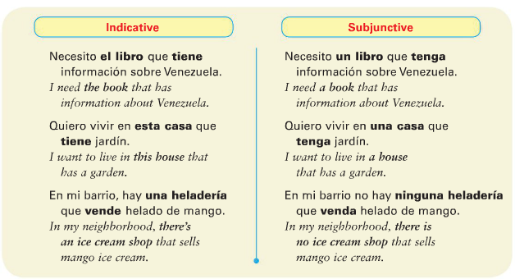
The subjunctive is used in an adjective clause that refers to a person, place, thing or idea that either does not exist or whose existence is uncertain or indefinite.

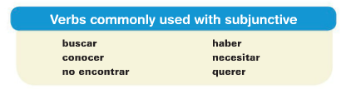

Verbs like buscar, querer, ​or ​necesitar ​plus ​que ​are used with the ​​subjunctive when they introduce something that is not known for certain. ​​ For example, you might say, I’m looking for a car that is fast.
The looking for part is indicative. The is fast has to be subjunctive because it’s not certain whether this specific car exists. = Busco un coche que sea rápido.
Use the indicative for the first verb and the subjunctive ​for ​​​the second verb. ​
I want a computer that doesn’t cost a lot. Quiero una computadora que no ___________ (costar) mucho.
You also need to use the subjunctive ​with expressions that ask about something ​​that may not exist. ​
- Is there a _____ that __? = ¿Hay ___ que___? ​ Is there pizza that doesn’t have cheese? ¿Hay pizza que no tenga queso?
- Do you know a _____ that ___? = ¿Conoces a___ que___? ​ Do you know a teacher who speaks Chinese? ¿Conoces un maestro que ____________________ chino?
- Do you have a ____ that ____? = ¿Tienes___ que___? ​Do you have a pen that writes with red ink? ¿Tienes una pluma que _______________ con tinta roja?
~~~If you are stating a fact, like I know someone who does this, or I have something that does this, it’s indicative, not subjunctive.~

Let’s change these existent statements to non-existent/uncertain/subjunctive statements. The first one is done for you.

- There is a Web site that ​has ​the information. Hay un sitio web que ​tiene ​la información. ​​
Change the above statement to a subjunctive situation.
_Busco un sitio web que tenga la información. I am looking for a website that has the information.__________
- I know a family that has 2 pools. Conozco a una familia que tiene dos albercas.
Change the above statement to a subjunctive situation. _______________________________________________________________________________________________________
3.You know some students who speak Portuguese. Conoces a unos estudiantes que hablan portugués.
Change the above statement to a subjunctive situation. _______________________________________________________________________________________________________
- A note about the A personal. When you’re talking about a hypothetical person, don’t use an “A” before the person. But if they definitely exist, use the “A.” When using “alguien” (anyone) and “nadie” (no one) as a direct object (NOT A SUBJECT) then use the A.
- Busco una persona que pueda escribir en japonés = I’m looking for a person who can write in Japanese. Existence is uncertain.
VS.
- Busco a la persona que puede escribir en japonés. I’m looking for THE person who can write in Japanese. They do exist.
- No conozco a nadie que sepa jugar al hockey = I don’t know anyone who knows how to play hockey.
Try these! Primero, decide si la oración es subjuntivo o indicativo. Después, escribe en español.
- We are looking for a student who understands math. S or I? en español: ____________________________________________________________________________________________
- We are looking for the student who understands science. S or I?
en español: ____________________________________________________________________________________________
- Is there a hotel that has a pool? S or I?
en español: ____________________________________________________________________________________________
- Do you know a teacher who lives in Newcastle? S or I? en español: ____________________________________________________________________________________________

- Are you looking for the hotel that has a pool? S or I? en español: ____________________________________________________________________________________________

- I don’t know anyone who gets 100 (sacar cien) in chemistry. S or I? en español: ____________________________________________________________________________________________
- We need to talk to the student who gets 100 in chemistry. S or I? en español: ___________________________________________________________________________________________

Try these! Decide whether they are S or I. then, fill in the correct verb form.
- Necesito una persona que (puede/pueda) cantar bien. (need a person = uncertain = subjunctive)
- Buscamos a alguien que (tiene/tenga) paciencia.
- ¿Hay restaurantes aquí que (sirven/sirvan) comida japonesa?
- Tengo una amiga que (saca/saque) fotografías muy bonitas.
- Hay una carnicería que (está/esté) cerca de aquí.
- No vemos ningún apartamento que nos (interesa/interese).
- Conozco a un estudiante que (come/coma) hamburguesas todos los días.
- ¿Hay alguien que (dice/diga) la verdad?
- Buscamos un hotel que _________________ (tener) piscina.
- ¿Sabe usted dónde _________________ (quedar) el Correo Central?
- ¿Hay algún buzón por aquí donde yo _________________ (poder) echar una carta?
- Ana quiere ir a la carnicería que _________________ (estar) en la avenida Lecuna.
- Encontramos un restaurante que _________________ (servir) comida típica venezolana.
- ¿Conoces a alguien que _________________ (saber) mandar un fax por computadora?
- Necesitas al empleado que _________________ (entender) este nuevo programa de computación.
- No hay nada en este mundo que _________________ (ser) gratis.

B.Combina las ideas para hacer una oración creativa.
Ex: Mi hermana necesita un vestido que sea verde y blanco para la fiesta.
1. Mi abuelo necesita ___
- Un collar que no cueste mucho
- Una bicicleta que sea nueva
- Una esposa que venga de Colombia
- Vecinos que limpien su patio
- Un doctor que entienda sus problemas
- Un gato que no tenga dientes grandes
- Un suéter que combine con sus pantalones
2. Mi papá quiere___
3. Mi hermana busca___
4. Mi hermano no tiene ___
5. Yo espero encontrar___
6. Mi mejor amigo(a) espera recibir ___
C. Termina la oración con sus propias ideas
7. Necesito un coche que ___________________________________.
8. En la playa, quiero encontrar a unos amigos que _____________________________________________.
9. En la universidad, busco ____________________________que _____________________________.
10. Los recién casados buscan una casa que _______________________________________________.
11. La niña de cinco años quiere ________________________ que_____________________________.
Refresher?? You may not remember /have learned ningún and algún and those positive/negative phrases. I have added them for you here:
Affirmatives | Negatives
sí (yes) | no (no)
alguien (somebody) | nadie (nobody)
algo (something) | nada (nothing)
también (also) | tampoco (neither)
o … o (either … or) | ni … ni (neither … nor)
siempre (always) | nunca, jamás (never)
alguno (algún, alguna, | ninguno (ningún, ninguna,
algunos, algunas) (some) | ningunos, ningunas) (none, not any)

Affirmative and Negative Expressions
Remember that Spanish uses a double negative: When a negative word follows the VERB, use “no” before the verb.
- No estoy haciendo nada ahora = I’m not doing anything now. (I’m not doing nothing)
- No conozco a nadie aquí = I don’t know anyone here! ( I don’t know no one)
- No tengo ningún problema. = I don’t have any problem.
Buuuuut when you use a negative word before the verb, you don’t need the “no.”
- Nunca trabajo los domingos = I never work on Sundays.
Affirmative and negative adjectives agree with the nouns that they modify (adjectives agree) =
algunas empresas, ninguna chica = Some businesses, no (not any) girl
Alguno and ninguno change to algún and ningún when followed by a masculine singular noun:
Estoy buscando algún trabajo, pero no encuentro ninguno. = I’m looking for some kind of job, but I’m not finding one.
No hay ningún libro que me guste = There is no book that I like.
Algo means something and nada means nothing. When a sentence is negative, nada must be used rather than algo—even when the English sentence would use “something.” In Spanish, you say something more like, “ You don’t do nothing.” Nada can also be used as an adverb to mean “not at all”:
No trabajas nada = You don’t work at all.
No me importa nada = I don’t care at all.
Escribe en español:
Affirmatives | Negatives
sí (yes) | no (no)
alguien (somebody) | nadie (nobody)
algo (something) | nada (nothing)
también (also) | tampoco (neither)
o … o (either … or) | ni … ni (neither … nor)
siempre (always) | nunca, jamás (never)
alguno (algún, alguna, | ninguno (ningún, ninguna,
algunos, algunas) (some) | ningunos, ningunas) (none, not any)
- There is no one __________________________
- Is there someone? __________________________
- Neither he nor she __________________________
- Me, neither (not I, either) __________________________
- There is something __________________________
- There is nothing __________________________
- He never, ever __________________________
- There aren’t any __________________________
Answer the questions by giving the new negative expression. If it helps you, see if there is a positive word that you are making negative in your answer.
- ¿Tienes una pluma? No, no tengo ninguna pluma.
- ¿Juegas deportes? = No, no juego ningún deporte. (Do you play sports? No, I don’t play ANY[not any] sport)
- ¿Conoces algunas chicas? = No, no conozco a ________________ chicas.
- ¿Estás comiendo algo? = No, no estoy comiendo _____________
- ¿Cuándo vas a la biblioteca? = No voy _______________
- Yo no terminé la tarea. ¿Y tú? = No la terminé ________________________
- ¿Vas al baile con alguien? = No, no voy con ________________________
- ¿Hiciste algo para tu cumpleaños? = No, no hice________________________
- ¿Le prestaste dinero a tu hermano? = No, no le presté ________________________
- No fui a esa fiesta. ¿Y María? = María no fue ________________________
- ¿Saliste anoche con tus hermanos? = No, no salí con ________________________
- ¿Cuándo visitas a tus primos? = No los visito________________________
- No me interesa la clase de historia. ¿Y tú? No me interesa _________________.
Past participles: making verbs into adjectives!
In English, we make verbs into adjectives in various ways.
Write = (The book is) written. Buy = (The car is) bought. Open = (The door is) open(ed).
What does “La carnicería está abierta” mean? _______________________________
What verb must “abierta” come from? ______________________________
How about, La oficina está cerrada? ______________________________ verb of cerrada? _________________
What do you notice about the word cerrada? ___________________________
-AR verbs: | -ER/IR verbs:
drop the AR,  add -ado. | drop the –ER/-IR, add -ido.
The regular verbs follow these rules:
estudiar = está _____________________ (is) studied.
vivir = está ______________________ (is) lived.
Comer = está _____________________ (is) eaten.
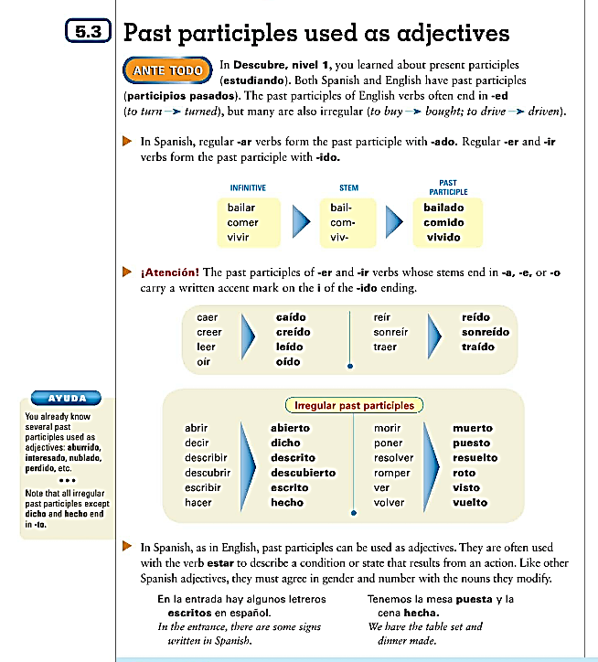

Spelling changes!

Irregulars!
Ir

Match in gender and number!

¡Practiquemos! In the second blank, write the participle/adjective form in english.
- Las calles están ____________________ (viajar) con frecuencia. ___________
- Hoy mi peluquería favorita está _________________ (cerrar). _____________
- Por eso, voy a otro salón de belleza que está _________________ (abrir) todos los días. _____________
- Queda en la Plaza Bolívar, una plaza muy _________________ (conocer). _____________
- Todos los productos y servicios de esta tienda están _______________ (describir) en un catálogo. _____________
- El nombre del salón está _________________ (escribir) en el letrero y en la acera (sidewalk). _____________
- Cuando esta diligencia esté _________________ (hacer), necesito pasar por el banco. _____________
Contesta las preguntas según el modelo.
- ¿Compraste las entradas para la fiesta? Sí, las entradas están compradas. (Yes, the tickets are bought)
- ¿Terminaste las tareas? _________________________________________________________
- ¿Confirmaste las reservaciones? _________________________________________________________
- ¿Firmaste el pasaporte? _________________________________________________________
- ¿Lavaste la ropa? _________________________________________________________
- ¿Resolviste el problema? _________________________________________________________
- ¿Pagaste las cuentas? _________________________________________________________
- ¿Hiciste las diligencias? _________________________________________________________
- ¿Hiciste las maletas? _________________________________________________________

Apuntes: ________________________________________________________________________________________________________________________________________________________________________________________________________________________________________________________________________________________________________________________________________________________________________________________________________________________________________________________________________________________________________________________________________________________________________________________________________________________________________________________________________________________________________________________________________________________________________________________________________________________________________________________________________________________________________________________________________________________________________________________________________________________________________________________________________________________________________________________________________________________________________________________________________________________________________________________________________________________________________________________________________________________________________________________________________________________________________________________________________________________________________________________________________________________________________________________________________________________________________________________________________________________________________________________________________________________________________________________________________________________________________________________________________________________________________________________________________________________________________________________________________________________________________________________________________________________________________________________________________________

Nosotros Commands
Nosotros commands express the idea of “let’s” do something. The speaker is included. To form these, you take the yo form and add the opposite “nosotros” ending. (This is the nosotros form of the present subjunctive also!). This goes for irregular “yo” forms as well.
Comer como comamos Comamos aquí. = Let’s eat here.
Compremos leche. = Let’s buy milk.
Poner pongo Pongamos la mesa. Let’s set the table.
NOTE: -AR and -ER verbs do not stem-change in the nosotros, so you do not change them in the nosotros commands. Pensar is e – ie but becomes pensemos
volver is o- ue but becomes volvamos
-IR verbs DO stem-change in the nosotros: either to –u or -i : servir = sirvamos.
pedir = _______________________
Dormir = ______________________

Ex: Contemos el dinero = Let’s count the money. (Notice that, although “contar” is a stem-changer, it does not change in the nosotros command form.)
To make a nosotros command negative, just add a “no” before it!
No comamos aquí = Let’s not eat here.
Hacer hago hagamos No hagamos la tarea = Let’s not do the homework.
Verbs that end in –car, -gar, -zar are going to stem-change:
Tocar toquemos, Pagar paguemos, Almorzar almorcemos
5 irregulars: (SIDES)
Ser | Seamos
Ir | Vamos (negative is vayamos)
Dar | Demos
Estar | Estemos
Saber | Sepamos

*You can also get the meaning “let’s” do something by using “Vamos a” but this can also mean “we are going to talk.” So to be clear, it’s best to use the nosotros command forms.
Try these!
- Let’s do a project. _________________________________2.Let’s not go to the store. _____________________________

IRREGULARS:
S Ir (vamos, no vayamos) D E S

Escribe en español:
- Let’s go! / Let’s not go! _______________________________________________
- Let’s not work! ____________________________________________________
- Let’s buy! ____________________________________________________
- Let’s eat! ____________________________________________________
- Let’s not sign ____________________________________________________
- Let’s cross! (the street) ____________________________________________________
- Let’s get in line! ____________________________________________________
- Let’s not send ____________________________________________________

ATTACHING PRONOUNS!
For positive commands with pronouns:
- form the command as usual,
- then attach the person pronoun (IOP),
- then the item pronoun (DOP) if there is one. (people first!)
- If there’s a DOP and a le or les, make the le or les a SE.
- The accent either goes on the A or the E of the –amos or –emos ending in order to keep the pronunciation correct.
- If there is a nos or a se attached, then the S is dropped from the –emos or –amos.
- Relajarse= reflexive. “let’s relax,” you drop the “S” on the end of relajemos, and then add the Nos. So you are left with “ Relajémonos” = let’s relax.
- Let’s brush! = cepillarse = cepillemos + nos = cepillémonos.

Let’s write it! (the book) Escribámoslo. Let’s give them it! (the bracelet) Démosela.

For negative commands with pronouns:
- first say no,
- then the IOP (person)
- then the DOP (item),
- then the command.
- If there’s a DOP and a le or les, make the le or les a SE.

Javier, no se lo ofrezcamos = let’s not offer them it.
Reflexives are the same, too:
Let’s not put them on (the sweaters). =No nos los pongamos

Reflexive verbs with pronouns work the same way as an IOP: attach it first. Remember that you will always need the reflexive pronoun for the reflexive commands!
Remember, not all nosotros commands are reflexive!
Once you have made the command positive, make it negative on the next line.
If there are 2 pronouns, you should replace both!
Positive + negative -
- Pagar (la cuenta ) ____paguémosla , no la paguemos
- Preparar (la comida) ________________________________________ ________________________________________
- Vender (las frutas) ________________________________________ ________________________________________
- Ofrecer (el postre) ________________________________________ ________________________________________
- Cruzar (la calle) ________________________________________ ________________________________________
- Practicar (los deportes) ________________________________________ ________________________________________
- Cepillarse (los dientes) ________________________________________ ________________________________________
- Lavar (la ropa, a ellos) ________________________________________ ________________________________________
- Pedir (el café) ________________________________________ ________________________________________
- Servir (el pollo, a ella) ________________________________________ ________________________________________
- Hacer (la tarea , a ellos) ________________________________________ ________________________________________
- Ser amables ________________________________________ ________________________________________
- Encontrar (las entradas) ________________________________________ ________________________________________
- Irse ________________________________________ ________________________________________

(from English to Spanish…..complete if you like a challenge)
- Let’s play it! (el partido) ________________________________________ __________________________
- Let’s play them! (the instruments) _______________________ __________________________
- Let’s work! ___________________________________ __________________________
- Let’s help! _______________________________________ __________________________
- Let’s follow them (the instructions) ______________________________ ____________________________________________
- Let’s get up! = _______________________________ ____________________________________________
- Let’s fall asleep! = _________________________ ____________________________________________
- Let’s brush our teeth! _______________________________ ____________________________________________
- Let’s brush them (the teeth) _______________________________ ____________________________________________
- Let’s order it! (the chicken) _______________________________ ____________________________________________
- Let’s study it (Spanish) _______________________________ _______________________________
- Let’s mail it to her! (la carta) _______________________________ _______________________________
- Let’s go out! _______________________________ ____________________________________________
- Let’s go! (irse) _______________________________ ____________________________________________
- Let’s make it (a cake) _______________________________ ____________________________________________

