Me llamo: __________________________________________ Descubre 2 Lección 3: La vivienda
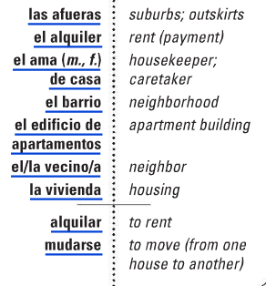
- La vivienda : Housing
C. Los muebles: furniture/furnishings
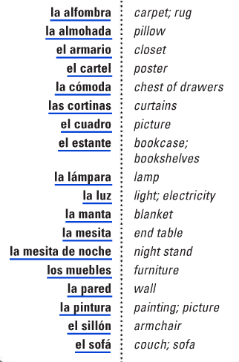

El departamento : apartment (Mex)
El hogar: the home

B.Las partes de una casa
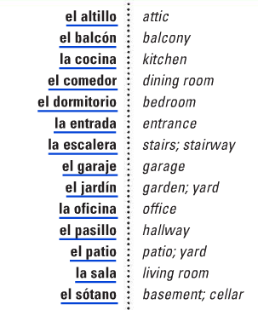

La cama : bed

Alternative regional vocab:
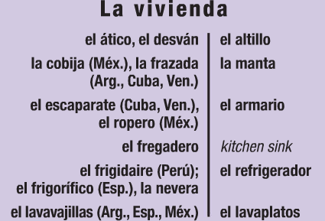

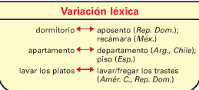

D.Los Quehaceres domésticos: household chores
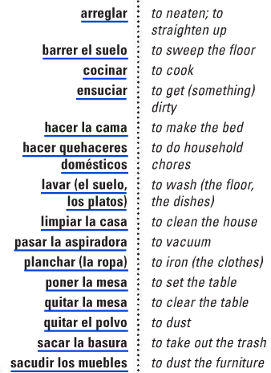
E.Los electrodomésticos: electric home appliances
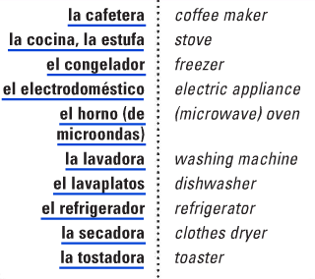

fregar : to mop trapear : to mop (Mex) la fregona / el trapo : the mop la escoba : the broom

Enchufar: to plug in

F. La mesa : the table G. Verbos y expresiones verbales: verbs and verbal expressions
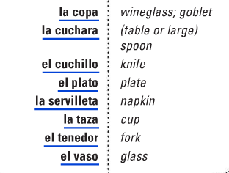
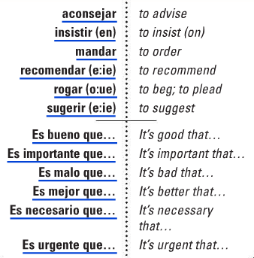
(especially those used with subjunctive)

Expresiones útiles:
Cuente/cuenta con nosotros/conmigo/ = You can count on us/me!
Le va a encantar =you’re going to love it!

There are many more verbal expressions that fit into this category: Pedir: to order/ request Prohibir: To prohibit (prohíbo, prohíbes: accent needed)

Escribe el vocabulario nuevo en el espacio: Which vocab word corresponds to the descriptions/hints?
- Una persona que vive cerca (near) de ti, o en tu barrio _____________________
- Las partes de la comunidad que están cerca de la ciudad, pero no son parte de la ciudad. Hay más espacio entre casas, normalmente. _____________________
- Cuando no quieres comprar algo, pero quieres pagar por uso temporario _____________________
- La parte de la casa en donde comes _____________________
- La parte de la casa que está al aire libre _____________________
- La parte de la casa que usas para subir y bajar _____________________
- El cuarto de la casa en donde duermes _____________________
- La parte de la cama en donde puedes poner la cabeza para descansar _____________________
- Puedes usar estos en las ventanas para tener menos sol, o para decoración _____________________
- Donde puedes poner tu agua, tu celular, y tus lentes cuando vas a dormir _____________________
- Una silla grande, la opción preferida de los abuelos _____________________
- La parte de la casa donde estacionas el carro _____________________
- Cuando tú cambias de casa (vives en una casa diferente) _____________________
- Donde puedes poner todos tus libros _____________________
- Lo que necesitas para tener luz artificial en tu casa _____________________
- Cuando los platos están sucios, puedes ponerlos en el _____________________
- Tienes que poner la comida fresca en el ____________________________ para conservarla.
- Lo que puedes usar para calentar (heat) la comida muy rápidamente. _____________________
- Lo que puedes usar para preparar galletas _____________________
- Cuando tienes mucha ropa sucia, necesitas ponerla en el ______________
- Cuando quieres comer pan crujiente y caliente, necesitas usar _____________________
- Cuando tienes frío, necesitas usar _______________ en el sofá o en tu cama
- Cuando el piso tiene partículas sucias, necesitas_____________________
- La parte de la casa en donde preparas la comida y lavas los platos _____________________
Haz definiciones para los siguientes: Create definitions for the following:
- La pintura_______________________________________________________________
- La secadora_______________________________________________________________
- La sala_______________________________________________________________
- Sacudir los muebles_______________________________________________________________
- La cafetera _______________________________________________________________

¡La casa!
Choose 3 rooms of a house. Draw pictures and use your new vocabulary to tell what activities are done in each. Escribe todo en español.

~~~~~~~~~~~~Gramática: ¡Mandatos! (commands) ~~~~~~~~~~~~
To tell someone to do or not to do something in a stronger way, we use commands. Familiar/ tú commands are used when you are addressing someone equal to you.
Positive “tú” / informal commands
Commands are used when ordering or telling someone to do something. This is often referred to as the "imperative" form of the verb. In Spanish, a “tú” command is for someone you’re friendly with: family, friends, peers, etc.
- Affirmative / Positive “tú” commands tell the person to do something.

Regular, positive Tú commands are formed by taking the regular él, ella, usted form of the verb.
(hablar - ar + a = habla) (comer - er + e = come) (escribir - ir + e = escribe)
Examples:
Compra (tú) el anillo. Come (tú) la pizza. Escribe (tú) la carta.
(You) Buy the ring. (You) eat the pizza. (You) Write the letter.
To form a Affirmative (positive) Tú command (as in, YES, DO this!):
- Use the él/ella/usted form of the present tense!
So, regular –AR verbs will end in ___________ and regular –ER/-IR verbs will end in ______
Things to remember:
If you stem-change in the he/she form, you ARE going to stem-change in the command.

Try these! Find the passport = Encuentra el pasaporte

1. Look for the terminal. _______________________________
2. Write your name. _____________________________
2. Look at the board. ______________________________
3. Use the cell phone. __________________________
4. Play with us! ____________________________

5. Study! ___________________________
6. Come back/return! ______________________________
7. Eat the sandwich! _____________________________
8. Run quickly! ____________________________

- Irregular Affirmative Tú Commands : (positive tú)
The difference is that these verbs don’t follow the regular rules above. So if you want to command someone to go, tell, do” then you use these forms. These irregular rules must be memorized.
Infinitive | Affirmative Tú Command
Venir
Decir
Salir
Hacer
Tener
Ir
Poner
Ser
Irregulars:

Way to remember: Vin Diesel has ten weapons, ay! =Ven Di Sal Haz Ten Ve Pon Sé
- Go to the store = Ve a la tienda.
- Be careful! _______________________________
- Be good. _________________________________
- Come to my house. ________________________________
- Tell the truth. _______________________________
- Set the table. ______________________________
- Go to your room! ____________________________________
- Leave from here! _______________________________________
- Do the homework. _________________________________

Negative Tú commands (No! Don’t do it!)
When you want to tell someone NOT to do something, use a negative command.
Negative tú commands are formed by taking the _________ form of the present tense,
dropping the _________, and adding the opposite “tú” ending. Sound familiar??

- If you start with an –AR verb, use the –ER/-IR verb ending for “tú.” (-es)
HABLAR Hablo Habl Hables. Final = __________________= don’t talk.
- If you start with an –ER or –IR verb, take the AR verb ending for “tú.” (-as)
ESCRIBIR EscriboEscrib escribas. Final = _____________________ = don’t write.
- If you stem-change in the present, you will still follow that in the commands.
Servir sirv no _________________.
Dormir duerm no ____________________________

- If the yo form is irregular, keep this irregular yo in the command.
Tener tengo teng Tengas. Final = _____________________ =don’t be scared.
Decir digo ________________________________________________________ = don’t say/tell.
- –Car, -Gar, - Zar also applies here, so that the pronunciation is correct.
car ques gar gues zar ces
  - No sacar la basura = no ____________________________
- -gar examples:
  - Jugar = no __________________________________
- -zar examples:
  - cruzar = no _____________________________
So remember: rule for positive tú?
- Take the ________________ form of the present tense.
- Are there irregulars? Which?_____________________________________________________________________
Rule for negative tú?
- Take the ________ form, drop the _______, add opposite ___________ ending (es or as)

Baila, no bailes = dance, don’t dance.
1. Speak more slowly. (hablar) _____________________ más lentamente.
2. Don't speak so quickly. No___________________tan rápido.
3. Write a letter to your mother. (escribir) ____________________una carta a tu mamá.
4. Don't write on the wall. No____________________en la pared.
5. Johnny, sing. (cantar) Juanito, __________________________
6. Johnny, don't sing. Juanito, no _____________________.
7. Open the door. (abrir) ____________________la puerta.
8. Don't open the door. No _____________________la puerta.
9. Begin now. (empezar) ___________________________ahora.
10. Don't begin now. No__________________________ahora.
11. Buy that. (comprar) _______________________eso.
12. Don't buy that. No_______________________eso.
13. Drink the juice. (tomar) __________________el jugo.
14. Don't drink the water. No___________________el agua.
15. Clean the kitchen. (limpiar) ___________________ la cocina.
6. Don't clean the house. No____________________(limpiar) la casa.
17. Take the medicine. __________________ (tomar) la medicina.
18. Don't take the medicine. No____________________(tomar) la medicina.
19. Read the book. _____________________ el libro.
20. Don’t read the magazine. No _________________ la revista.
21. Tell the truth (Decir)______________ la verdad.
22. Don’t tell lies. No ____________ mentiras.
23. Follow the rules. (seguir) _____________________ las reglas.
24. Don’t follow the path. No______________________ el sendero.
25. Look for an answer. ______________________ una respuesta.
26. Don’t look for the treasure. No ______________________ el tesoro.
Irregular Negative Tú Commands :
Some verbs have irregular forms for negative tú commands. None of the yo forms here end in yo, which is why they have special forms. Can you guess which infinitive goes with each command below?
- Don’t be bad. _________________________________
- Don’t go! (irse)________________________________
- Don’t be sad. _______________________________
- Don’t be mean! _______________________________

Infinitive | Negative tú command
 | des
 | estés
 | vayas
 | seas
 | sepas

Combinación: Watch for irregulars and –car,-gar,-zar!
      - Go, don’t go _______________________________________________________
      - See, don’t see _______________________________________________________
      - Be, don’t be (estar) _______________________________________________________
      - Be, don’t be (ser) _______________________________________________________
      - Give, don’t give _______________________________________________________
      - Look for, don’t look for _______________________________________________________
      - Take out, don’t take out _______________________________________________________
      - Cross, don’t cross _______________________________________________________
      - Pay, don’t pay _______________________________________________________
10.Play, don’t play _______________________________________________________
11. Order, don’t order _______________________________________________________
12. Serve, don’t serve _______________________________________________________
13. Start, don’t start _______________________________________________________
14. Close, don’t close _______________________________________________________

Relative Pronouns
In both English and Spanish, relative pronouns are used to combine two sentences or clauses that share a common element (like a noun or a pronoun). See below.

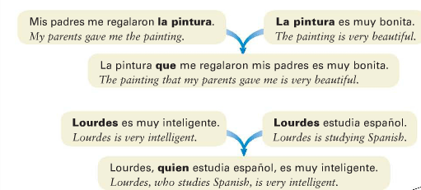
This longer sentence combines both ideas from the shorter sentences above.
This longer sentence combines both ideas from the shorter sentences above.

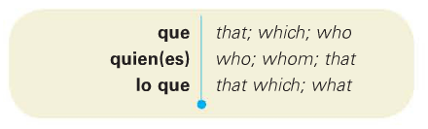
Spanish has 2 frequently-used relative pronouns. They look like question words. However, when these are used as question words, they have accents. When used as pronouns, they NEVER have accents.

Que is the most frequently used relative pronoun, and it can refer to things or to people. In English, we can omit the word “that” in some situations (The store I went to was closed vs The store THAT I went to was closed) but in Spanish you cannot omit the que.
The pronoun quien refers only to people. It’s often used after a preposition (a, de, con, en) or the personal a.
Quien = singular. Quienes = plural.
Ellas son las chicas de quienes me hablaste =They are the girls who you talked to me about (of whom you talked to me)
Sometimes we have who/whom questions in English. In Spanish, you can generally just use “que.”
Lola, quien es estudiante, es de Cuba. OR Lola, que es estudiante, es de Cuba.
You can use “lo que” to refer to an abstract idea, situation, or event. It can mean what, that which, or the thing that.
Ejemplo Lo que me molesta es el calor = What bothers me is the heat.
Lo que me interesa es el arte = The thing that interests me is art.

Completa con que, quien, quienes, or lo que.
- Voy a usar los libros _______________ están en la biblioteca.
- Ana vive con una chica a _________________ conocimos el año pasado.
- ¿Sabes ___________________ creo? Debes descansar.
- La oficina tiene todo ________________ necesitamos.
- Puedes usar los platos ________________ __ están a la derecha.
- Los hombres ________________ ____ viven en el apartamento son de Panamá.
- Los niños a ________________ __ vimos anoche son de los estados unidos.
- La comida ________________ _ hay en la cafetería es saludable.
- _______________ __ necesitas es una chaqueta nueva.

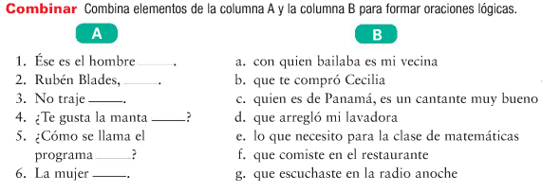
~~~~~~~~~~~~~~Formal Commands / Los Mandatos Formales y plurales~~~~~~~~~~~~~~~
Do you remember how to form the usted (formal) commands?
Diga la información. Pase por aduana.
______________________________________________________________________________________________
The Ustedes Command (plural) is formed by taking the YO form of the verb, dropping the O, and adding the opposite ending in the present-tense, third person plural (they ending):
For –AR verbs, drop the O and add EN. Ex: Hablar Hablo ______________________
For –ER / -IR verbs, drop the O and add AN. Ex: Comer Como ______________________
Come in, all of you. Pasen ustedes.
Turn off the lights! ¡Apaguen las luces! Look, everyone! ¡ ______________________, todos!
Do the work! ¡ ______________________ el trabajo! (ustedes) Start the homework: _____________la tarea.

Obviamente hay irregulares
Verb | Ustedes Command
Ser
Ir
Dar
Estar
Saber

Escribe el mandato formal positivo y negativo:
- ustedes / empezar ________________________________________________
- Usted / sacar ________________________________________________
- Usted / escribir ___________________________________________
- tú / dar ________________________________________________
- Ustedes /ser ________________________________________________
- Usted / jugar ________________________________________________
- Ustedes / pagar ________________________________________________
- tú/ probar ________________________________________________
- tú / dar ________________________________________________
- Ustedes / buscar ________________________________________________
- tú / ir ________________________________________________
- Ustedes / hacer ________________________________________________
- Usted / preparar ________________________________________________
- Tú / practicar ________________________________________________
- Ustedes / competir ________________________________________________
- Usted / servir ________________________________________________
- Tú / pedir ________________________________________________
- Ustedes / perder ________________________________________________
- Ustedes / escuchar ________________________________________________
- Ustedes / tener ________________________________________________
- Usted /decir ________________________________________________
- Tú /decir ________________________________________________
- Usted / traer _______________________________________________
- tú/ salir ________________________________________________
- Usted / cruzar ________________________________________________
- Ustedes/ sacudir ________________________________________________
- tú / doblar ________________________________________________
- Ustedes/ conseguir (e-i) ________________________________________________
- Ustedes / ir ________________________________________________
- Usted / mezclar ________________________________________________
- Ustedes / quitar________________________________________________
- Usted / barrer________________________________________________
- Ustedes / arreglar________________________________________________
- Ustedes/ ensuciar ________________________________________________
- Ustedes /entender________________________________________________
- Usted / oír ________________________________________________

Commands with PRONOUNS
For positive commands with pronouns
- form the command as usual,
- then add the person pronoun (IOP), (me te le nos les, change the le or les to SE)
- then the item pronoun (DOP) if there is one. (lo la los las)

- If you are attaching 1 pronoun, the accent goes on the 3rd to last.
- Attaching 2 pronouns, the accent goes on the 4th to last.
- If attaching a le or les with a DOP, you must change these to “se.”
If a command only has ONE syllable (haz, pon) then an accent is only needed when 2 pronouns are attached. Házmela = do it for me.
Reflexive verbs with pronouns work the same way as an IOP: attach it first. Remember that you will always need the reflexive pronoun for the reflexive commands!

- Javier, look for them (the shoes) = Búscalos.
- Javier, look for the shoes for me. Look for them for me.
- Javier, búscamelos.
- Give the fruit to them =
- Dásela (since you can’t have lela, you get sela here)
- REFLEXIVES: Relax! = Relájate.
- Rafael, put it on (the shirt ) Póntela.

Tú commands with pronouns:

- lavar el suelo = Lávelo
- sacudir los muebles = _____________________________________
- cepillarse los dientes _____________________________________
- ponerse los vestidos_____________________________________
- lavarse las manos_____________________________________
- quitarse los zapatos_____________________________________
- enseñar la carta a mí_____________________________________
- cocinar la cena a nosotros_____________________________________
- lavar los platos a ellas _____________________________________
- sacar la basura _____________________________________
- mover (o-ue) los muebles _____________________________________
- moverse _____________________________________
- terminar los exámenes _____________________________________
- tell me it! _____________________________________
- bring me them! _____________________________________
- bring him it! _____________________________________
- show them it! _____________________________________
- serve them it! _____________________________________
- translate it! _____________________________________

Now use the same phrases and verbs to create the negative versions of the commands. Remember, you cannot attach to negatives. You start with NO, then the IOP (person, me te le nos les) then the it/them item if there is one. Be careful to check WHICH command you need to form (usted, ustedes, or tú!)

- Señor, no lavar el suelo = no lo lave.
- Chicos, no sacudir los muebles = _____________________________________
- tú, no cepillarse los dientes _____________________________________
- tú, no ponerse los vestidos_____________________________________
- Chicos, no lavarse las manos_____________________________________
- tú, no enseñar la carta a mí_____________________________________
- Chicos, no cocinar la cena a nosotros_____________________________________
- tú, no lavar los platos a ellas _____________________________________
- Chicas, no sacar la basura _____________________________________
- Señor, no mover (o-ue) los muebles _____________________________________
- Chicos, no moverse _____________________________________
- tú, no terminar los exámenes _____________________________________
- Señores, don’t tell me it! _____________________________________
- tú, don’t bring me them! _____________________________________
- Chicos, don’t bring him it! _____________________________________
- Chicas, don’t show them it! _____________________________________
- tú, don’t serve them it! _____________________________________
- Chicas, don’t translate it! _____________________________________

Create some commands using the vocabulary listed: use positive or negative. Use your vocabulary list for this, and decide whether to use usted, ustedes, or tú commands.
- Las camas (the beds) = Chicas, ¡háganlas!
- La cocina _____________________________________
- El garaje _____________________________________
- Las cortinas _____________________________________
- Los muebles _____________________________________
- Las pinturas _____________________________________
- Las almohadas _____________________________________
- La tostadora _____________________________________
- Las copas_____________________________________
- Los tenedores _____________________________________
- Los platos _____________________________________

~~~~~~~~~~Gramática: Reciprocal Reflexives~~~~~~~~~~~~~~~~~~~~~
Read the passage below, and see if you can translate the meaning into English.

¡Cuando mi mejor amiga y yo nos vemos en la escuela, siempre nos abrazamos! Una vez, mi amiga y su ex-novio se vieron en la cafetería, pero no se hablaron.

ex-novio
Translation: ______________________________________________________________________________________________________________________

______________________________________________________________________________________________________________________

What does it mean when something is reciprocated?

You have learned that reflexive verbs indicate that the subject is doing something to themselves. Reciprocal reflexives (los reflexives recíprocos), on the other hand, express a shared or reciprocal action between two or more people or things. In this context the pronouns (nos, se) mean “(to) each other” or “(to) one other”
In Spanish, we can also use reflexive verbs to express the idea of “each other” or “one another.”
*Fun (English) fact:
“each other” technically can only refer to two people =You and I help each other.
“one another” refers to three or more = The students in the class share with one another.
me (won’t be used) | nos
Te (won’t be used) | x
Se (won’t be used) | se
The Spanish reflexives can be used for both of these cases.
The reflexive pronouns are still the same:

Why won’t you use any of the singular column pronouns?
*With reflexive verbs used reciprocally, you will always have a plural ending, because you are referring to more than one person. (each other/ one another).
Here are some verbs that can be used to show reciprocal action:
to hug (each other) |  | to help (each other)
to kiss (each other) |  | to meet/run into (each other) | encontrarse
to greet (each other) | saludarse | to talk to (each other)
to write (each other) |  | to get mad at (each other) | enojarse
to look at (each other) |  | to see (each other)
to understand (each other) |  | to love (each other)
To support (each other) | apoyarse

- Alicia and I know each other well = Alicia y yo nos conocemos bien.
- My grandma and I write to each other ____________________________________________
- Carlos and Paco talk to each other ____________________________________________
- We don’t understand each other ____________________________________________
- My friends used to understand each other ______________________________________________________
- We used to always support each other ____________________________________________________

~~~~~~~~~~~~Stressed possessive adjectives and possessive pronouns~~~~~~~~~~~~~~~~
Read the conversations below, and see if you can translate then into English.
-Este lápiz es tuyo? -Sí, es mío. _________________________________________________________
-¿Esa galleta es mía?- No, es suya. _________________________________________________________
-¿Cómo están los perros tuyos? Porque los míos están terribles hoy. __________________________________________________________________________________________________________________

If you want to stress who owns something, like “it’s MINE” or “that dog of yours,” you have a few other adjectives to use.
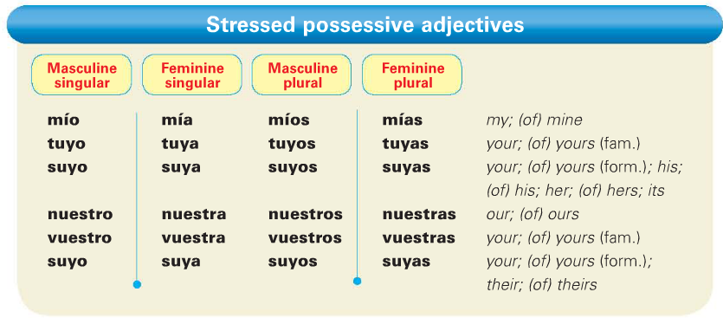
    - Juliana is a friend of mine = Juliana es una amiga mía.
    - That book is yours? ¿Ese libro es tuyo?
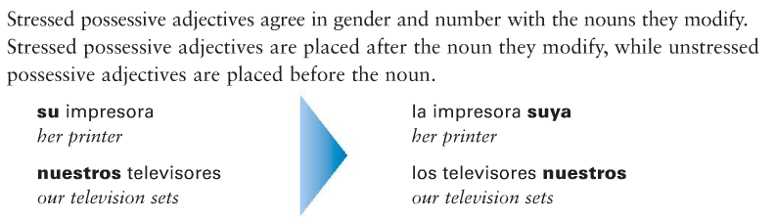
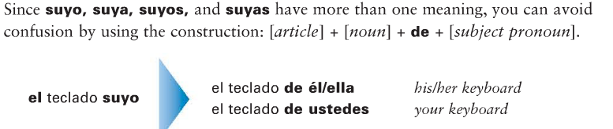

Correct the statements below so that we know whose is what! Watch for gender and number.
- Ejemplo: ¿La calculadora es tuya? (his) No, es suya. (The calc is yours? No, it’s his.)
- ¿Las computadoras son tuyas? (ours) ___________________________________
- ¿La cámara digital es nuestra? (mine) ___________________________________
- ¿Las plumas son nuestras? (yours) ___________________________________

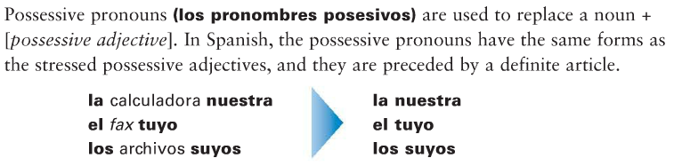

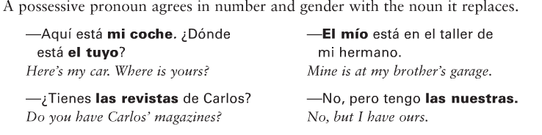
Escribe en español usando los pronombres posesivos.
- Las computadoras de nosotros = las nuestras
- El perro del chico = el suyo
- El coche de mí = ________________
- El medicamento de ti = _______________
- La gasolina de nosotros = _______________
- Los controles remotos de las chicas ____________________
- La comida de nosotros ____________________________
- La clase de ella __________________________

Vocabulario de Descubre 2, Lec 2 (the one we skipped while we piloted).
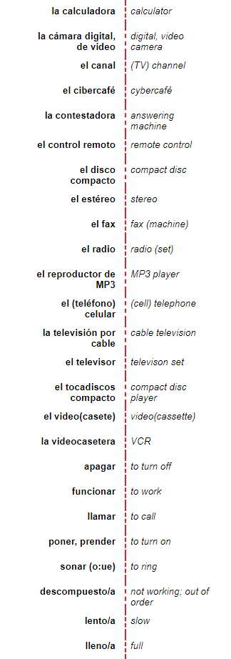
A. La Tecnología B. La Computadora
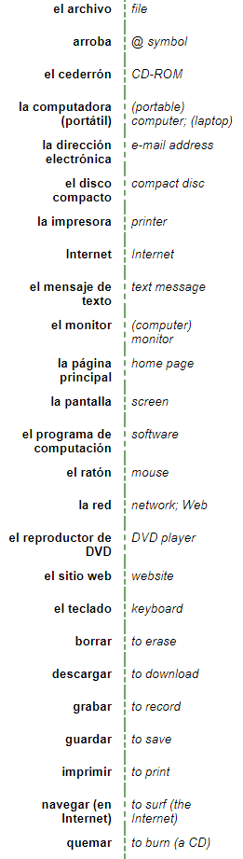

Más Vocabulario de Descubre 2, Lec 2 (the one we skipped while we piloted).

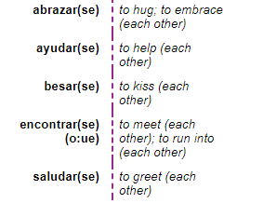
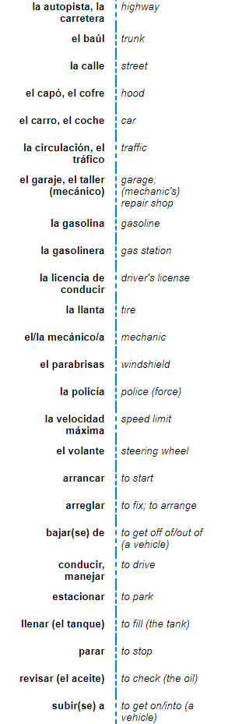
C. El Carro D. Verbos

E.Otras expresiones
actualmente | currently/nowadays
