Me llamo________________________________________ Descubre 2 Capítulo 3: La vivienda
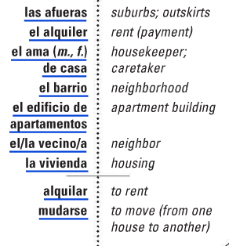
- La vivienda : Housing
C. Los muebles : furniture
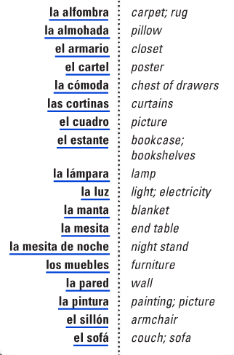

El hogar: the home
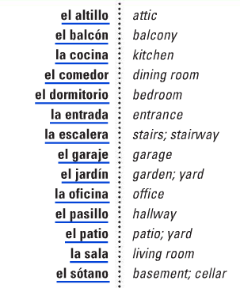
B.Las partes de una casa

Alternative regional vocab:

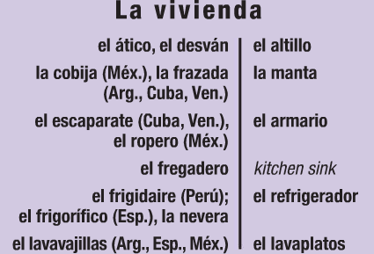
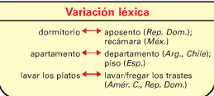

After studying this chapter, I can: Recognize rooms in a house and identify household objects Describe household chores Understand and respond to formal commands Give formal commands
SOON I can: Express my attitude toward something using the subjunctive Express will and influence using the subjunctive

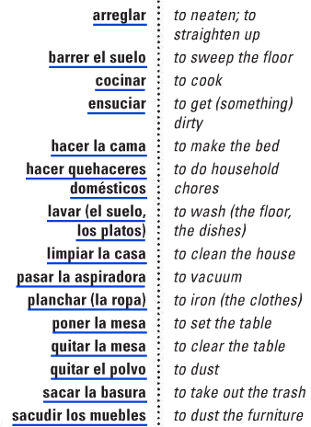
D.Los Quehaceres domésticos: household chores
E.Los electrodomésticos: electrical home appliances
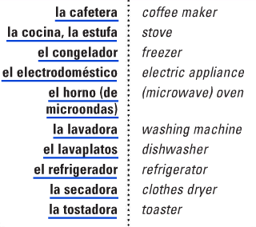

Enchufar: to plug in
F. La mesa : the table G. Verbos y expresiones verbales: verbs and verbal expressions
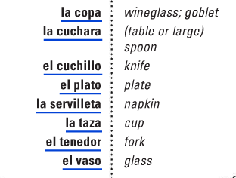
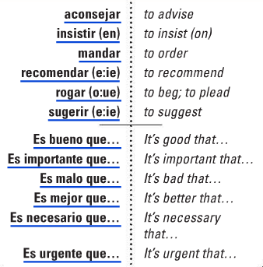
(especially those used with subjunctive)

Fun phrases:
Cuente/cuenta con nosotros/conmigo/ = You can count on us/me!
¡Te va a encantar! = You’re going to love it!
¡Le va a encantar! He/she’s going to love it!

There are many more verbal expressions that fit into this category: Pedir: to order/ request Prohibir: To prohibit (prohíbo, prohíbes: accent needed)

~~~~~~~~~~~~~~~~~~~~~Relative Pronouns~~~~~~~~~~~~~~~~~~
In both English and Spanish, relative pronouns are used to combine two sentences or clauses that share a common element (like a noun or a pronoun). See below.

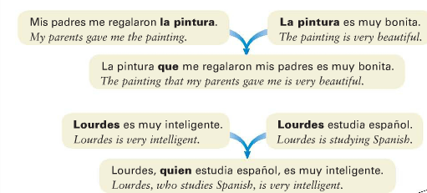
This longer sentence combines both ideas from the shorter sentences above.
This longer sentence combines both ideas from the shorter sentences above.

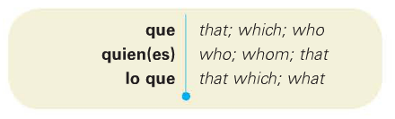
Spanish has 2 frequently-used relative pronouns. They look like question words. However, when these are used as question words, they have accents. When used as pronouns, they NEVER have accents.

Que is the most frequently used relative pronoun, and it can refer to things or to people. In English, we can omit the word “that” in some situations (The store I went to was closed vs The store THAT I went to was closed) but in Spanish you cannot omit the que.
The pronoun quien refers only to people. It’s often used after a preposition (a, de, con, en) or the personal a.
Quien = singular. Quienes = plural.
Ellas son las chicas de quienes me hablaste =They are the girls who you talked to me about (of whom you talked to me)
Sometimes we have who/whom questions in English. In Spanish, you can generally just use “que.”
Lola, quien es estudiante, es de Cuba. OR Lola, que es estudiante, es de Cuba.
You can use “lo que” to refer to an abstract idea, situation, or event. It can mean what, that which, or the thing that.
Ejemplo Lo que me molesta es el calor = What bothers me is the heat.
Lo que me interesa es el arte = The thing that interests me is art.

Completa con que, quien, quienes, or lo que.
- Voy a usar los libros _______________ están en la biblioteca.
- Ana vive con una chica a ___________________ conocimos el año pasado.
- ¿Sabes ___________________ creo? Debes descansar.
- La oficina tiene todo ________________ necesitamos.
- Puedes usar los platos ________________ __ están a la derecha.
- Los hombres ___________________ viven en el apartamento son de Panamá.
- Los niños a ________________ vimos anoche son de los estados unidos.
- La comida ________________ _ hay en la cafetería es saludable.
- ________________ necesitas es una chaqueta nueva.

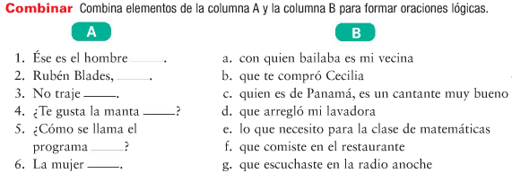
~~~~~~~~~~~~~~Formal Commands / Los Mandatos Formales~~~~~~~~~~~~~~~
Commands: With respect!
It is very important to be polite when traveling to other countries. When addressing people, you may need to suggest that they do something, but it needs to sound polite. There is an easy way to do this in Spanish: you use a formal command.
The Usted/ formal command is formed by taking the YO form of the verb in the PRESENT, dropping the O and adding the opposite ending in the present-tense, third person singular (él/ella/usted ending):
- For –AR verbs, drop the O and add E. Ex: Hablar Hablo _________________
- For –ER / -IR verbs, drop the O and add A. Ex: Comer Como _________________
Ejemplo: Señor Chavez, por favor entre el museo. Mr. Chavez, please enter the museum.
Ejemplo: No coma el pastel. Do not eat the cake.
To make these negative, just add “no” before the command. Don’t watch tv = No vea la television.
The Ustedes Command (plural) is formed by taking the YO form of the verb, dropping the O, and adding the opposite ending in the present-tense, third person plural (they ending):
For –AR verbs, drop the O and add EN. Ex: Hablar Hablo ______________________
For –ER / -IR verbs, drop the O and add AN. Ex: Comer Como ______________________
Come in, all of you. Pasen ustedes.
Look, everyone! ¡ ______________________, todos!
Do the work! ¡ ______________________ el trabajo!
Remember those irregular yo forms!
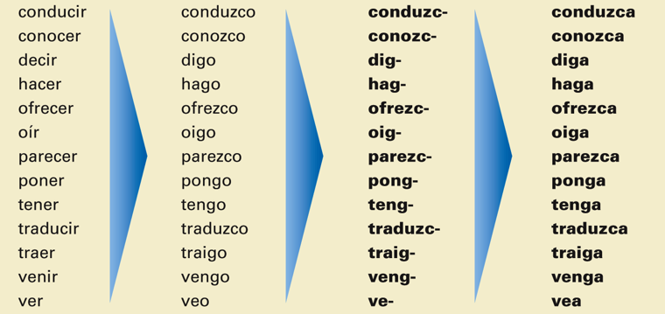
Bring the cake! (traer) ____________________
Verb | Usted Command | Ustedes Command
Estudiar
Abrir
Aprender
Tener | Tenga
Hacer
Poner
Decir
Salir
Venir

Obviamente hay irregulares
Verb | Usted Command | Ustedes Command
Ser | Sea
Ir | Vaya
Dar | Dé
Estar | Esté
Saber | Sepa

CAR, GAR, ZAR will apply here too, just NO ACCENTS:
Jugar becomes JUEGO. Drop O, add E, can’t have Jueg + e because that makes a “hey” sound.
Keep the GUE = Juegue.
(usted)Look for the dog = Busque el perro.

(ustedes) 1. Start the homework: _____________la tarea.
(ustedes) 2. Don’t play with those kids: No ______________________con esos niños.
(ustedes) 3. Don’t take the picture! ¡No _______________________________ la foto!

Escribe el mandato formal positivo y negativo:
- ustedes / empezar ________________________________________________
- Usted / sacar ________________________________________________
- Usted / escribir ___________________________________________
- Usted / dar ________________________________________________
- Ustedes /ser ________________________________________________
- Usted / jugar ________________________________________________
- Ustedes / pagar ________________________________________________
- Ustedes/ probar ________________________________________________
- Usted / usar ________________________________________________
- Ustedes / buscar ________________________________________________
- Usted / ir ________________________________________________
- Ustedes / hacer ________________________________________________
- Usted / preparar ________________________________________________
- Ustedes / practicar ________________________________________________
- Ustedes / competir ________________________________________________
- Usted / servir ________________________________________________
- Usted / pedir ________________________________________________
- Ustedes / perder ________________________________________________
- Ustedes / escuchar ________________________________________________
- Ustedes / tener ________________________________________________
- Usted /decir ________________________________________________
- Usted / traer _______________________________________________
- Ustedes/ salir ________________________________________________
- Usted / cruzar ________________________________________________
- Ustedes/ sacudir ________________________________________________
- Usted / doblar ________________________________________________
- Ustedes/ conseguir (e-i) ________________________________________________
- Ustedes / ir ________________________________________________
- Usted / mezclar ________________________________________________
- Ustedes / quitar________________________________________________
- Usted / barrer________________________________________________
- Ustedes / arreglar________________________________________________
- Ustedes/ ensuciar ________________________________________________
- Ustedes /entender________________________________________________
- Usted / oír ________________________________________________

Commands with PRONOUNS
For positive commands with pronouns
- form the command as usual,
- *then add the person pronoun (IOP), (me te le nos les, change the le or les to SE)
- then the item pronoun (DOP) if there is one. (lo la los las)
NOTES:
*If you have a le or les with a DOP (lo la los las), change the le or les to SE.
**If you have a reflexive, that counts as a person pronoun (ME SE TE NOS SE) so it goes first.
- If you are attaching 1 pronoun, the accent goes on the 3rd to last.
- Attaching 2 pronouns, the accent goes on the 4th to last.
- If attaching a le or les with a DOP, you must change these to “se.”

It’s all about making the COMMAND SOUND just like it did before you got all crazy and added things to it.
If a command only has ONE syllable (haz, pon) then an accent is only needed when 2 pronouns are attached. Házmela = do it for me.
Reflexive verbs with pronouns work the same way as an IOP: attach it first. Remember that you will always need the reflexive pronoun for the reflexive commands!
- Javier, look for them (the shoes) = Búscalos.
- Javier, look for the shoes for me. Look for them for me.
- Javier, búscamelos.
- Children, look for them for me.
- Búsquenmelos.
- Give the fruit to them =
- Dásela (since you can’t have lela, you get sela here)
- REFLEXIVES: Relax! = Relájate.
- Rafael, put it on (the shirt ) Póntela.

- Señor, lavar el suelo = Lávelo
- Chicos, sacudir los muebles = _____________________________________
- Estudiantes, cepillarse los dientes _____________________________________
- Chicas, ponerse los vestidos_____________________________________
- Chicos, lavarse las manos_____________________________________
- Señor, enseñar la carta a mí_____________________________________
- Chicos, cocinar la cena a nosotros_____________________________________
- Chicos, lavar los platos a ellas _____________________________________
- Chicas, sacar la basura _____________________________________
- Señor, mover (o-ue) los muebles _____________________________________
- Chicos, moverse _____________________________________
- Estudiantes, levantarse _____________________________________
- Chicas, terminar los exámenes _____________________________________

- Señores, tell me it! _____________________________________
- Chicas, bring me them! _____________________________________
- Chicos, bring him it! _____________________________________
- Chicas, show them it! (enseñar) _____________________________________
- Chicos, serve them it! (servir la pizza) _____________________________________
- Chicas, translate it! _____________________________________

Now use the same phrases and verbs to create the negative versions of the commands. Remember, you cannot attach to negatives. You start with NO, then the IOP (person, me te le nos les) then the it/them item if there is one.

- Señor, no lavar el suelo = no lo lave.
- Chicos, no sacudir los muebles = _____________________________________
- Estudiantes, no cepillarse los dientes _____________________________________
- Chicas, no ponerse los vestidos_____________________________________
- Chicos, no lavarse las manos_____________________________________
- Señor, no enseñar la carta a mí_____________________________________
- Chicos, no cocinar la cena a nosotros_____________________________________
- Chicos, no lavar los platos a ellas _____________________________________
- Chicas, no sacar la basura _____________________________________
- Señor, no mover (o-ue) los muebles _____________________________________
- Chicos, no moverse _____________________________________
- Chicas, no terminar los exámenes _____________________________________

- Señores, don’t tell me it! _____________________________________
- Chicas, don’t bring me them! _____________________________________
- Chicos, don’t bring him it! _____________________________________
- Chicas, don’t show them it! _____________________________________
- Chicos, don’t serve them it! _____________________________________
- Chicas, don’t translate it! _____________________________________
Create some commands using the vocabulary listed: use positive or negative. You will need to use your vocabulary list for this.
- Las camas (the beds) = Chicas, ¡háganlas!

- La cocina _______________________________
- El garaje _____________________________________
- Las cortinas _____________________________
- Los muebles ________________________________
- Las pinturas ______________________________
- Las almohadas _____________________________________
- La tostadora ________________________________
- Las copas_________________________________
- Los tenedores _________________________________
- Los platos _______________________________

~~~~~~~~~~~~~~~~~Gramática~~~~~~~~~~~~~~~~~~~
Read the following letter, paying close attention to the bolded word forms and the underlined/italicized phrases.
Querid@ amig@,
1.Es bueno que tú vayas a México para estudiar. ¡Quiero que tú tomes muchas fotos! 2.También, es importante que tú y tus amigos viajen mucho y que conozcan muchas ciudades nuevas y a personas interesantes. 3.Espero que tu familia nueva sea muy simpática y que te incluyan en todas sus actividades. ¡Insisto en que me traigas muchos regalos! Recomiendo que pruebes toda la comida. 4.Siempre es bueno explorar las comidas nuevas cuando viajas. 5.Deseo que tú regreses con una habilidad de hablar muy bien el español. 6.Mientras que estés allí, es necesario que estudies un poco también. 7.¡Recomiendo que busques un novio o novia hispanohablante porque es más fácil aprender el español así!
Con un amigo: discuss the following questions.
- What did you notice about the forms of the bolded words?
_______________________________________________________________________________________________________________
- What patterns or trends do you see in the italicized/underlined phrases, if any? (think about the meanings of the words used, and the structure of the phrases)
_________________________________________________________________________________________________________________
- Are there any outliers? (look at number 4…)
_________________________________________________________________________________________________________________
Recipe =

______________________ + ______________________ + ___________________ + _________________________

~~~~~~~~~~~~~~~~~~~~~~~¡El subjuntivo!~~~~~~~~~~~~~~~~~~
“The subjunctive is not a tense; rather, it is a mood. Tense refers to when an action takes place (past, present, future), while mood reflects how the speaker feels about the action. The subjunctive mood is rarely used in English, but it is widely used in Spanish” (http://www.studyspanish.com/lessons/subj1.htm)

- With the exception of commands, all the verb forms you have been using have been in the indicative mood. Commands were in the IMPERATIVE mood. The indicative is used to state facts and to express actions or states that the speaker considers to be real and definite. In contrast, the subjunctive mood expresses the speaker’s attitudes toward events, as well as actions or states the speaker views as uncertain or hypothetical.

- The subjunctive is mainly used to express:
1) will and influence, 2) emotion, 3) doubt, disbelief, and denial, and 4) indefiniteness and nonexistence
~~~~~~~~~~~~~~~~~How to form the present subjunctive~~~~~~~~~~~~~
Take present yo, drop o, add opposite ending! Sound familiar?
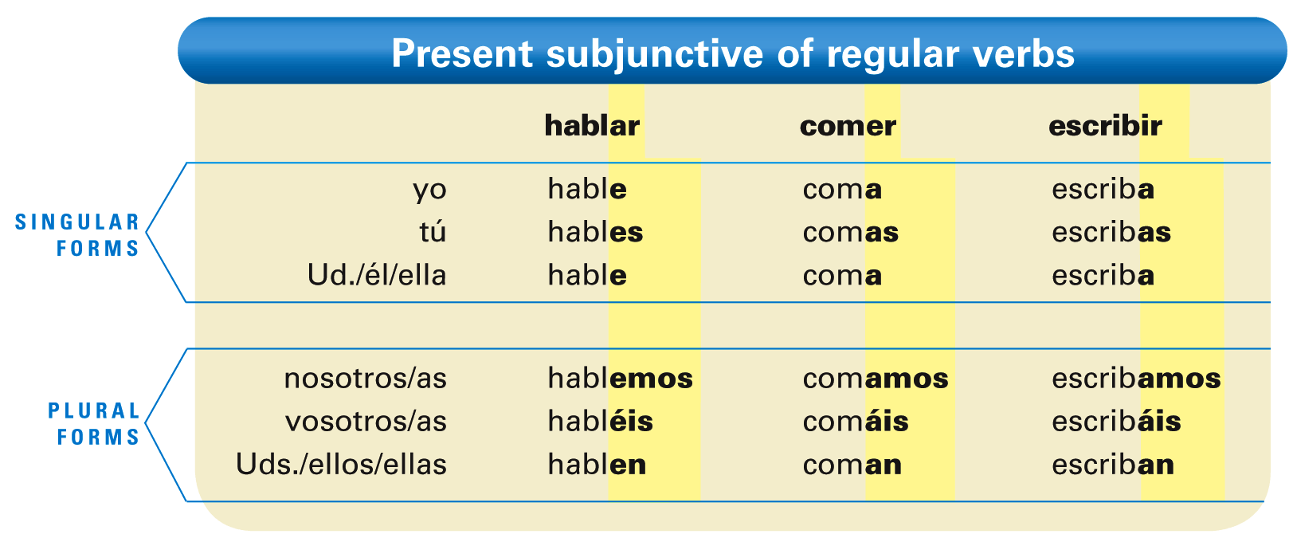
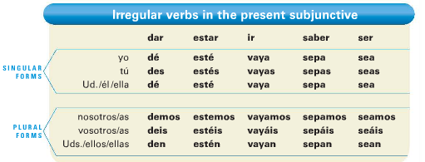
Irregular verbs in the present subjunctive:
D I S H E S !
DAR = _____________________________
IR _____________________________
SER _____________________________
HABER _____________________________
ESTAR _____________________________
SABER _____________________________
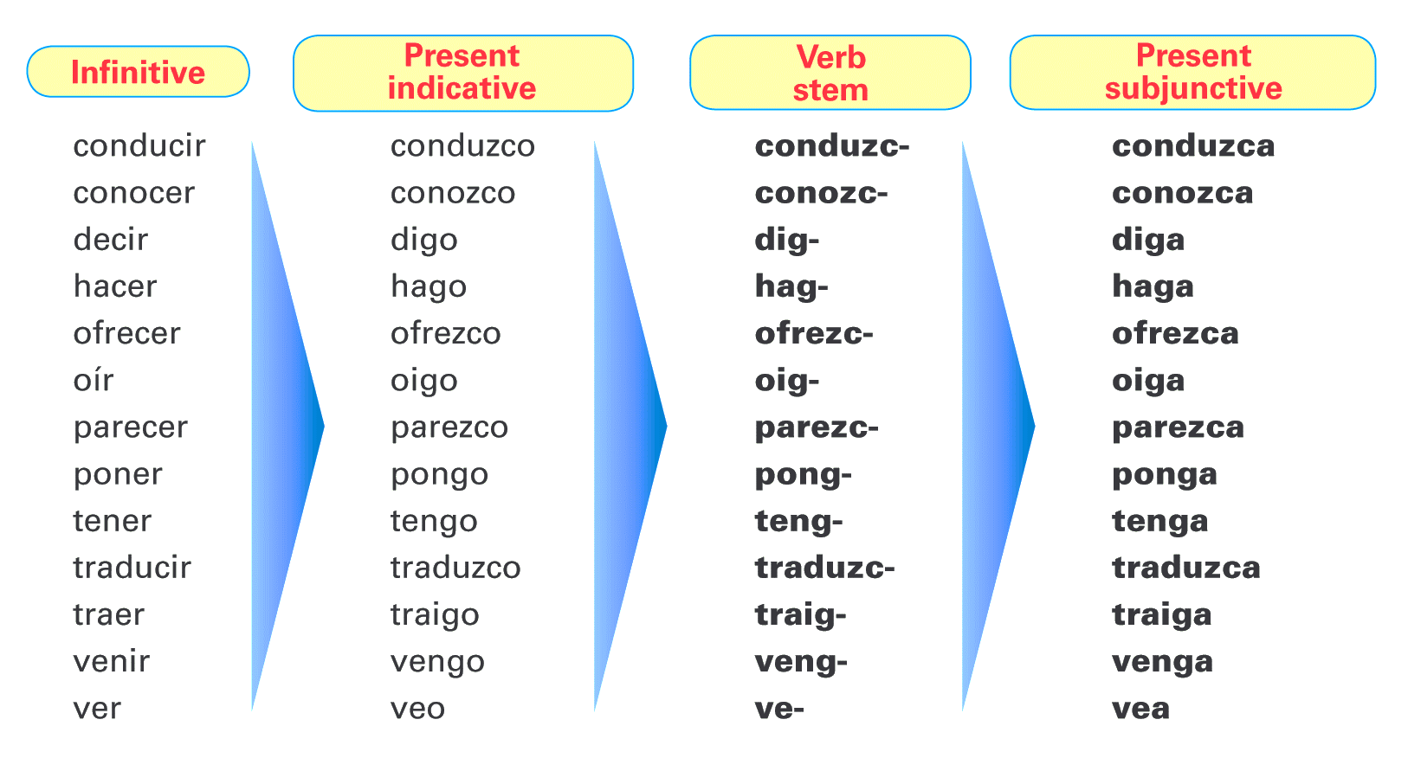
Irregular yo
will follow:

CAR GAR ZAR will apply in all forms!
-CAR -QUES,-QUEN,- QUEMOS
-GAR -GUES, -GUEN,-GUEMOS
-ZAR -CES, -CEN, -CEMOS

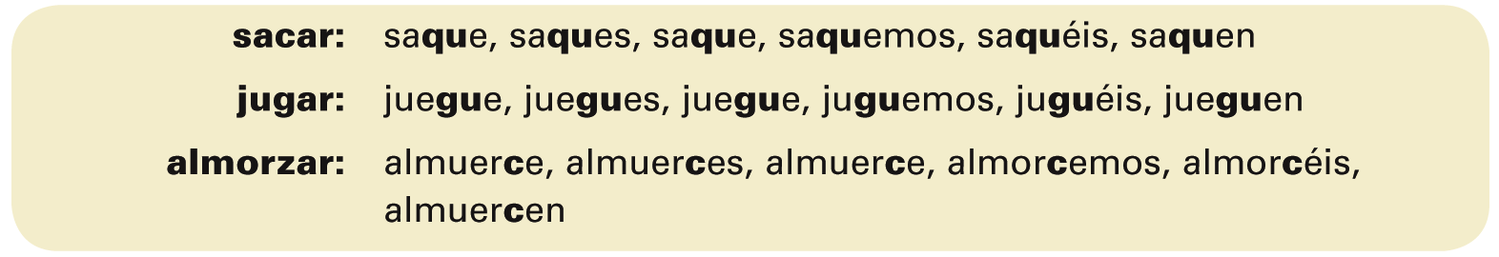

-cer and -cir will often become zca =
Conozca, traduzcas, produzcamos, conduzcan

Stem-changing:
In the present subjunctive, stem-changing verbs that end with -AR or -ER will stem change in every form but nosotros (and vosotros)
Ella ustedes nosotros
Jugar = jueguen, juguemos
Entender = Entienda, entendamos
Empezar = ________________________empiecen____________________________________
Contar =_____________________________________________________________
Mostrar ________________________________________________________________
Perder=_____________________________________________________________
-IR verbs stem change in every form of the subjunctive. The nosotros form stem changes to only one letter: ( U or I )
Ella ustedes nosotros
Pedir = _______________pida_______________________________________________
Servir =______________________________________________________________________________
Dormir =______________________________________________________________________________
Vestir = ______________________________________________________________________________
Preferir =______________________________________________________________________________
Sentir = =______________________________________________________________________________

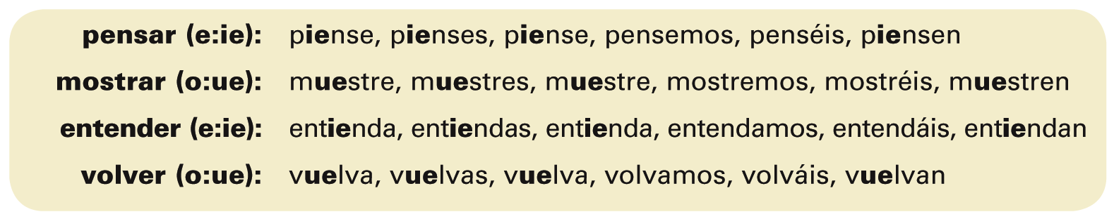
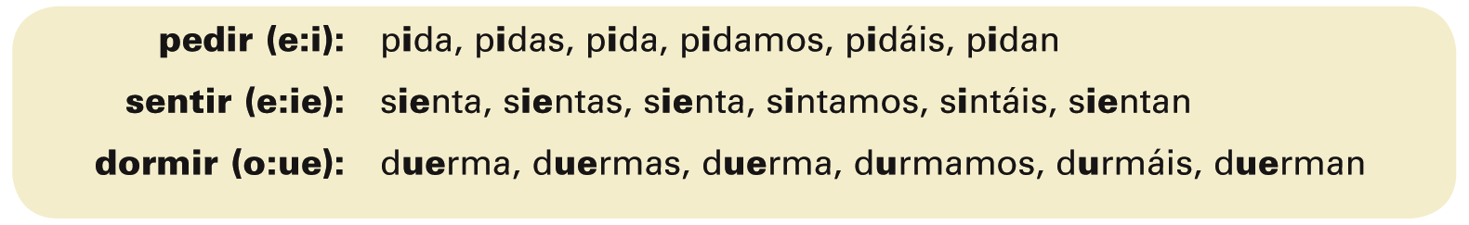

- Escribe las formas correctas del subjuntivo de los verbos indicados.
- Alquilar, beber, vivir. Que yo alquile, beba, viva.
- Estudiar, aprender, asistir. que tú ________________________________________________
- Encontrar, poder, dormir. que ellos________________________________________________
- Hacer, tener, venir. que nosotros________________________________________________
- Dar, hablar, escribir. Que nosotros ________________________________________________
- Pagar, empezar, buscar. que nosotros________________________________________________
- Entender, dormir, saber. que ustedes________________________________________________
- Ser, ir, saber. que tú________________________________________________
- Estar, dar, oír. que yo ________________________________________________

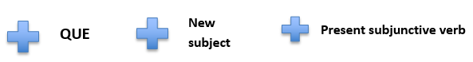
This is your recipe for the subjunctive:
(Key)

- Key: The subjunctive with IMPERSONAL EXPRESSIONS
- These impersonal expressions are always followed by clauses in the subjunctive:
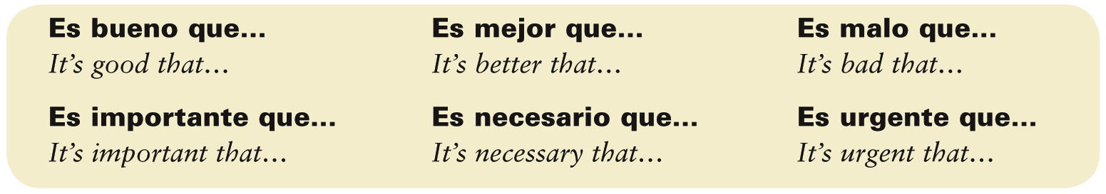
You need the subjunctive with impersonal expressions when you have two different subjects:
- It’s = one subject.
- Then you have the expression like “important” or “interesting”
- and then you have QUE,
- then a new subject like a different person or thing,
- then the subjunctive form of the new verb:

Subject /expression + QUE + new subject + subjunctive
It’s bad that that Jacinta is not in school today =
Es malo QUE Jacinta no esté en la escuela hoy.
Impersonal expression (this is the “key/trigger”) +que + new subject + present subjunctive of the verb
BUT
If you don’t have a new subject, then you don’t need a QUE, and you would follow the phrase with an infinitive (not conjugated).
It’s important to study= One subject = it.
Es importante estudiar (one subject? Just use the infinitive – to study) = estudiar.
It’s important that you study. (2 subjects. Also, are you definitely studying? No. This person speaking feels that it’s important, but you can’t say “estudias” because that means you definitely study. The subjunctive is going to open up the idea that there is no guarantee here).
In Spanish: Es importante que tú estudies. (2 subjects)
It’s important that you study (for you to study)
The subjunctive is somewhat dying out in English. Instead of “that” we use “for (someone) to.”
It’s necessary for you guys to read more = what you are really saying is
“it is necessary that you guys read more”
Es necesario que ustedes lean más.
In Spanish, all of these sentences would have to be reworded with a “that” (que) and then a new subject and the verb in the subjunctive.

Re-write those sentences with a “that” in English:
- It’s good for you guys to spend time together. _____________________________________________________
- It’s not necessary for you to study more. _____________________________________________________
- It’s possible for my mom to be home by 5. _____________________________________________________
- Complete the sentences with the verb given. Then create your own ending to the open-ended prompts.
- Es importante / ustedes / llegar a tiempo Es importante que ustedes lleguen a tiempo
- Es bueno / yo / descansar _________________________________________________
- Es malo /tú / no comer frutas______________________________________________________________
- Es terrible / los estudiantes / no /tener tiempo libre ________________________________________________________________________________________________
- Es necesario / mis padres _____________________________________________________________
- Es malo / tú ____________________________________________________________________
- Es terrible/ el maestro _______________________________________________________________________

- Key: The subjunctive with verbs of WILL AND INFLUENCE
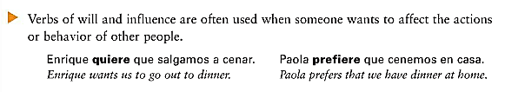
- ¡Atención! In English, verbs or expressions of will and influence often use the infinitive, such as I want you to go. This is not the case in Spanish, where the subjunctive would be used in a subordinate clause.
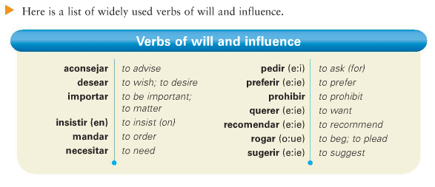
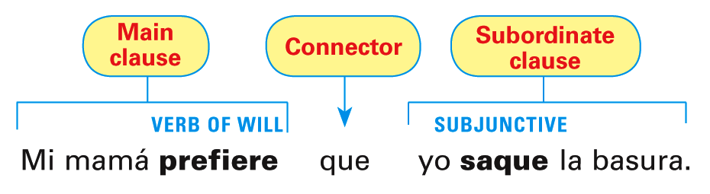
- When the main clause contains one subject and an expression of will or influence, and you have a new subject, then the subjunctive is required in the subordinate clause.
My mom prefers that I take out the trash (Prefers for me to take out the trash)
If there is NO change of subject, use the infinitive. Mi mama prefiere sacar la basura. = My mom prefers to take out the trash.
A.For the following examples, circle the subjects. If there are 2 subjects, you will need to use the subjunctive in the second clause. If there is only one subject (no subject change), then you will write the infinitive.
- Yo recomiendo que ustedes ____________________ (arreglar) la sala.
- Yo te sugiero que tú ___________________ (ir) con ella al supermercado.
- Él necesita que yo le ___________________ (prestar) dinero.
- No queremos que tú ___________________ (hacer) nada especial para nosotros.
- Mis papás quieren que yo ___________________ (limpiar) mi cuarto.
- Ellos nos piden que nosotros ___________________ (ayudar) a preparar la comida.
- Quieren que tú _______________ (sacar) la basura todos los días.
- Quiero __________________ (descansar) esta noche.
- Es importante que ustedes _______________ (limpiar) los estantes.
- Su tía les manda que _______________ (poner) la mesa.
- Te aconsejo que no _______________ (salir) con él.
- Mi tío insiste en que mi prima _______________ (hacer) la cama.
- Prefiero _____________ (ir) al cine.
- Es necesario _____________ (estudiar).
- Recomiendo que ustedes _________ (pasar) la aspiradora.
- Escribe la forma correcta del verbo.
- Es interesante que ustedes _________________(ir) a España.
- Necesito que ustedes ______________(poner) la mesa.
- Las chicas quieren que yo no les __________________(dar) tarea.
- Mi familia quiere que nosotros les _________________(visitar).
- El maestro pide que nosotros le ________________(ayudar) con el proyecto.
- Mis padres desean que yo les ______________ (decir) la verdad.
- Tus amigos recomiendan que tú _____________(sacar) la basura.
- Es importante que los estudiantes _______________(entender) la información.
- Yo prefiero que __________________(empezar) la fiesta más tarde.
- Escoge el verbo correcto y escríbelo en el espacio.
abramos hagan den comas llegue aprendan tomemos

- Yo sugiero que ustedes _______________ la tarea.
- Recomendamos que tú ________________ en la cafetería.
- Es bueno que las niñas __________________muchas lenguas extranjeras.
- El doctor prefiere que yo ___________________ temprano a la cita.
- La enfermera recomienda que nosotros ______________ la medicina.
- Ella insiste en que nosotros _______________________ la puerta.
- Crea oraciones nuevas con el subjuntivo.
- Recomendar / terminar = Ustedes recomiendan que nosotros terminemos el proyecto.
- Necesitar / lavar _____________________________________________________
- Pedir / limpiar_____________________________________________________
- Es malo / planchar _____________________________________________________
- Es urgente / arreglar ____________________________________________________
- Querer / jugar____________________________________________________

Here are some examples of the subjunctive being used in English:
The doctor recommends that he take the pills with food.
Subjunctive conjugation: he take
The law requires that you be 18 years old to vote.
Subjunctive conjugation: you be
If I were insanely rich, I wouldn't work and I’d travel through the world!
Subjunctive conjugation: I were
So far, you have studied verb tenses in the indicative mood. The indicative mood is used to express factual information, certainty, and objectivity.
Tú vas al Perú en diciembre. = You are going to Peru in December.

The above sentence merely reports the fact that you are going to Peru in December, so the indicative mood is used.
Tus padres quieren ir a Perú en diciembre: Your parents want to go to Peru in December.
How many subjects do you see in this sentence?

Let’s change the sentence a bit to reflect subjectivity/uncertainty/how someone feels about the situation, and also to add a new subject:
Tus padres quieren que tú vayas al Perú en diciembre =
Your parents want that you go to Peru in December. / your parents want you to go to Peru in December. How many subjects do you see in this sentence now

Same subject? You can just use the infinitive: Tus padres quieren IR.
Different subject and a verb of influence/impersonal expression? SUBJUNCTIVE.
We can’t say “tú vas” here because that states that you are definitely going. Instead, we know someone wants it to happen, but it’s still not quite certain enough to use the indicative (indicative = everything else you’ve done in Spanish besides commands).
Many times for the subjunctive, you will see two parts of a sentence, and these two parts will form two separate clauses. You are going to have the main clause with one subject (which we will call the “key/llave” or “trigger” for the subjunctive) and the subordinate/dependent clause with another subject (which depends fully on the main clause).

If there are 2 subjects, circle both. Then underline the “key/trigger.”
The doctor recommends that he take the pills with food.
Subjunctive conjugation: ___________________________
The law requires that you be 18 years old to vote.
Subjunctive conjugation: ___________________________
My mom wants me to go to the store.
Subjunctive conjugation: __________________________
How many subjects do you see in the following sentences?
It’s important to study. ______________
It’s necessary to take a train. ____________
It’s not possible to complete that by Friday. _____
It’s not possible for him to complete that by Friday. ____

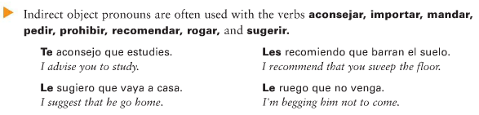
How many subjects do you see in the above examples?
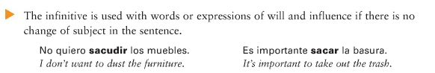

How many subjects do you see in the above examples?
Doubt, denial, desire, demands, impersonal expressions = all subjunctive!
Truth and certainty= not subjunctive!
Unos ejemplos en inglés:
I want John to go to the store.
(The clause "I want" tells us that the speaker feels that there is uncertainty as to whether John goes to the store.)
I hope that John goes to the store.
(The clause "I hope" tells us that the speaker feels that there is uncertainty as to whether John goes to the store.)
It is possible that John will go to the store.
(The clause "it is possible" tells us that the speaker feels that there is uncertainty as to whether John goes to the store.)
It's good that John goes to the store.
(The clause "it's good" alerts us that the speaker is about to express a subjective opinion.)
It's important that John goes to the store.
(The clause "it's important" alerts us that the speaker is about to express a subjective opinion.)
It’s true that John goes to the store = NOT subjunctive!
I know that John goes to the store = NOT subjunctive!

Decide whether the following phrase is a key the subjunctive or the indicative.

- It’s better that____
- It’s urgent that____
- It’s necessary that____
- It’s important to____
- It’s true that____
- It’s good that____
- I want that____
- He demands that ____
- It’s good that ____
- I know that ____
- We insist that____
- He needs that____
- We recommend that___
- They request that___
- It’s important that ____
- It’s important to _____
- It’s necessary to ____
- I want that____
- She begs that____
- We prefer to____
- We prefer for them to____
22.They prefer that____
- I desire to____
- We desire for them to____
- It’s definitely true that ____
- It’s necessary that ____
- It’s sad that _____
- It’s terrible that ______
- I need to ____
- It’s important to spend time with friends ___
- It’s good for her to spend time with friends ____
- It’s sad to lose __________
- It’s sad that they lose__________
- Create your own! ______________________________________

