Nombre: _______________________Español 1 Descubre 1 Lección 2: En La Clase
Check off what you can do after completing this chapter:

- Say what classes you take
- Say what activities you like and don’t like
- Ask questions about other people’s likes and dislikes
- Describe the location of people and things
- Tell time
- Say what you and others do using –AR verb conjugations

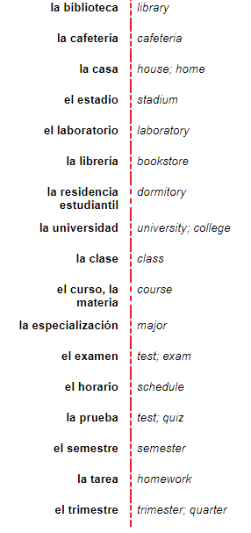
- La escuela (school)
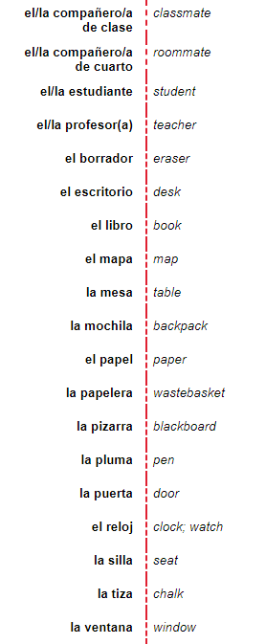

- Las materias (subjects)
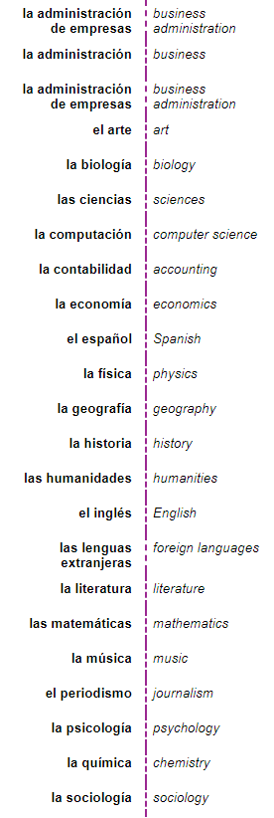
el almuerzo……………………………….. lunch
la clase ……………………………….. the class
la educación física………………………………..gym
los estudios sociales………………………………..social studies

C.Prepositions

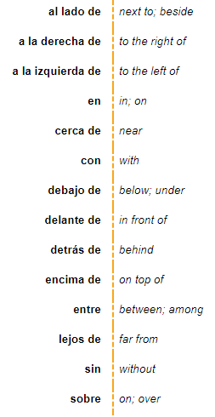

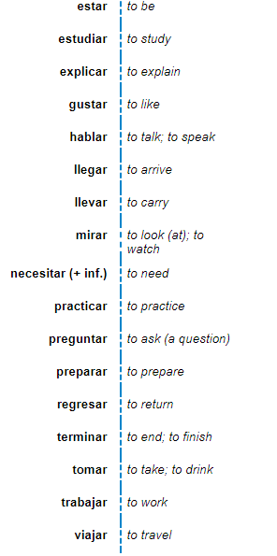
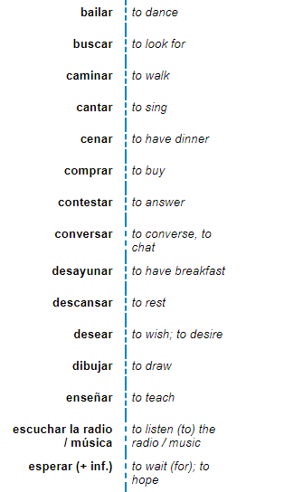
D.Verbos

E.Question words (interrogativas)
(Sing to the tune of Jingle Bells)

¿Por qué? Why,
¿Cuándo? When,
¿Qué? What , ¿Dónde? Where,
¿Cuánto? How much,
¿Cómo? How,
y ¿Quién? means who,
is there ¿HAY?

(verse tune)
¿Adónde? Means to where
¿Cuál? Is which one
¿Cuántos? Means how many too
Now isn’t Spanish Fun! Hey!

F.Telling time and discussing schedules
¿A qué hora (es)...? ………………………………..At what time (is something occurring)) . . . ?(for events and classes, etc)
¿Qué hora es? ……………………………….. What time is it?(RIGHT NOW)
A la(s)... ……………………………….. At . . . o’clock.(to talk about when an event occurs)
Son las..………………………………... It is . . . o’clock (for any time except for 1 o’clock)
Es la una..………………………………... It is one o’clock.
de la mañana……………………………….. in the morning (with a time)
de la tarde ………………………………..in the afternoon (with a time)
de la noche……………………………….. at night (with a time)
la hora……………………………….. hour; time
el horario ………………………………..schedule
menos ………………………………..to, before (telling time)
el minuto……………………………….. minute
...y cuarto……………………………….. quarter past
...y (diez) ……………………………….. (ten) past
...y media……………………………….. half past
por la mañana ………………………………..in the morning (no time mentioned)
por la tarde……………………………….. in the afternoon (no time mentioned)
por la noche……………………………….. at night (no time mentioned)
G. Los números
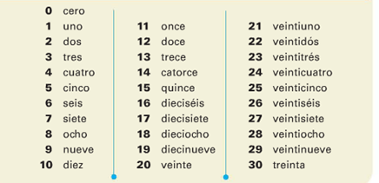

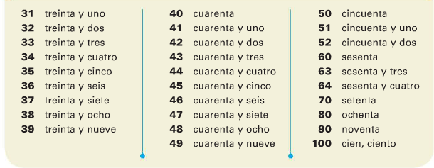

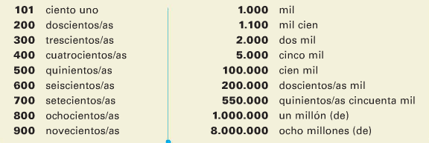

TELLING TIME Useful expressions:
and, plus = y minus = menos
15 minutes (quarter) = cuarto 30 minutes (half) = media
What time is it? = ¿Qué hora es? At what time? = ¿A qué hora?
ONE O’CLOCK: es la una (only for 1:00) + y + minutes
ANY OTHER TIME: son las + hour (when it is two-twelve) + y + minutes
Examples: It is one o’clock. = Es la una.
It is 5:15. = Son las cinco y cuarto / Son las cinco y quince.
It is 7:50 = Son las ocho menos diez.

Escribe en español:

- It’s 6:03 PM. ____________________________
- It’s 2: 15_________________________________
- It’s 7: 20_________________________________
- It’s 1:30 _________________________________

Contesta:
- ¿A qué hora es la clase de ciencias? ______________________________________________
- ¿A qué hora es la clase de español? _____________________________________________
- ¿A qué hora es la fiesta? _____________________________________________
- ¿Qué hora es? _____________________________________________

Gramática:
GUSTAR: Saying what someone likes to do
Me gusta  (means I like/something pleases me ) | Nos gusta  (means we like/ something pleases us)
Te gusta  (means you like / something pleases you) | x
Le gusta  (means he likes, she likes,  you formal like /something pleases he/she you F) | Les gusta  (means they masc like, they fem like, all of you like /something pleases them or all of you)

To say someone DOESN’T Like, just put a NO before the me, te, le, nos, or les.
No me gusta correr = I don’t like to run.
¿Cómo se dice….? Use section D of your paquete.
- I like to draw. Me gusta dibujar
- He likes to sing. Le gusta cantar
- I don’t like to dance. No me gusta bailar
- We don’t like to work! ¡No nos gusta trabajar!
- They like to teach. Les gusta enseñar
- We like to listen to music. Nos gusta escuchar música

If you want to mention the specific person who likes to do an activity, you need to add “a” before that person’s name or title, then the pronoun that goes right before gusta.
Ex: Diana likes to run = First add the A = A Diana
Then add the pronoun that goes with “she” = le gusta
Finally, add the activity: correr.
Put it all together: A Diana le gusta correr = Diana likes to run.
Recipe: A + person + pronoun + gusta + activity.
Same thing if you have a group of people:
My friends like to draw = A mis amigos
Pronoun = les for they
All together = A mis amigos les gusta dibujar.

If you are ANSWERING a question: ¿Te gusta cantar? (Do you like to sing?)
Sí, me gusta cantar (Yes, I like to run)
No, no me gusta cantar = (No, I don’t like to sing = 2 negatives for No and Don’t)

To say whether you like or don’t like an item or more than one item:
Use GUSTA for liking one item or liking an activity Use GUSTAN for liking several items.
GUSTA | GUSTAN
Infinitives: (bailar, dibjuar)  Single items: La clase | Plural items: Las clases  Los chocolates

Ejemplo: I like the clases = Me gustan las clases.
We don’t like tests = No nos gustan los exámenes.
They like the new book.= Les gusta el libro nuevo
Contesta:
¿Te gusta hablar en la clase? Sí, me gusta hablar en la clase
¿Te gusta preparar pizza? Sí, me gusta preparar pizza
¿Te gustan las clases en la escuela? Sí, me gustan las clases en la escuela
¿Te gustan los exámenes? No, no me gustan los exámenes
¿Te gusta la tarea? No, no me gusta la tarea

Notes: __________________________________________________________________________________________________________________________________________________________________________________________________________________________________________________________________________________________________________________________________________________________________________________________________________________________________________________________________________________________________________________________________________________________________________________________________________________________________________________________________________________________________________________________________________________________________________________________________________
AR Verbs! CONJUGATING!
Look at section D (pg 3) of your paquete. What do you notice about the endings of all of these verbs?
Conjugating –AR verbs in the present tense!
Verbos -AR: present tense endings.
-o | -amos
-as | x
-a | -an
Conjugating –AR verbs in the
present tense:
Drop the -AR and add the
appropriate ENDING _______

(yo) HABLO  (I talk, I do talk) | HABLAMOS  (We talk/we do talk)
(tú) HABLAS  (you talk, you do talk) | x
HABLA  (he she you formal talks,does talk) | HABLAN  They /all of you talk, do talk)
hablar = to talk

1. Buscar, tú buscas
2. Hablar, ella habla
3. Escuchar, nosotros escuchamos
4. Mirar, ellas miran
5. Trabajar, yo trabajo
6. Viajar, tú y yo viajamos
7. Enseñar, la maestra enseña

Ahora, escribe en español. To make it negative, put the NO before the CONJUGATED VERB.

8.He studies él estudia
9. They prepare. Ellos preparan
10. We converse. Nosotros conversamos
11. They have breakfast. Ellos desayunan
12. He does buy. Él compra
13. Do you answer? ___¿Contestas tú?
14. We arrive. Nosotros llegamos
15. They don’t walk. Ellos no caminan

16. They need ellos necesitan

