Nombre: _____________________Descubre 2 Capítulo 2: La tecnología
- La Tecnología B. La Computadora
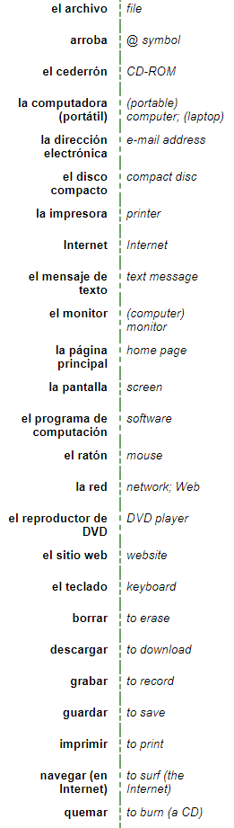
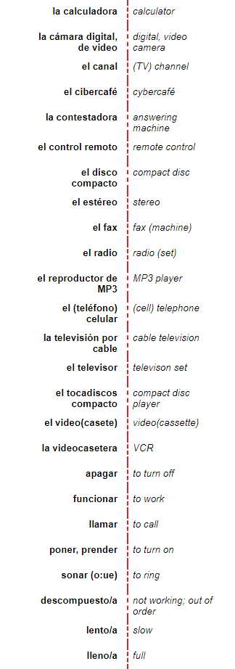

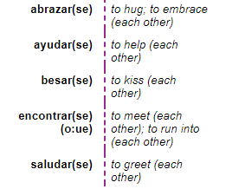
- El Carro D. Verbos
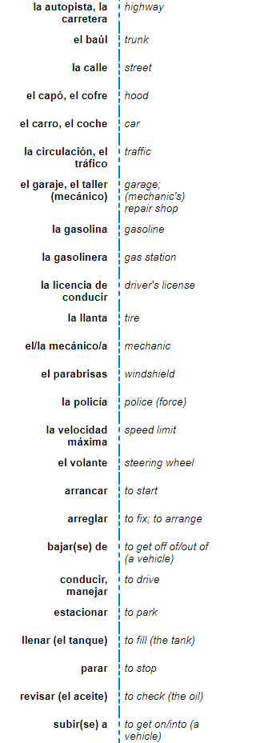

E.Otras expresiones
actualmente | currently/nowadays
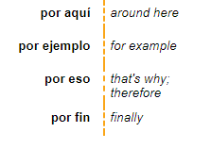

Accentos: why they matter
se vs. sé el vs. él te vs. té porque vs. por qué que vs qué

este vs. éste vs. esté cuando vs cuándo donde vs. dónde

Can you think of any others?
~~~~~~~~~~~~~~~~~Gramática: Reciprocal Reflexives~~~~~~~~~~~~~~~~~~~~~~~~~
What does it mean when something is reciprocated?

You have learned that reflexive verbs indicate that the subject is doing something to themselves. Reciprocal reflexives (los reflexives recíprocos), on the other hand, express a shared or reciprocal action between two or more people or things. In this context the pronouns (nos, se) mean “(to) each other” or “(to) one other”
In Spanish, we can also use reflexive verbs to express the idea of “each other” or “one another.”
*Fun (English) fact:
“each other” technically can only refer to two people =You and I help each other.
“one another” refers to three or more = The students in the class share with one another.
me (won’t be used) | nos
Te (won’t be used) | x
Se (won’t be used) | se
The Spanish reflexives can be used for both of these cases.
The reflexive pronouns are still the same:

Why won’t you use any of the singular column pronouns?
*With reflexive verbs used reciprocally, you will always have a plural ending, because you are referring to more than one person. (each other/ one another).
Here are some verbs that can be used to show reciprocal action:
to hug (each other) |  | to help (each other)
to kiss (each other) |  | to meet/run into (each other)
to greet (each other) |  | to talk to (each other)
to write (each other) |  | to get mad at (each other)
to look at (each other) |  | to see (each other)
to understand (each other) |  | to love (each other)

- Alicia and I know each other well = Alicia y yo nos conocemos bien.
- My grandma and I write to each other ____________________________________________
- Carlos and Paco talk to each other ____________________________________________
- We don’t understand each other ____________________________________________
~~~~~~~~~~~~Gramática: ¡Mandatos! (commands) ~~~~~~~~~~~~
To tell someone to do or not to do something in a stronger way, we use commands. There are many types, but we are going to start with familiar/ tú commands for when you are addressing someone equal to you.
Positive “tú” / informal commands
Commands are used when ordering or telling someone to do something. This is often referred to as the "imperative" form of the verb. In Spanish, a “tú” command is for someone you’re friendly with: family, friends, peers, etc.
- Affirmative / Positive “tú” commands tell the person to do something.

Regular, positive Tú commands are formed by taking the regular él, ella, usted form of the verb.
(hablar - ar + a = habla) (comer - er + e = come) (escribir - ir + e = escribe)
Examples:
Compra (tú) el anillo. Come (tú) la pizza. Escribe (tú) la carta.
(You) Buy the ring. (You) eat the pizza. (You) Write the letter.
To form a Affirmative (positive) Tú command (as in, YES, DO this!):
- Use the él/ella/usted form of the present tense!
If it’s easier:
make regular –AR verbs have an A on the end, and make regular –ER/-IR verbs have an E on the end.
Things to remember:
If you stem-change in the he/she form, you ARE going to stem-change in the command.
Try these! Prepare the food = Prepara la comida.

1. Eat the sandwich. _______________________________
2. Learn quickly. ______________________________
3. Work with a friend. __________________________
4. Play with us! ____________________________
5. Study! ___________________________
6. Come back/return! ______________________________
7. Turn on the computer! _____________________________
8. Erase my name! ____________________________

- Irregular Affirmative Tú Commands : (positive tú)
The difference is that these verbs don’t follow the regular rules above. So if you want to command someone to go, tell, do” then you use these forms. These irregular rules must be memorized.
Infinitive | Affirmative Tú Command
Decir
Hacer
Ir
Poner
Salir
Ser
Tener
Venir
Irregulars:

Way to remember: Vin Diesel has ten weapons, ay! =Ven Di Sal Haz Ten Ve Pon Sé
- Go to the store = Ve a la tienda.
- Be careful! _______________________________
- Be good. _________________________________
- Come to my house. ________________________________
- Tell the truth. _______________________________
- Set the table. ______________________________
- Go to your room! ____________________________________
- Leave from here! _______________________________________
- Do the homework. _________________________________

Negative Tú commands (No! Don’t do it!)
When you want to tell someone NOT to do something, use a negative command.
Negative tú commands are formed by taking the _________ form of the present tense,
dropping the _________, and adding the opposite “tú” ending.

- If you start with an –AR verb, use the –ER/-IR verb ending for “tú.” (-es)
HABLAR Hablo Habl Hables. Final = __________________= don’t talk.
- If you start with an –ER or –IR verb, take the AR verb ending for “tú.” (-as)
ESCRIBIR EscriboEscrib escribas. Final = _____________________ = don’t write.
- If you stem-change or have an irregular yo form, you will still follow that in the commands.
If the yo form is irregular, the same rule applies.
Tener tengo teng Tengas. Final = _____________________ =don’t be scared.
Decir digo ________________________________________________________ = don’t say/tell.
- –Car, -Gar, - Zar also applies here, so that the pronunciation is correct.
car ques gar gues zar ces
- -car examples:
  - Sacar = ¡No saques el libro! (Don't take out the book!)
- -gar examples:
  - Jugar = ¡No juegues con la comida! (Don't play with your food!)
- -zar examples:
  - Almorzar =¡No almuerces! (Don't have lunch!)
  - Cruzar =¡No cruces la calle! (Don't cross the street!)

So remember: rule for positive tú?
- Take the ________________ form of the present tense.
Rule for negative tú?
- Take the ________ form, drop the _______, add opposite ___________ ending (es or as)

Baila, no bailes = dance, don’t dance.
1. Speak more slowly. (hablar) _____________________ más lentamente.
2. Don't speak so quickly. No___________________tan rápido.
3. Write a letter to your mother. (escribir) ____________________una carta a tu mamá.
4. Don't write on the wall. No____________________en la pared.
5. Johnny, sing. (cantar) Juanito, __________________________
6. Johnny, don't sing. Juanito, no _____________________.
7. Open the door. (abrir) ____________________la puerta.
8. Don't open the door. No _____________________la puerta.
9. Begin now. (empezar) ___________________________ahora.
10. Don't begin now. No__________________________ahora.
11. Buy that. (comprar) _______________________eso.
12. Don't buy that. No_______________________eso.
13. Drink the juice. (tomar) __________________el jugo.
14. Don't drink the water. No___________________el agua.
15. Clean the kitchen. (limpiar) ___________________ la cocina.
6. Don't clean the house. No____________________(limpiar) la casa.
17. Take the medicine. __________________ (tomar) la medicina.
18. Don't take the medicine. No____________________(tomar) la medicina.
19. Read the book. _____________________ el libro.
20. Don’t read the magazine. No _________________ la revista.
21. Tell the truth (Decir)______________ la verdad.
22. Don’t tell lies. No ____________ mentiras.
23. Follow the rules. (seguir) _____________________ las reglas.
24. Don’t follow the path. No______________________ el sendero.
25. Look for an answer. ______________________ una respuesta.
26. Don’t look for the treasure. No ______________________ el tesoro.
Irregular Negative Tú Commands :
Some verbs have irregular forms for negative tú commands. None of the yo forms here end in yo, which is why they have special forms. Can you guess which infinitive goes with each command below?
Infinitive | Negative tú command
 | des
 | estés
 | vayas
 | seas
 | sepas

- Don’t be bad. _________________________________
- Don’t go! (irse)________________________________
- Don’t be sad. _______________________________
- Don’t be mean! _______________________________

Combinación: Watch for irregulars!
      - Go, don’t go _______________________________________________________
      - See, don’t see _______________________________________________________
      - Be, don’t be (estar) _______________________________________________________
      - Be, don’t be (ser) _______________________________________________________
      - Give, don’t give _______________________________________________________
      - Look for, don’t look for _______________________________________________________
      - Take out, don’t take out _______________________________________________________
      - Cross, don’t cross _______________________________________________________
      - Pay, don’t pay _______________________________________________________
10.Play, don’t play _______________________________________________________
11. Order, don’t order _______________________________________________________
12. Serve, don’t serve _______________________________________________________
13. Start, don’t start _______________________________________________________
14. Close, don’t close _______________________________________________________

~~~~~~~~~~~~~~~~~~~~Por vs. Para~~~~~~~~~~~~~~~~~~~
Both can mean for, but when do you use them?
POR | PARA
- Explanations (often means on behalf of, in favor of, instead of.)  Compré el regalo por Maria. (instead of her buying it)  El habló por el presidente. (on behalf of, in place of) | 1. Destination or purpose  Salieron para la universidad.(They left for college)  Este regalo es para ti. (The gift is for you!)  Estudia para abogado (same as “para ser abogado” = to be a lawyer)  Compré el regalo para María.  Es una caja para dulces. (The box is for the purpose of holding candy)
- Errands: Used to show the reason for an errand.  El niño fue por agua. (will return) | - In order to  Necesito gafas para leer.  Trabaja para ganar dinero.
3. Movement: (passing through, along, around)  Viajaron por España  Entré por la ventana.  Caminó por el pasillo. | - Destination in time/ due date  Necesito la tarea para mañana.  (due date)
4.Period of time/Duration: (how long, move through)  Bailaron por tres días! | - Comparison of inequality/stereotype  Para cubano, habla muy bien el inglés. (For a Cuban, he speaks English really well. You didn’t expect him to speak so well).  Es informal para reina* (you’d expect her to be formal since she’s a queen, but she’s not)  * for + profession, in Spanish, leave out the “a.” So just “para doctor”
5.Manner, Means, Motive (way)  La llevaba por la mano. (by the hand)  La carta llegó por correo. (by mail)  Lucha por la libertad. (for liberty = reason, NOT destination)  ALSO: Gracias por la ayuda. | 5. Estar para: (to be about to, to be ready to)  Estoy para salir.( I’m ready to leave.)  Está para llover. (It’s about to rain)
- Estar por:  (To be inclined to, to be in the mood to)  Estoy por salir.  Está por divertirse. | 6.Personal preference:  Para mí, la clase es fácil. (To me / For me, the class is easy!)
- Indefinite / General time or place
Van a estar aquí por diciembre. (They will be here around December)
Las llaves están por aquí.
(The keys are around here)

Por | Para
8. Por + infinitive= what REMAINS to be done: Queda mucho por pintar: There is a lot left to be painted.
9. In exchange for: Me dio cien dólares por mi collar.
10. Opinion or estimation that was wrong:
Lo tomé por intelectual: I took him for an intellectual (He WAS NOT)
11. Indicate measure or number: Los venden por docenas (They sell them by the dozen).
Vuela a 100 millas por hora (miles per hour)

Acronym that some find helpful: PERFECT PARA.
Purpose: Pongo lentes PARA ver mejor.
Express opinión: PARA mí, el chocolate es más rico que nada.
Regalo: Giving gift to someone: ¡Este regalo es PARA ti!
Future Destination: Francisco toma el avión PARA México.
Expected date: Termina la tarea PARA mañana.
Compare: PARA maestro de química, no sabe nada de veneno.
To “in order TO” Tienes que estudiar PARA mejorar en español.
¡Práctica!
- Decide si la frase necesita POR o PARA. No tienes que escribir más de la palabra POR o PARA
- My parents should be arriving sometime in July. ___
- Is the homework due tomorrow? ___
- I took you for my friend! ___
- My keys have to be around here somewhere! ___
- The thief came in through the window. ___
- We went to Florida by way of Georgia. ___
- Are the students arriving by plane? ___
- Hurry! The train is about to leave! ___
- For a celebrity, he’s pretty hideous. ___
- My friend is studying to be a lawyer. ___

Escribe POR o PARA en el espacio.
- El hombre vende las manzanas _______ diez pesos.
- _________ ser un actor de comedia, no cuenta chistes muy cómicos.
- ¿Cuánto pagaste __________ el libro?
- Necesito el papel __________ el jueves.
- Si estás enfermo, yo puedo comprar el libro _________ ti.
- Feliz cumpleaños, este suéter es __________ ti.
- Voy a pasar _________el parque esta tarde.
- No podemos salir esta noche __________ la lluvia.
- _________ mi padre, trabajar es importante.
- Te tomé ___________________ una buena persona
- Estudio _________________ sacar buenas notas.

~~~~~~~~~~~~~~~~~~~~~~~~~~Possessive Adjectives~~~~~~~~~~~~~~~~~~~~~~~
The below is from Spanish 1.
My (singular)  My cat=  My (plural)  My cats= | Our (singular)  Our house=  Our (plural)  Our houses=
Your (singular)  Your dog=  Your (plural)  Your dogs= | x
His (singular)  His book==  His (plural)  His books=  Her (singular)  Her book=  Her (plural)  Her books=  Your formal (singular)  Your book (sir)= your books sir _____________ | Their (singular)  Their class=  Their (plural)  Their classes=  All of your (singular)  Your homework=  All of your (plural)  Your homeworks=

~~~~~~~~~~~~Stressed possessive adjectives and possessive pronouns~~~~~~~~~~~~~~~~
If you want to stress who owns something, like “it’s MINE” or “that dog of yours,” you have a few other adjectives to use.
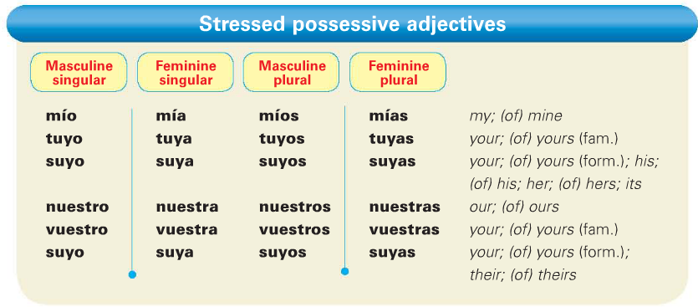
    - Juliana is a friend of mine = Juliana es una amiga mía.
    - That book is yours? ¿Ese libro es tuyo?
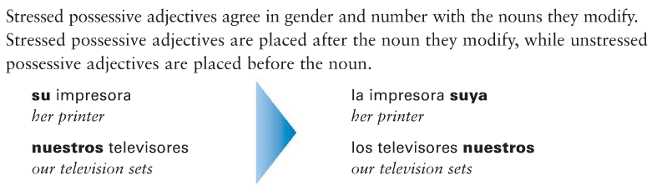
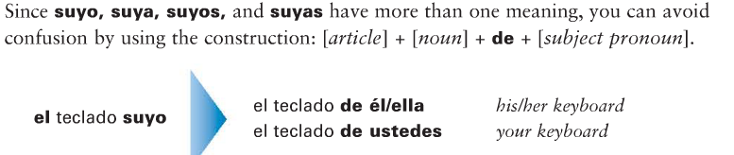

Correct the statements below so that we know whose is what! Watch for gender and number.
- Ejemplo: ¿La calculadora es tuya? (his) No, es suya. (The calc is yours? No, it’s his.)
- ¿Las contestadoras son tuyas? (ours) ___________________________________
- ¿La cámara digital es nuestra? (mine) ___________________________________
- ¿Las llantas son nuestras? (yours) ___________________________________

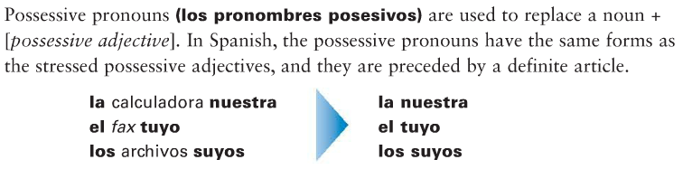

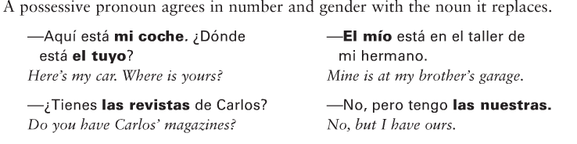
Escribe en español usando los pronombres posesivos.
- Las computadoras de nosotros = las nuestras
- El perro del chico = el suyo
- El coche de mí = ________________
- El medicamento de ti = _______________
- La gasolina de nosotros = _______________
- Los controles remotos de las chicas ____________________
- La comida de nosotros ____________________________
- La clase de ella __________________________

