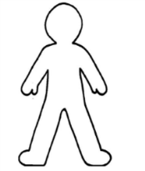
Me llamo _______________________ Español 2 Descubre 2 Lección 1: En el consultorio (At the Doctor’s Office)
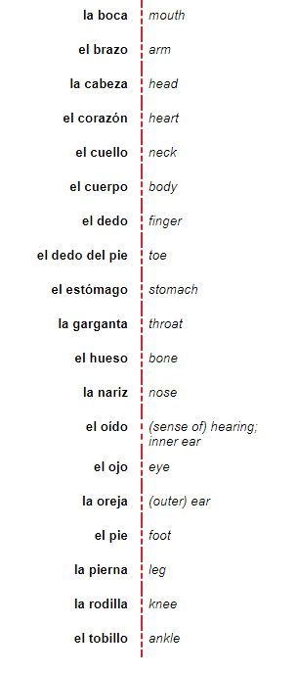
- El cuerpo: The body B. La salud (health)
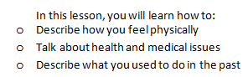
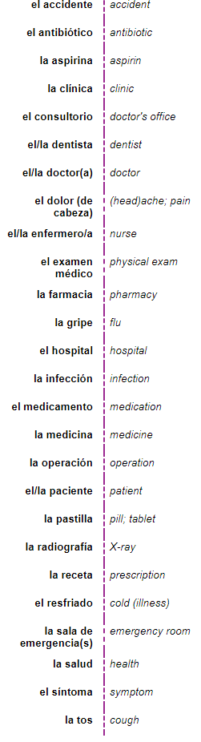

C. Los Verbos
Note that to drop (to let fall) is DEJAR CAER.
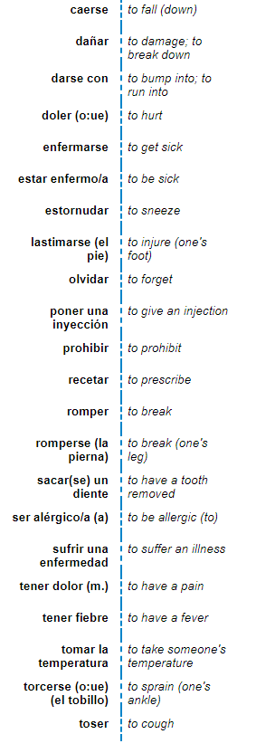
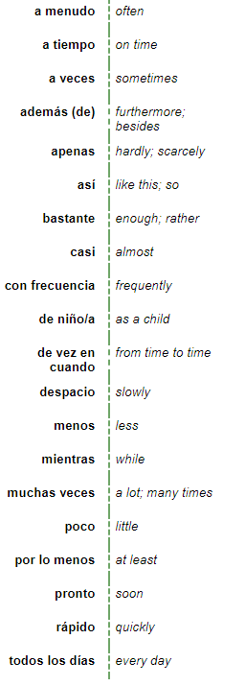
D. Los adverbios

E. Adjetivos _____________

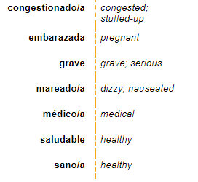

~~~~~~~~~~~~~~~~Gramática~~~~~~~~~~~~~~~~~~
Me duele la cabeza
Me duelen los pies.
- DOLER = to _____________
What kind of verb is DOLER? 1. ______________________
And 2. __________________________
How to use DOLER:
1. Decide who is being hurt
(that’s me, te, le, nos , les)
2. Decide what part of the body is doing the hurting (el brazo, los pies)
3. Conjugate doler for the part(s) of the body.
4. All together = pronoun, verb, body part.
5.Me duelen los pies. = My feet hurt (me).
1.Your eyes hurt = ____________________________________________
2. My arm hurts. ____________________________________________
3. Her throat hurts. ____________________________________________
You can specify who is being hurt by putting “A” and the person’s name before the pronoun( me te le nos les).
4. My mom’s ear hurts ______________________________________________
- Leer mi mente: ¡Vocabulario!
Choose a vocab word from sections A and B that might work as an answer to the definitions.
- Tiene tu cerebro adentro _________________________________________
- El lugar a donde vas para una visita rutina o cuando estás enfermo _____________________________
- Se usa para tirar la pelota _________________________________________
- La persona en el consultorio que toma la temperatura y la presión, no es un doctor ________________
- Lo usas para oler las flores _______________________________________
- Vas a su oficina para limpiar los dientes, o cuando te duelen los dientes ______________________
- El lugar a donde vas cuando tienes una emergencia ____________________________
- La parte de tu cuerpo donde te pones collares _____________________________
- Usas estas partes del cuerpo para contar y para tocar instrumentos _______________________________
- Puedes sentirte el amor _____________________________________
- Cuando tienes la gripe, te duele. Es difícil hablar _________________________________________
- El lugar a donde vas para obtener/conseguir la receta _________________________________________
- Existen dentro de tu cuerpo. Son blancos (esqueletos) _________________________________________
- La persona enferma en el hospital _________________________________________
- Lo que tomas para combatir tu enfermedad _________________________________________
- Son partes (feas) de tus pies _________________________________________
- La parte de tu pierna que se dobla (bends/folds) fácilmente _________________________________________
- Cuando te hacen cirugía _________________________________________
- Después de comerla, tu comida espera aquí para digestión. _________________________________________
- Se usa (one uses it) para hablar y comer _________________________________________
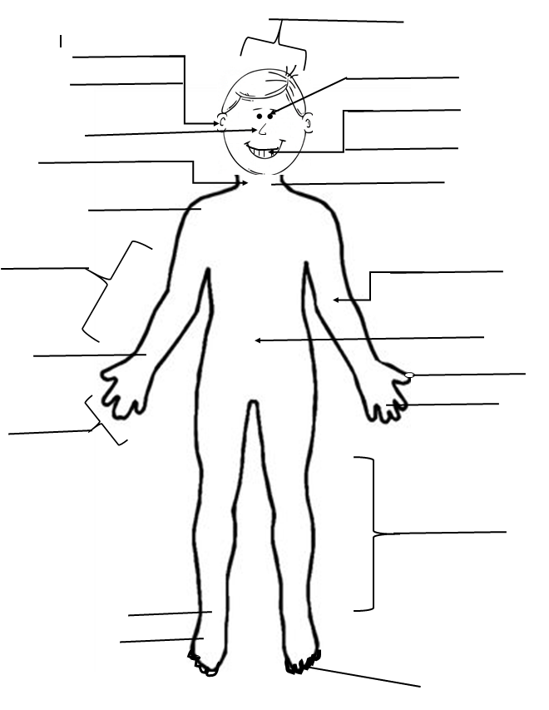
- Formas diferentes de medicamento: __________________________________________
D. Las partes del cuerpo:
[Type a quote from the document or the summary of an interesting point. You can position the text box anywhere in the document. Use the Drawing Tools tab to change the formatting of the pull quote text box.]
[Type a quote from the document or the summary of an interesting point. You can position the text box anywhere in the document. Use the Drawing Tools tab to change the formatting of the pull quote text box.]

Los verbos reflexivos:
Which of the verbs to the left are reflexive? How do you know?
________________________________________________________________________________________________________
____________________________________________________
The Me, te, se, nos, and se are all ways that the reflexive pronoun “se” is changed to match the subject.
The ending of the verb and the reflexive pronoun will always match!
I do to, at, for me/myself =ME | We do to, at, for ourselves =NOS
You do to, at, for you / yourself = TE | x
He she you (f) does to, at, for himself/herself/yourself (f)= SE | They do/all of you do to, at, for themselves/all of yourselves = SE
Remember…..recuerdas….
Bañarse:
(yo) me baño
(I bathe myself)

Más reflexivos:
Which tense do you think you will most likely use for the verbs torcerse el tobillo, enfermarse, and lastimarse?
Escribe en español:
- You get sick in the winter. (Tú)Te enfermas en el invierno.
- I get sick in the spring. ________________________________________________________
- I always used to get sick/ always got sick in the spring.
__________________________________________________________________________________
- I got sick last week. ____________________________________________________________________________

- He broke his leg ________________________________________________________________________________
El pretérito: Repaso
Regular endings:
é | amos
aste
ó | aron
í | imos
iste
ió | ieron
-AR -ER/-IR

In the yo form preterite:
-car __________________ -gar __________________________ -zar _______________________
- Nadar, yo ___________________________ ella ___________________________ ustedes _________________________
- Buscar, yo ___________________________ ella ___________________________ ustedes _________________________
- Comer yo ___________________________ ella ___________________________ ustedes _________________________
- Vivir yo ___________________________ ella ___________________________ ustedes _________________________
- Entender yo _________________________nosotros _____________________ ustedes _________________________
- Comenzar yo _________________________nosotros _____________________ ustedes _________________________
- Jugar yo _________________________nosotros _____________________ ustedes _________________________
- Cerrar Tú _________________________nosotros _____________________ ustedes _________________________
- Sacar yo _________________________nosotros _____________________ ustedes _________________________
- Dormir Tú _________________________nosotros _____________________ ustedes _________________________
- Servir Tú _________________________nosotros _____________________ ustedes _________________________
___________verbs are the only verbs that can stem-change in the preterite. They can only stem change in the 3rd person(sandalia) and they change to just ONE letter: U or I.
Stem-changing Verbs= Verbs ending in –ir that have a stem change in the present tense change from:
o->u
e->i
in the forms of él/ella/usted and ellos/ellas/ustedes.
Stem-change | Stem -change

- Dormir
Nosotros ______________________
Ellos ______________________
- Divertirse
Yo ______________________
Nico ______________________
- Pedir
Tú ______________________
Uds. ______________________

- Seguir
Ale y yo ______________________
Ella ______________________
- Preferir
Yo ______________________
Silvia ______________________
- Vestirse
Nosotros ______________________
Ana y Juan_____________________
Irregular preterite:

i-Stem Verbs
hacer
Querer
Venir

u-Stem Verbs
Haber
Poder
Poner
saber

uv-Stem Verbs
Andar
Estar
tener

Preterite Endings for these Verbs:

-----------------------------------------------------------------------------------------------------------------------------------------

j-Stem Verbs

Decir
Traer
conducir

Preterite Endings for these Verbs **ellos**

-----------------------------------------------------------------------------------------------------------------------------------------
Escribe la forma correcta del verbo en el pretérito
Ver, yo_____________________ ellos _________________________________ nosotros _____________________________
Venir, yo____________________ ellos _________________________________ nosotros _____________________________
Querer, él ___________________________ ellos _____________________________ nosotros _____________________________
Ser, usted ___________________________ ellos _____________________________ nosotros _____________________________
Decir, usted ___________________________ ellos _____________________________ nosotros _____________________________
Poder, tú ___________________________ to _____________________________ nosotros _____________________________
Estar, yo ___________________________ ellos _____________________________ nosotros _____________________________
Poner, ella ___________________________ ellos _____________________________ nosotros _____________________________
Saber, usted ___________________________ tú _____________________________ nosotros _____________________________
Escribe una oración en el pretérito:

- Yo / andar en bicicleta ___________________________________________________________
- Ellos / querer comer chocolate_____________________________________________________
- Tú / poder correr en el partido_____________________________________________________
- Alfredo / conducir la camioneta____________________________________________________
- Mis padres / traer la tarjeta de crédito_______________________________________________
- Usted / decir que era hora de comer________________________________________________
- Lupe y Martin / hacer una excursión________________________________________________
- Nosotros / tener que sacar dinero__________________________________________________
- Yo / estar en la tienda ___________________________________________________________
- Mi madre/ saber la verdad________________________________________________________
- La guía / venir del sendero________________________________________________________
- Tú y yo / poner el kayak en al lago__________________________________________________

Escribe las formas en el pretérito
Dar Ver

Ser/Ir

Escribe una oración en el pretérito.

- Yo / ir / pharmacy______________________________________________________
- Los pacientes / ver / pills __________________________________________________
- Mi tío y yo / dar / prescription ___________________________________________________
- El hospital / ser/ fantástico __________________________________________________________
- X-rays / ser / rápido ____________________________________________________________
- T$ú$ / ir de vacaciones ____________________________________________________
- Yo no / ver/ la doctora __________________________________________________________
- Tú / dar la medicina______________________________________________________

The Imperfect Tense
The imperfect tense is another past tense in Spanish. You use the preterite to tell about completed actions in the past. The imperfect is used to describe habitual actions in the past, things you always used to do, or what continuing action was occurring before an interruption.
The imperfect is used to describe something that was not perfected or not completed in the past. You
use it to…
- say how old someone was
- tell what time it was
- tell what the weather was like
- talk about something that was happening (continuous action in the past
- talk about something you used to do
FORMATIONS! Rule: take the infinitive, drop the -AR, -ER, or -IR, and then add these new endings!
Regular verbs in the imperfect take these endings:
AR: -ER/-IR: (same endings!)

Trabajar Escribir

Querer:

Iba
Only three verbs are irregular in the imperfect!
era
veía
Ser: Ir:

Ver:
Los USOS DEL IMPERFECTO
Cuando yo era niña, íbamos a la playa. = When I was little (continuous action), we used to go (habitual action) to the beach.
You don’t see the beginning of the speaker being a young child, so you use the imperfect. The íbamos form for Ir (to go) implies that it was a usual/habitual/customary action that occurred in the past.
Notice that there is no WORD for “used to.” Instead, you get this connotation from using the imperfect tense.
Try these!
- Yo siempre _________________ (played) a los deportes.
- Cuando yo _________________ niña, mis hermanos y yo ________________(spent) mucho tiempo juntos.
- Las chicas ____________________(watched) muchas películas.
- Mi familia ______________________ (went/used to go) a la playa todos los veranos.
- Las estudiantes ___________________ (were) muy contentas en la escuela.
- Cuando mi padre ______________ (was) joven, _______ (he was) alto y __________ (had) pelo castaño.
- Mi madre siempre nos ______________ (read) cuentos antes de dormir.
Contesta en español:
- ¿Dónde vivían tus abuelos? _______________________________________________________
- ¿Adónde iban tú y tu familia en el verano? ____________________________________________________________________________________
Preterite vs. Imperfect
You have learned two verb forms used for the past tense: the preterite and the imperfect. How do you know when to use each one?
You really need to picture the situation. Do you see a specific beginning or ending? If so, use the preterite for that verb. A las cinco, yo empecé mi tarea. =At 5, I started my homework.
If it’s a continued action in the scene, use the imperfect.
The people were afraid = Las personas tenían miedo. (you don’t see the start of the people being scared)
You can apply both tenses to talk about two overlapping events.
• the imperfect for what was going on at the time (continued event)
• the preterite for the action that occurred or interrupted.
My friend called. ( (interruption)

When I was studying, my friend called me.
Cuando yo estudiaba, mi amiga me llamó.
(While I studied/when I was studying) continued action)

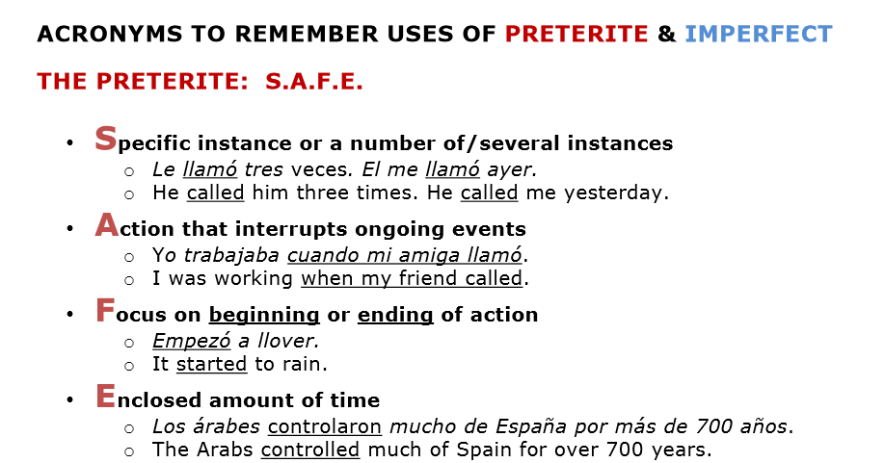

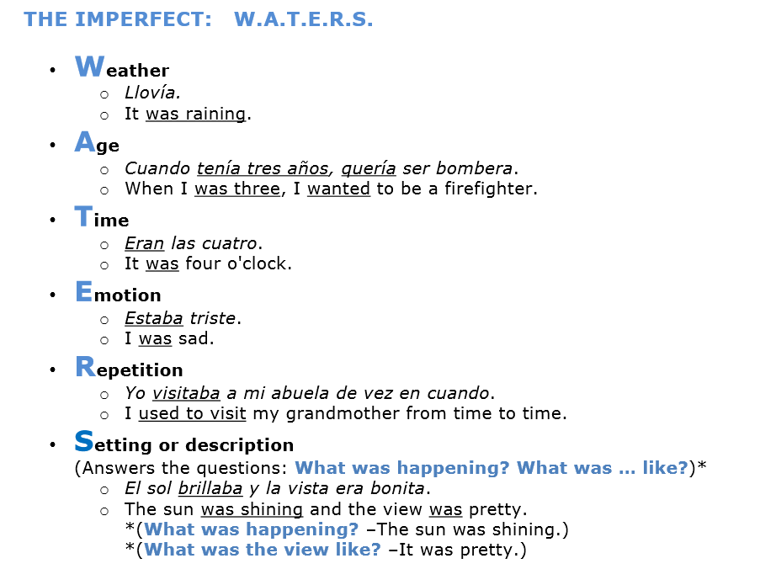

For each verb, write a P if the tense should be preterite and an I if the tense should be imperfect.
- During college, I always studied and partied a lot.
- I didn’t use a calculator on the homework last night.
- My family supported the governor in all the elections.
- We were fundraising for cheer when we heard the news.
- I was enjoying a walk in the park when it started to rain.
- All of the students worked hard every day.
- My family and I would always make sundaes every summer.
- We used to date.
- We were friends back then, but we stopped talking.
- We were on our way to the party when my dad called.
- I was climbing trees when I fell.
- While my mom made dinner, I studied a lot.
- Last night I talked to my boyfriend for 3 hours.
- The spoiled child would cry when he didn’t get the toy he wanted.
- Why did you throw trash in the street?
- I bought lunch yesterday.
- I was buying my lunch when the bell rang.
- When I was little, we used to live in Bellevue.
Based on the above sentences, what kinds of words trigger the use of the imperfect? _________________________________________________
Based on the above sentences, what kinds of words trigger the use of the preterite? _________________________________________________
Phrases that trigger the imperfect tense: _________________________________________________
Phrases that trigger the preterite tense: _________________________________________________

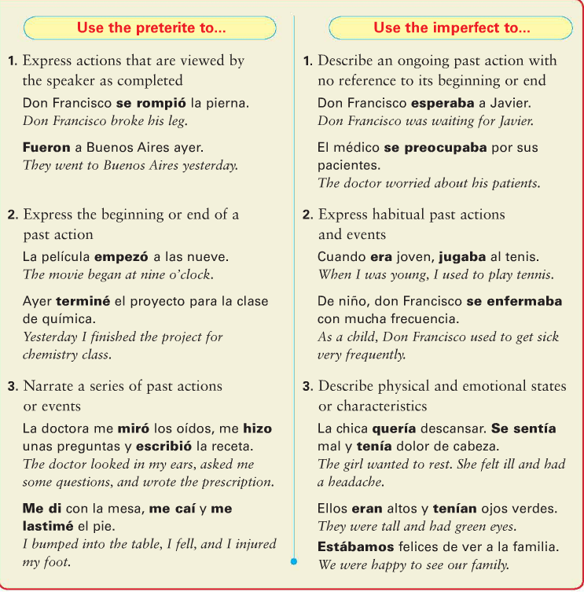
Apuntes: ________________________________________________________________________________________________________________________________________________________________________________________________________________________________________________________________________________________________________________________________________________________________________________________________________________________________________________________________________________________________________________________________________________________________________________________________________________________________________________________________________________________________________________________________________________________________________________________________________________________________________________________________________________________________________________________________________________________________________________________________________________________________________________________________________________________________________________________________________________________________________________________________________________________________________________________________________________________________

~~~~~~~~~~~~~~~~~~~~~~~~~~¡ADVERBIOS!~~~~~~~~~~~~~~~~~~~~~~~~~~~
Adverbs in Spanish!
Adverbs describe an action. In English, adverbs tell when, where, how, how long, or how much.
In English, many adverbs end in -ly.
In Spanish, many adverbs end in –mente.
In Spanish, adverbs can be formed by:
- Starting with the feminine form of the adjective (fabuloso fabulosa)
- adding -mente to the singular feminine form (fabulosamente)
- adding -mente to the singular form if it ends an E or a consonant (L or Z etc) (facilmente)
- If the adjective has an accent, the adverb does as well.
rápido → rápida: Ricardo corre rápidamente. Ricardo runs quickly/rapidly.
Frecuente + mente = Competimos frecuentemente. = we compete frequently.
Fácil + mente = Hice la tarea fácilmente. I did the homework easily.
alegre frequente preocupado fácil lento activo rápido serio contento tranquilo triste perezoso

- Usa una de los adjetivos en la caja para crear una oración con un adverbio nuevo.
Modelo: estudiar ciencias = Anoche, yo estudié ciencias seriamente.
1. terminar mi almuerzo _______________________________________________________
2. planear la fiesta________________________________________________
3. Participar en la clase _______________________________________________________
4. El señor /perder sus lentes _______________________________________________________
5. Tomar el examen _______________________________________________________
6. comer un pastel de chocolate _______________________________________________________
7. Decir adiós a sus amigos _______________________________________________________

HACE… QUE…
Constructions with HACE QUE PRESENT:
Use “hace (time period) que” to describe what’s been going on or what happened some time ago:
- To describe how long something has been going on, use:
- hace + the period of time + que + the present tense
- Hace dos años que estudio español=
- It makes 2 years that I study Spanish (I’ve been studying Spanish for 2 years)
In this sentence, it’s implied that the speaker is still doing the activity, in this case, still studying Spanish.
With a question, you just add the idea of “how much time?”
- cuánto tiempo + hace + que + the present tense
- ¿Cuánto tiempo hace que sales con ella? (how long have you been going out with her?)
- ¿Cuánto tiempo hace que estudias español?
- How much time does it make that you study Spanish?
Try these!
Escribe en español:
- I have been studying for 2 hours. (It makes 2 hours that I study) _______________________________________________________________________
- We have been sick for one week. _______________________________________________________________________
- How long has your mom been at the doctor’s office? _______________________________________________________________________
Contesta en español:
- ¿Cuánto tiempo hace que juegas tu deporte favorito? _______________________________________________________________________
- ¿Cuánto tiempo hace que eres amigos con tu mejor amigo? _______________________________________________________________________

Constructions with HACE QUE PAST:
- When you want to express the idea of “ago,” you use the preterite tense of the verb.
- Hace +amount of time + que + preterite verb
- (you can also switch the order to “preterite verb + hace + time without a que!)

I met Juan 5 years ago. = Hace 5 años que conocí a Juan. OR
Conocí a Juan hace 5 años.

He finished that book many years ago = Hace muchos años que terminó el libro OR
Terminó el libro hace muchos años

To ask how long ago did something happen, you use the same format as before:
- ¿Cuánto tiempo + hace + que + the preterite?
- How long ago did you go to Mexico?
- ¿Cuánto tiempo hace que fuiste a México?
Try these: (you may have to reword this so it sounds like “it makes ___ time that verb)
Escribe en español:
- I went to the doctor’s office three days ago. ______________________________________________
- How long ago did you visit Hawaii? ______________________________________________

Contesta en español:
- ¿Cuánto tiempo hace que visitaste a tus abuelos? ______________________________________________
- ¿Cuánto tiempo hace que te rompiste un hueso? ______________________________________________
- ¿Cuánto tiempo hace que saliste a cenar con tu familia? _________________________________________

El “se” impersonal
​In English, we see impersonal expressions all around us. For example, you might see a sign that says “Drivers needed,” “books sold here,” or “house for sale.” We don’t exactly know who specifically is selling something or needing something, but we get the idea.
In Spanish, you can use the pronoun ​ se ​ in order to avoid ​​specifying the person who is doing the action of the verb.
If you are talking about an infinitive or singular noun, use the él/ella ​/usted form of the verb:
Se vende apartamento = apartment for sale/ apartment rented here.
Se habla español = Spanish is spoken here.
If you are talking about a plural item, you use the ellos/ellas/ustedes ​form. ​​
Se venden libros = books sold here
Try these!
- Vender / coche _______________________________
- Necesitar / hispanohablantes _______________________________
- Buscar / conductor _______________________________
- Reparar /carros _______________________________

Escribe en español:
- House for rent (use alquilar) ________________________________
- Necesitar / medicines _________________________________________________________
- Bicycle for sale __________________________________
- Workers needed _________________________________________________________
- Spanish is spoken _________________________________________________________
- Vender /iphones _________________________________________________________
To express ONE SHOULD (do something) you can say, Se debe (verb).
One should eat vegetables = Se debe comer verduras.

You also can use “SE” for certain expressions in Spanish that allow you to express something that was unplanned/allow you to get out of the responsibility. For example, in Spanish, you didn’t forget your homework, it forgot itself to you! = Se me olvidó la tarea
I let fall the pencil = Dejé caer el lápiz. (I dropped the pencil)
The pencil fell (itself) to me, I didn’t drop it (not my fault!)= Se me cayó el lápiz.
- I forgot my book =The book forgot (itself )to me = ______________________________________________
- I dropped my phone = the phone fell (itself) to me ______________________________________________
- You dropped your papers =the papers let themselves fall to you = ______________________________________________

