Nombre:_________________________ Español 3: Capítulo 15: Gente que se divierte
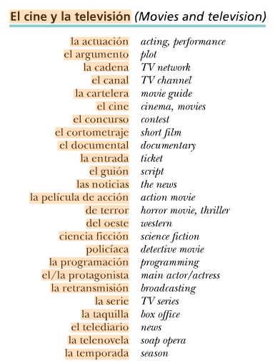
A.
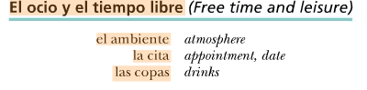
C.
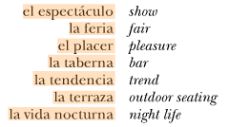

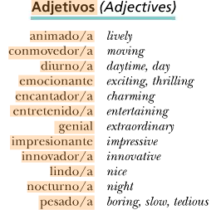
D.

B.

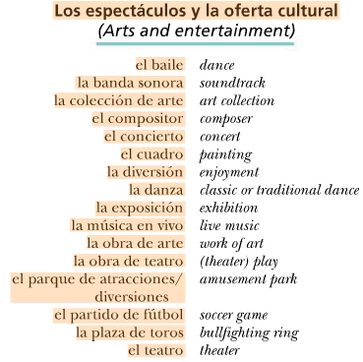
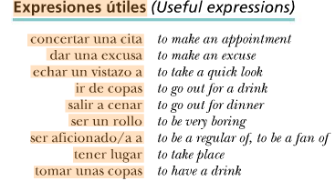
E.

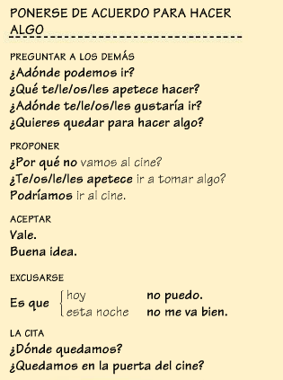
F. G.
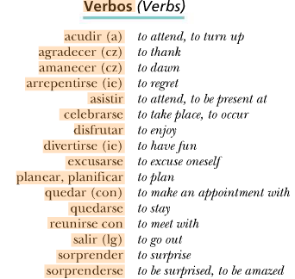

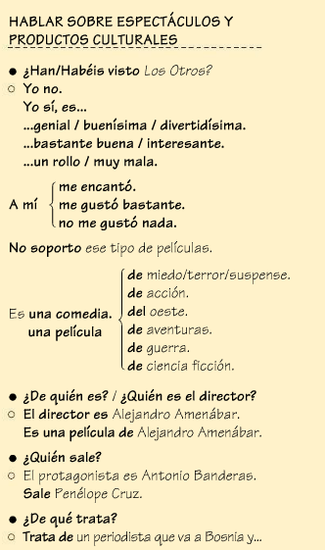
H.

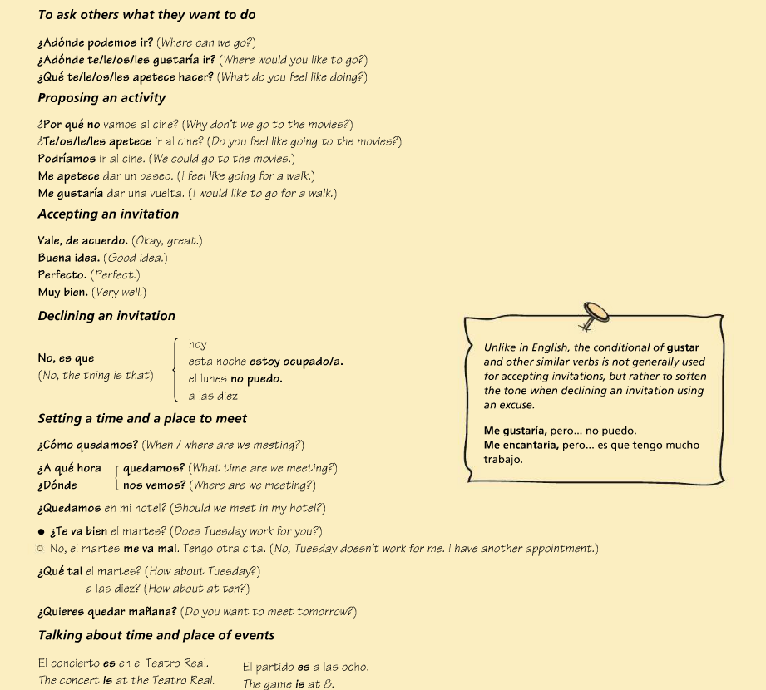

¡EL SUBJUNTIVO!
The subjunctive is a mood, not a tense. It is used with expressing wishing, wanting, hoping, doubt, uncertainty, probability, and some opinions. There are more uses, but in this chapter we will just be focusing on the use of the subjunctive for expressing opinion, probability, and doubt.
“The subjunctive is not a tense; rather, it is a mood. Tense refers to when an action takes place (past, present, future), while mood reflects how the speaker feels about the action. The subjunctive mood is rarely used in English, but it is widely used in Spanish.” (http://www.studyspanish.com/lessons/subj1.htm)
Here are some examples of the subjunctive being used in English:
1.The doctor recommends that he take the pills with food.
Subjunctive conjugation: _________
2.The law requires that you be 18 years old to vote.
Subjunctive conjugation: _________
3.My mom wants me to go to the store. (rephrase using “that” to help get your mind around the subjunctive)
Subjunctive conjugation: _____
I doubt he is at work right now.
Subjunctive conjugation: _________

So now, USING the subjunctive with doubt, probability, or opinion:
You will have an expression of doubt, probability/uncertainty, or opinion in the main clause of the sentence which will act as the trigger or key, opening the door of the subjunctive.
“trigger/key”+que + new subject + present subjunctive of the verb
It’s possible that you ( will) study. (are you definitely studying? No. This person speaking is expressing a possibility that may not happen. You can’t say “estudias” because that means you definitely study. The subjunctive is going to open up the idea that there is no guarantee here).
ALSO: notice that in English we add the word “will” to this kind of expression. You do NOT use the future tense for this. It’s just subjunctive.
I doubt he will go =Dudo que él vaya = NOT future tense!!

In Spanish: Es importante que tú estudies.
It’s important that you study (for you to study)
Sometimes in English we don’t say things exactly grammatically correct(ly), so sometimes instead of “that” we use “for (subject) to.”

It’s necessary for you guys to get good grades on this quiz = what you are really saying is
“it is necessary that you all get good grades on this quiz.”
Es necesario que ustedes saquen buenas notas en esta prueba.

Subjunctive recipe:
Subjunctive trigger + QUE + new subject + subjunctive form of the next verb

Doubt, denial, desire, demands, impersonal expressions = all subjunctive!
Some expressions will not need the subjunctive….why don’t these need the subjunctive?
- It’s true that Spanish class is awesome.
- It is obvious that there is snow outside.
- There is no doubt that the students have played in the snow.
THE FORMATION OF THE PRESENT SUBJUNCTIVE:
Step 1: take the yo form of the verb. (irregulars included)
Step 2: Drop the o.
Step 3: Add the opposite ending (-AR verbs get ER endings, -ER/-IR verbs get –AR endings)
Remember, since you are switching endings, the –car, -gar, -zar rules apply!
Take the yo form, drop the O, add the opposite ending.
Tomar = Tomo, drop the o, switch endings, this will get “e” all the way through:
Tome, tomes, tome, tomemos, tomen
Coma | Comamos
Comas
coma | coman
Hablar: Comer:
Hable | Hablemos
Hables
Hable | hablen

Escribir:
Escriba | escribamos
escribas

haga | hagamos
hagas

Hacer:
For -ar and -er stem-changing verbs, the formula applies except that
there is no stem change in the nosotros form ( same as commands!! )
Poder: Empezar:
Pueda | podamos
puedas
empiece | empecemos
empieces

For -ir stem-changing verbs, the stem change in the nosotros form follows these patterns:
o ue verbs change o u; eie verbs change e i; e:i verbs change e i.
Remember dormir and durmiendo?
Dormir: Sentir:
Sienta | sintamos
sientas

Duerma | dormamos
duermas

Buscar: Llegar:
busque | busquemos
busques
Llegue | lleguemos
llegues

almuerce | almorcemos
almuerces
Decir: Almorzar:
diga | digamos
digas

Irregulars: DISHES!
Dar- dé________________________________________
Ir - vaya________________________________________
Ser- sea ________________________________________
Haber – haya ________________________________________
Estar-esté ________________________________________
Saber- sepa ________________________________________
(Ver is not considered irregular but it becomes VEA)
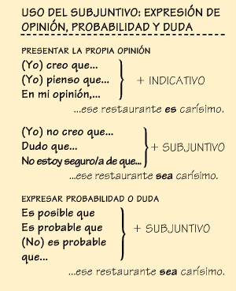
Apuntes: ________________________________________________________________________________________________________________________________________________________________________________________________________________________________________________________________________________________________________________________________________________________________________________________________________________________________________________________

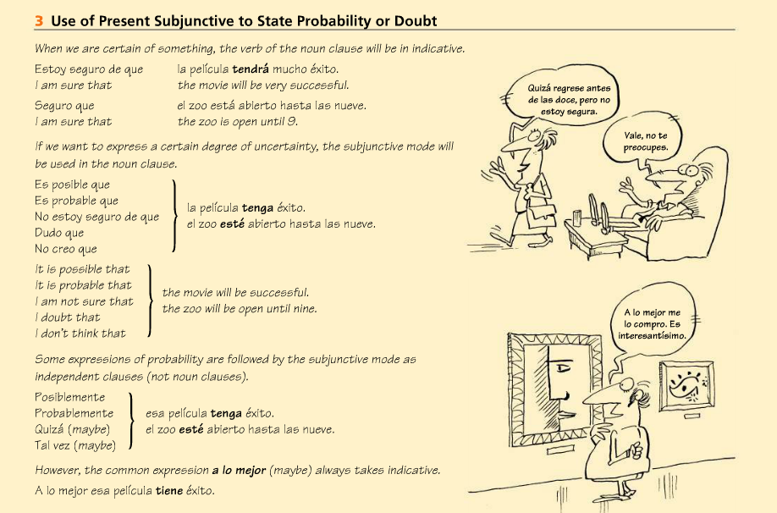

- Decide si la frase necesita “S” para elsubjuntivo o “I” para el indicativo.

- I doubt that____
- We don’t think ____
- We think ____
- I know that ____
- I’m sure that___
- It’s definitely true that ____
- It’s likely that ____
- It’s certain that _____
- I believe that ______
- You don’t doubt that ____
- It’s not probable that ___

In order for the subjunctive to be used in noun clauses, three conditions must be met:
- The sentence must contain a main clause and a subordinate clause (this is a clause that depends on the main clause: A subordinate clause—also called a dependent clause—will contain both a subject and a verb. This combination of words will not form a complete sentence. It will instead make a reader want additional information to finish the thought.

- The main clause and the subordinate clause must have different subjects. The two clauses will be brought together by the word QUE, which will mean “THAT.”

- The main clause must communicate certain messages, such as wanting, impersonal persuasion, doubt, or emotional reactions.

(this is the “trigger”) +que + present subjunctive of the verb
Apuntes: _________________________________________________________________________________________________________________________________________________________________________________________________________________________________________________________________________________________________________________________________________________________________________________________________________________________________________________________________________________________________________________________________________________________________________________________________________________________________________________________________________________________________________________________________________________________________________________________________________________________________________________________________________________________________________________________________________________________________________________________________________________________________________________________________________________________________________________________________________________
Decide si la frase necesita “S” para el subjuntivo o “I” para el indicativo. Usa una palabra en el banco para terminar la oración.
Concertar una cita dar una excusa ir de copas conocer a mi familia salir a cenar tener lugar
ir a la fiesta quedarse acudir haber mucho tráfico estar de vacaciones arrepentirse disfrutar
saber la verdad planificar

- Estoy segura de que ____________________________________________________
- No estoy seguro de que ____________________________________________________
- Seguro que ____________________________________________________
- Es posible que ____________________________________________________
- Dudo que ____________________________________________________
- No dudo que ____________________________________________________
- Pienso que ____________________________________________________
- No pienso que ____________________________________________________
- Quizá ____________________________________________________
- Es probable que ____________________________________________________
- Dudamos mucho que ____________________________________________________
- No dudo que ____________________________________________________

Crea DOS oraciones: A = NO subjuntivo, B = subjuntivo. ¡USEN UNA VARIEDAD DE SUJETOS!
Ejemplo:
Creer / encontrar el perro
- Creo que encontramos el perro
- No creo que encontremos el perro.

- Dudar / ir al baile
A. __Mitchell no duda que Gisele va al baile __________________________________
B. _Mitchell duda que Gisele vaya al baile___

- Estar seguro / llover
A. __Estamos seguros que llueve_______________________________________________
B. __No estamos seguros que llueva____

- It’s possible /venir a la clase
A. Es cierto que vienen a la clase (need new trigger bc es posible = always subjunctive)
B. __Es posible que vengan los estudiantes a la clase ___

